Stoneyburn & Bents War Memorial WW2

Those Who Died

T/213318 Dvr William Adamson RASC  349 Gen Transport Coy | 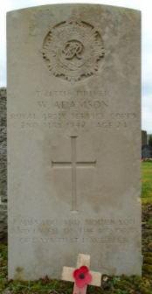  DRIVER WILLIAM ADAMSON  Service Number: T/213318  Regiment & Unit/Ship  Royal Army Service Corps  349 Gen. Transport Coy.  Date of Death  Died 02 May 1942 Age 24 years old  Buried or commemorated at  WHITBURN CEMETERY East Extn. Grave V.78. United Kingdom  Country of Service United Kingdom  Additional Info  Husband of Mary W. Adamson, of Stoneyburn.  Personal Inscription  I MISS YOU AND MOURN YOU AND DWELL ON THE MEMORIES OF DAYS THAT HAVE BEEN  West Lothian Courier 15th May 1942  Soldier’s Death – The death of a local soldier, Driver William Adamson (25) RASC, whose home is at 38 Cuthill Terrace, Stoneyburn, took place in All Saint’s Emergency Hospital, Broomgrove, England. It appears that Adamson and another driver were walking along the Road towards Webbeath about 10:30 on April 24th, when he was knocked down by a private car and received fatal injuries. The other driver Ernest Albert Walker, RASC was also knocked down and received injuries. Deepest sympathy goes out to Mrs Adamson who is a daughter of Mr and Mrs Archibald Cowan. The funeral took place on Wednesday to Whitburn Cemetery. The Longridge Home Guard turned out.  Midlothian Advertiser 22nd May 1942  Fatal Motor Accident – the death of a local soldier, Driver William Adamson, (25) RASC, whose home is at 38 Cuthill Terrace, Stoneyburn, took place in All Saints’ Emergency hospital, Bromsgrove, England. It appears that Adamson and another driver were walking along the Road towards Webheath about 10:30 on April 24th when he was knocked down by a private car and received fatal injuries.
182667 Sgt David Anthony  RAFVR | DAVID ANTHONY  SERGEANT DAVID ANTHONY  Service Number: 1826667  Regiment & Unit/Ship  Royal Air Force Volunteer Reserve 550 Sqdn.    Date of Death  Died 17 March 1945 Age 25 years old  Buried or commemorated at DURNBACH WAR CEMETERY 7. K. 21. Germany  Country of Service United Kingdom  Additional Info  Son of Robert Anthony and of Elizabeth Anthony (nee Kerr); husband of Anne Anthony (nee Brown), of Stoneyburn, West Lothian.  Personal Inscription  TILL THE DAY BREAKS  Surname ANTHONY Forename David  Rank Sgt Service number 182667  Place of birth Whitburn Date of death 17 March 1945  Theatre of death RAFVR BC Cause of death d.  SNWM roll ROYAL AIR FORCE and DOMINION AIR FORCES  Unit name In or attached to ROYAL AIR FORCE and DOMINION AIR FORCES  Full Name Anthony, David  Date Of Death 17 Mar 1945 Fate Killed in action  Rank Name Sergeant Service Number 182667  Age On Death 25  Aircraft Lancaster I Aircraft Number NG336  Base North Killingholme, Lincs  Buried Or Commemorated Durnbach War Cemetery, Germany  Fate Details Crashed Near Schwabisch Hall During A Raid on Nuremberg, the Pilot Survived and Was Captured  Residence Place Stoneyburn, West Lothian  Trade Agent  Primary Unit Royal Air Force Volunteer Reserve  Secondary Unit 550 Squadron  Archive Reference Airmen Died in the Second World War  Aircraft Lancaster I  Conflict Period World War II Served For United Kingdom  Midlothian Advertiser 24th December 1943  Presentation & Social – the Stoneyburn Ambulance Class held a Presentation & Social in the ARP Hall on Friday evening. Mrs Halliday occupied the chair; the occasion was to mark the leaving of Mr David Anthony for the RAF. Dr Sherry said a few words and after which Mrs Halliday made the presentation Mr Anthony suitably replied. Sons were rendered by Mr Stankaitis and Mr Anthony, and a trio of three ladies obliged, Misses Cunningham, Bowman and Wynn. A dance followed music being supplied by Mrs j Cherry. The evening was brought to a close with the singing of Auld Kang Syne and God Save the King..  West Lothian Courier 23rd March 1945  Whitburn Airman Missing  Official intimation has been received that Sergeant David Anthony (24), RAF, son of Mr and Mrs Robert Anthony, 22 Gateside, Whitburn is reported missing following operations over enemy territory. He joined the RAF sixteen months ago prior to which he was employed as a miner at Foulshields Colliery, Stoneyburn., his wife resides at Wilson Terrace Bents, Stoneyburn.
3192556  LCpl Anthony Cassells  5th Btn KOSB | LANCE CORPORAL ANTHONY CASSELLS  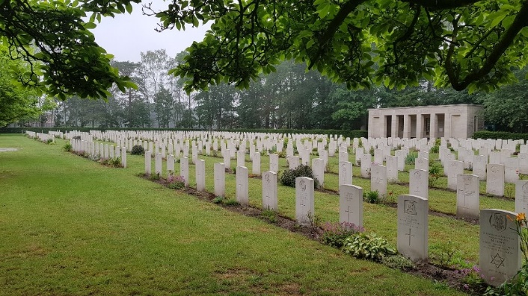  Service Number: 3192556  Regiment & Unit/Ship  King's Own Scottish Borderers 5th Bn.  Date of Death  Died 08 April 1945 Age 27 years old  Buried or commemorated at  SAGE WAR CEMETERY 6. E. 11. Germany  Country of Service United Kingdom  Additional Info  Son of Anthony and Ursula Cassells, of Stoneyburn, West Lothian.  Personal Inscription  R.I.P.  West Lothian Courier 23rd March 1945  Whitburn Airman Missing  Official intimation has been received that Sgt David Anthony (24), RAF, son of Mr and Mrs Robert Anthony, 23 Gateside, Whitburn, is reported missing following operations over enemy territory. He joined the RAF sixteen months ago, prior to which he was employed as a miner at Foulsheils Colliery, Stoneyburn. His wife resides at Wilson Terrace, Bents, Stoneyburn.  West Lothian Courier 4th May 1945  On Active Service – Cassells – Killed in action in April in Germany LCpl Anthony Cassells, KOSB aged 27 years, dearly beloved son of Mrs Millar and the late Anthony Cassells (fell last war) and stepson of Mr Joseph Millar, 115 Cuthill Crescent, Stoneyburn, West Lothian. RIP
7938798  Trooper James H Curran  RAC  1st Derbyshire Yeomanry | TROOPER JAMES HENRY CURRAN  Service Number: 7938798  Regiment & Unit/Ship  Royal Armoured Corps  1st Derbyshire Yeomanry  Date of Death  Died 06 May 1944 Age 23 years old  Buried or commemorated at  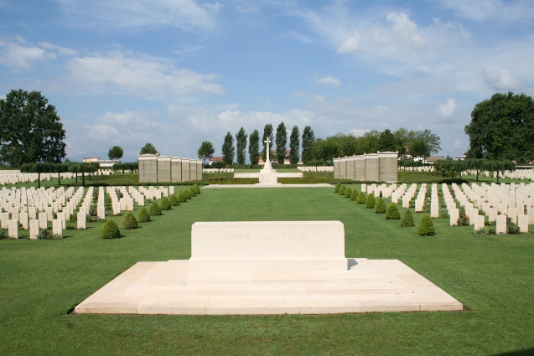  CASSINO WAR CEMETERY VIII. E. 22. Italy  Country of Service United Kingdom  Additional Info  Son of Daniel and Annie Curran, of Stoneyburn, West Lothian.  Personal Inscription  ETERNAL REST GIVE UNTO HIM, O LORD; AND LET PERPETUAL LIGHT SHINE UPON HIM, R.I.P.  West Lothian Courier 19th May 1944  Bents Soldier Killed – Mr and Mrs Daniel Currin, 20 Gardner Terrace, Bents, have received official notification that their son James 23 years of age, Armoured Corps has been killed in action. Prior to enlisting he was employed by United Colleries, Ltd. This is the second son lost, their other son Thomas 26 years old was torpeodoed 2.5 years ago in a tanker.  Midlothian Advertiser 26th May 1944  Local War Casualties – Mr and Mrs Daniel Currin, 20 Gardner Terrace, Bents, have been officially notified that their son Pte James Currin, (23), Armoured Corps has been killed in action. This is the second loss sustained by Mr and Mrs Currin. Another son, AB Thomas Currin, was lost at sea 2.5 years ago.
1774807 Gunner Thomas Curran  3/2 Maritime Rgt  Royal Artillery | GUNNER THOMAS CURRAN  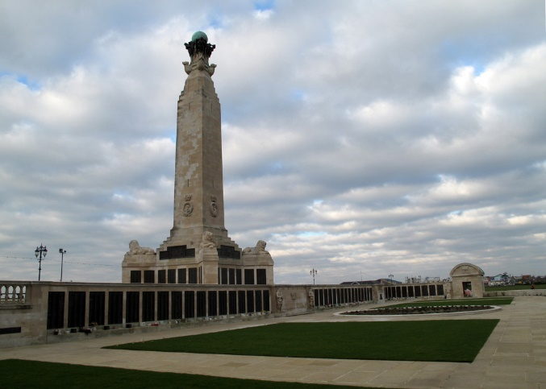  Service Number: 1774807  Regiment & Unit/Ship  Royal Artillery  3/2 Maritime Regt  Date of Death  Died 24 November 1941 Age 21 years old  Buried or commemorated at  PORTSMOUTH NAVAL MEMORIAL Panel 61, Column 3. United Kingdom  Country of Service  United Kingdom  Additional Info  Son of Daniel and Annie Curran, of Stoneyburn, West Lothian.
141016 PO John Dymock  25 Sqdn RAFVR | PILOT OFFICER JOHN MEIKLE DYMOCK  Service Number: 141016  Regiment & Unit/Ship  Royal Air Force Volunteer Reserve 25 Sqdn.  Date of Death  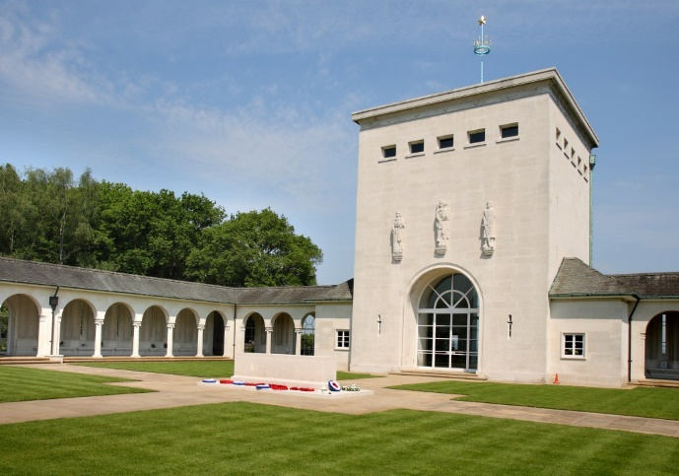  Died 13 June 1943 Age 33 years old  Buried or commemorated at  RUNNYMEDE MEMORIAL Panel 131. United Kingdom  Country of Service United Kingdom  Additional Info  Son of Mr. and Mrs. Alexander Dymock; husband of Isobel Daly Dymock.  West Lothian Courier 27th November 1942  Dymock – At 20 Chester Street, Edinburgh on 18th November 1942, to Isabel (nee Ewing), wife of Sgt John M Dymock, RAF, Dalziel Place Stoneyburn, a son.
2696634  LCpl Charles Brown Fairley  Scots Guards | 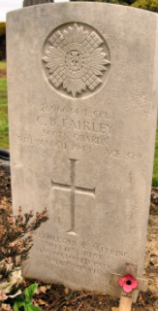  LANCE CORPORAL CHARLES BROWN FAIRLEY  Service Number: 2696634  Regiment & Unit/Ship  Scots Guards  Date of Death  Died 09 March 1944 Age 32 years old  Buried or commemorated at  WEST CALDER CEMETERY Sec. P. Grave 62. United Kingdom  Country of Service United Kingdom  Additional Info  Son of Eli James Fairley and Joan Thomson Fairley; husband of Agnes Redmond Fairley, of Stoneyburn, West Lothian.  Personal Inscription  PEACEFULLY HE IS SLEEPING, SWEETEST REST HAS FOLLOWED PAIN. SADLY MISSED  West Lothian Courier 23rd January 1942  Stoneyburn –– Mrs Charles Fairley has been notified that her husband, Charles Fairley, Scots Guards, is now safe and in hospital. He had previously been reported missing.  Midlothian Advertiser 30th January 1942  Stoneyburn Missing men Safe – Mrs Charles Fairley, 119 Cuthill Crescent, Stoneyburn, has been notified that her husband Charles Fairley, Scots Guards, is now safe and in hospital. He has previously been reported missing.  West Lothian Courier 17th March 1944  Stoneyburn – died in hospital – L/Cpl Charles Fairley, 33 years of age, Guardsman, died in Bangour Hospital on Thursday. He was a prisoner in Italy and was released when the British went in. He served 2.5 years in the Middle East and then two years at home. He came home on leave, was taken to hospital and died in a month’s time. He leaves a widow and one son, five years of age.
3053728  3053728 LCpl Hugh Gibson  2nd Btn Royal Scots  POW died on the Lisbon Maru | LANCE CORPORAL HUGH GIBSON  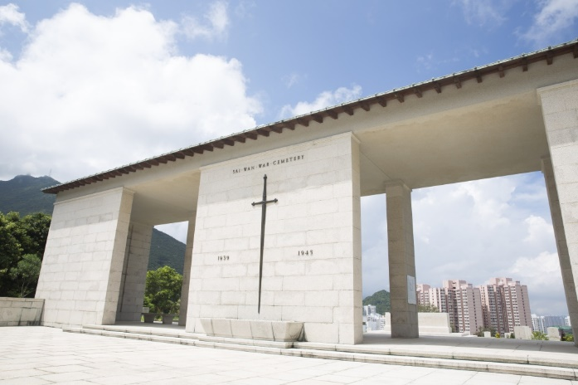  Service Number: 3053728  Regiment & Unit/Ship  Royal Scots 2nd Bn.  Date of Death  Died Between 01 October 1942 and 02 October 1942 Age 27 years old  Lisbon Maru  Buried or commemorated at  SAI WAN MEMORIAL Column 11. China, (including Hong Kong)  Country of Service United Kingdom  Additional Info  Son of Charles and Catherine Valentine Gibson.  West Lothian Courier 7th August 1942  Stoneyburn Prisoner of War – Official intimation has been received by Mr and Mrs Frame, Muir Terrace, Stoneyburn, that their nephew Hugh Gibson, The Royal Scots, is now a prisoner of war in Japanese hands. He had previously been reported missing at Hong Kong. He has been in the Army for 10 years.  Midlothian Advertiser 7th August 1942  Missing and Prisoner – Mr and Mrs Frame of 17 Muir Terrace, Stoneyburn have received intimation that their nephew LCpl Hugh Gibson of the Royal Scots is a prisoner of war in Japanese hands. LCpl Gibson has been in the Army for ten years.  Midlothian Advertiser 5th February 1943  Stoneyburn – Missing – LCpl Hugh Gibson of the Royal Scots, previously reported a prisoner of war in Hong King has been reported missing since the sinking of the Lisbon Maru.  West Lothian Courier 11th June 1943  Stoneyburn Soldier a Prisoner – Mr and Mrs Frame, 17 Muir Terrace, Stoneyburn, have received a letter from their nephew, Hugh Gibson, The Royal Scots, who was reported a prisoner on Christmas Day 1941, and later reported lost after the sinking of a ship. He is still a prisoner in Hong Kong and writes saying he is well  West Lothian Courier 10th November 1944  Stoneyburn Casualty – Lt QMr T Gibson, 16 Main Street, Stoneyburn (at present in Palestine) has received intimation that his brother LCpl Hugh Gibson, The Royal Scots, who was a prisoner of war in Japanese hands had been reported as killed on active service, following the sinking of the “Lisbon Marie” 2nd October 1942.  Midlothian Advertiser 17th November 1944  Stoneyburn – Lieut Qtr Master T Gibson, 16 Main Street, Stoneyburn (at present in Palestine has received intimation that his brother LCpl Hugh Gibson, The Royal Scots, who was prisoner of war in Japanese hands, has been reported killed on active service following the sinking of the “Lisbon Marie,” on 2nd December 1942.
Patrick Gillon Merchant Navy  SS North Britain | ORDINARY SEAMAN PATRICK GILLON    Regiment & Unit/Ship  Merchant Navy  S.S. North Brit ain (Newcastle-on-Tyne)  Date of Death  Died 05 May 1943 Age 20 years old  Buried or commemorated at  TOWER HILL MEMORIAL Panel 74. United Kingdom  Country of Service United Kingdom  Additional Info  Son of Patrick and Annie Gillon, of Stoneyburn, West Lothian.  West Lothian Courier 21st May 1943  Stoneyburn Merchant Navyman Lost – Mr and Mrs Patrick Gillon, 135 Cuthill Crescent, Stoneyburn, have received official intimation that their son, Pat, (20) Merchant Navy, has been lost in the Atlantic through enemy action.
2700615  Guardsman John Harvey 3rd Btn Scots Guards | GUARDSMAN JOHN WILLIAM HARVEY  Service Number: 2700615  Regiment & Unit/Ship  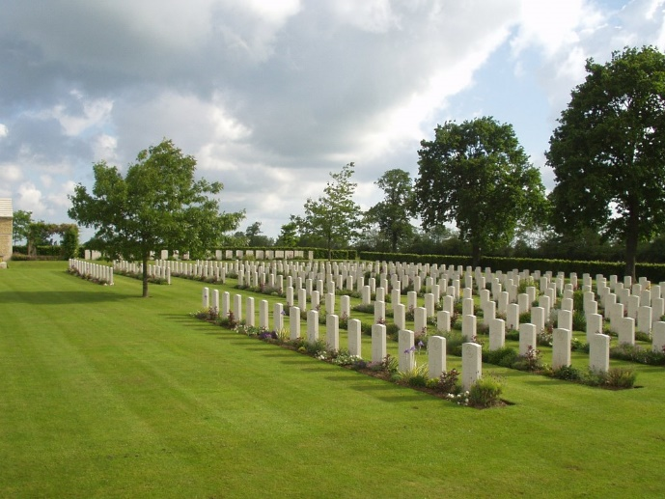  Scots Guards 3rd Bn.  Date of Death  Died 30 July 1944 Age 22 years old  Buried or commemorated at  HOTTOT-LES-BAGUES WAR CEMETERY VIII. A. 4. Spec. Memorial. France  Country of Service United Kingdom  Additional Info  Son of John William and Emily Harvey, of Liverpool.  Personal Inscription  GOD'S GREATEST GIFT, REMEMBRANCE
3059328  Pte William Higgins  2nd Btn Royal Scots | 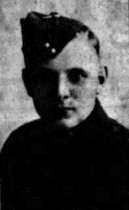  PRIVATE WILLIAM HIGGINS  Service Number: 3059328  Regiment & Unit/Ship  Royal Scots 2nd Bn.  Date of Death  Died 24 December 1941 Age 22 years old  Buried or commemorated at  SAI WAN MEMORIAL Column 12. China, (including Hong Kong)  Country of Service United Kingdom  Additional Info  Son of William and Agnes Higgins of Stoneyburn, Scotland.  First Name: William Surname: Higgins  DOB: Circa 1919 Age: 22  Birth County: West Lothian.  Nationality: British Resided County: West Lothian.  Date of Death: 24/12/1941  Information: Parents: William and Agnes Higgins of Stoneyburn, Scotland.  Rank: Private Service Number: 3059328  Service: British Army Regiment: Royal Scots Battalion: 2nd Battalion  West Lothian Courier 23rd January 1942  Stoneyburn Soldier Missing – Mr and Mrs Higgins, 16 Auchenhard Terrae, Stoneyburn have received official intimation that their son, Pte William Higgans, The Royal Scots, has been posted missing in Hong Kong. Pte Higgans who is 23 years of age, joined up 3 years ago and proceeded to Hong Kong 2 years ago. He was employed at Loganlea Colliery prior to joining up.  West Lothian Courier 29th January 1943  Stoneyburn Soldier Killed – Mr and Mrs W Higgans, 15 Auchenhard Terrace, Stoneyburn, have received official intimation that their son, William (23) The Royal Scots, was killed in action at Hong Kong on 24th December 1941. After his training he was drafted to Hong Kong over a year ago. Before joining up he was employed as a machineman in Loganlea Colliery.  From the Regimental Diary  24 December was a relatively quiet day by comparison with those before, nevertheless a further seven were killed and fifteen wounded. One area of progress, unfortunately rather late in the action, was the delivery of 200 pairs of brown PT shoes for use at night. It was estimated that their arrival improved the Battalion’s patrolling by 100% that night – sadly on what was to be the last one. A Company, 14 strong, and D, only 7, were sent back to rest that night having fought almost continuously since 9 December with no rest and little time to reorganise.
2984802 Pte John Hughes 2nd Seaforth Highlanders | PRIVATE JOHN HUGHES  Service Number: 2984802  Regiment & Unit/Ship  Seaforth Highlanders 2nd Bn.  Date of Death  Died 05 November 1942 Age 21 years old  Buried or commemorated at  EL ALAMEIN WAR CEMETERY IX. D. 13. Egypt  Country of Service United Kingdom  Additional Info  Son of Charles and Flora Hughes, of Glasgow.  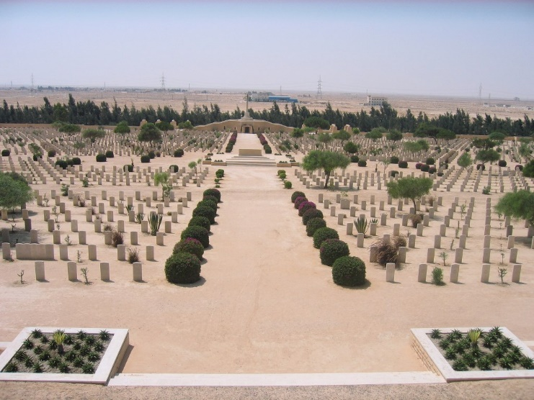  Personal Inscription  NO EARTHLY WEALTH CAN EVER REPLACE  OUR DEAR SON'S SMILING FACE  West Lothian Courier 27th November 1942  Stoneyburn Soldier Missing – Mrs John Hughes, 35 Cuthill Crescent, Stoneyburn, has received official intimation that her husband Pte John Hughes, Seaforth Highlanders, is reported missing. He has been in the Middle East about 7 or 8 months. Before joining up he was employed as a painter in Edinburgh. He is a son of the late Frank and Mrs Hughes, Main Street, Stoneyburn.  Midlothian Advertiser 27th November 1942  Missing – Mrs Hughes of 35 Cuthill Crescent has received official intimation that her husband John Hughes has been missing since 2nd November. He is in the Seaforth Highlanders and took part in the advance in the Middle East. Before Joining the Army, he was employed as a painter in Edinburgh  Midlothian Advertiser 4th December 1942  Local Soldier Missing – Mrs John Hughes, 35 Cuthill Crescent, Stoneyburn has received official intimation that her husband Pte John Hughes, Seaforth Highlanders is reported missing. He has been in the Middle East about seven or eight months. Before joining up he was employed as a painter in Edinburgh. He is a son of the late Frank and Mrs Hughes, Main Street, Stoneyburn  West Lothian Courier 10th December 1943  Stoneyburn soldier Presumed killed – Mrs John Hughes, who resides with her parents, Mr and Mrs Robert Currie, 35 Cuthill Crescent, Stoneyburn has been notified that her husband must be presumed killed. He was reported missing in North Africa in November 1942. He was called up three years ago and joined the Seaforth Highlanders. He was a son of the late Frank and Mrs Hughes, Main Street, Stoneyburn.  In civil life he was a painter with the United Collieries Ltd and latterly with a firm in Edinburgh. He leaves a wife and young son.  Midlothian Advertiser 17th December 1943  Presumed Killed – Mrs John Hughes of 35 Cuthill Crescent, has received official intimation that her husband must now be presumed killed. He was reported missing in North Africa in November 1942. He was called up three years ago to the Seaforth Highlanders. He is the son of the late Frank and Mrs Hughes, Main Street, Stoneyburn. His employment, painter with the United Collieries and latterly with a firm in Edinburgh. He leaves a wife and young son.
185130 Pilot Officer James McLean 608 Sqdn RAFVR | PILOT OFFICER JAMES McLEAN  Service Number: 185130  Regiment & Unit/Ship  Royal Air Force Volunteer Reserve 608 Sqdn.  Date of Death  Died 06 November 1944 Age 26 years old  Buried or commemorated at  TRANENT NEW CEMETERY Sec. A. Grave 409. United Kingdom  Country of Service United Kingdom  West Lothian Courier 17th November 1944  On Active Service – McLean – Killed in air operation in November 1944 Pilot Officer James McLean beloved only son of Mr and Mrs William McLean, Bents, Stoneyburn (late of Bo’ness) and devoted brother of Cis and Barbara.  (no grave photo on CWGC nor on Find a Grave).
3047575  Gunner Daniel Molloy  120 Field Rgt RA | 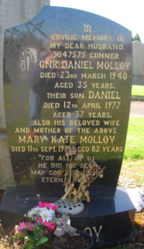  GUNNER DANIEL MOLLOY  Service Number: 3047575  Regiment & Unit/Ship  Royal Artillery 120 Field Regt.  Date of Death  Died 23 March 1940 Age 35 years old  Buried or commemorated at  WHITBURN CEMETERY East Extn. Grave V.126. United Kingdom  Country of Service United Kingdom  Additional Info  Son of Patrick and Sarah Molloy; husband of Mary McCready Molloy, of Stoneyburn.
C/SSX 27523 AB Alex Morris Royal Navy | ABLE SEAMAN ALEXANDER THOMSON MORRIS  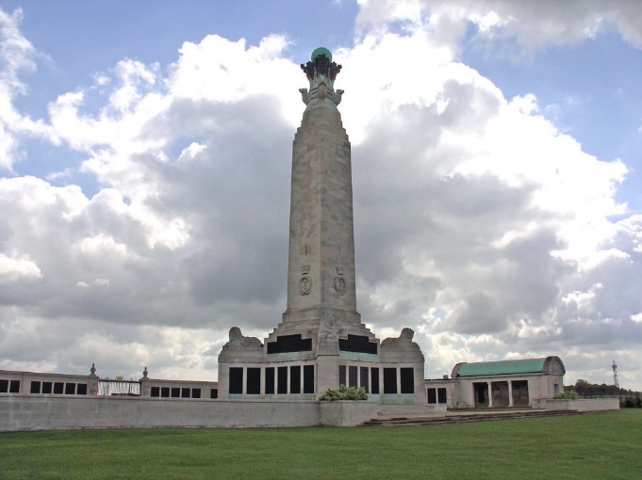  Service Number: C/SSX 27523  Regiment & Unit/Ship  Royal Navy H.M.S. Ibis  Date of Death  Died 10 November 1942 Age 23 years old  Buried or commemorated at  CHATHAM NAVAL MEMORIAL 55, 2. United Kingdom  Country of Service United Kingdom  Additional Info  Son of James and Agnes Morris, of Stoneyburn, West Lothian.  West Lothian Courier 4th December 1942  Stoneyburn Sailor Presumed killed – On Monday morning Mr and Mrs James Morris 76 Cuthill Crescent, Stoneyburn received an official telegram which stated that their son, Alex T Morris, RN 23 years of age, was missing following war action., and is presumed killed. The telegram also stated that a letter would follow. Morris has been in the navy for 4 years and had been mostly on convoy work with destroyers. He had been twice wounded. Prior to joining up he was employed in the mines.  Midlothian Advertiser 4th December 1942  Missing – Mr and Mrs Morris of 76 Cuthill Crescent have received official intimation that their son Able Seaman A Morris, is missing presumed killed. He is 22 years of age and before joining the Navy four years ago was employed with Mr Frew at Stoneheap Farm.
127187 Flying Officer William Paton  38 Sqdn RAFVR | FLYING OFFICER WILLIAM PATON  Service Number: 127187  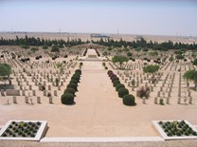  Regiment & Unit/Ship  Royal Air Force Volunteer Reserve 38 Sqdn.  Date of Death  Died 21 June 1943  Buried or commemorated at  ALAMEIN MEMORIAL Column 268. Egypt  Country of Service  United Kingdom  Midlothian Advertiser 30th January 1942  Prisoner of War – Mr and Mrs David Paton, 12 Cuthill Terrace, Stoneyburn have been notified that their son, William, MA, MC, is a prisoner of war in Germany. Before joining up he was a miner in Loganlea Colliery.  West Lothian Courier 18th September 1942  Airman’s Promotion – William Paton, RAF, son of Mr and Mrs Thomas Paton, 39 Cuthill Crescent, has been promoted Pilot Officer. He is 24 years of age and was a member of Dunfermline Burgh Police Force before he joined up, prior to which he was employed in Loganlea Colliery. He is the first young man of the village who has had this distinction and we offer him our congratulations and wish him the best of luck.  When he joined up, he was sent overseas for training, after which he returned to England. This is his first leave for a year and exactly a year after joining up 3rd September 1942, he received his commission. He was home for seven days and returned to the south of England where he expects to have further training for three months.  Midlothian Advertiser 25th September 1942  Local Airman’s Promotion – William Paton, RAF, son of Mr and Mrs Thomas Paton, 39 Cuthill Crescent, has been promoted Pilot Officer. He is 24 years of age and was a member of Dunfermline Burgh Police force before he joined up, prior to which he was employed in Loganlea colliery. He is the first young man of the village who has had this distinction and we offer him our congratulations and wish him the best of luck.  West Lothian Courier 9th July 1943  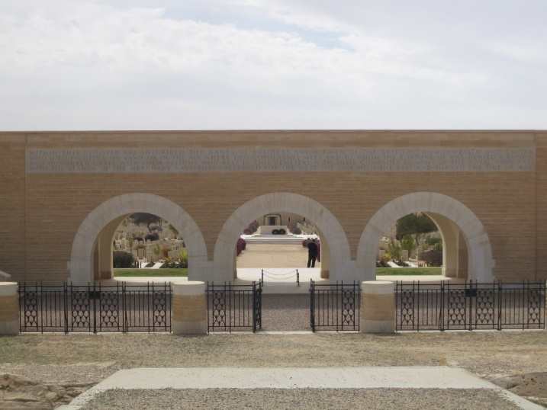  Stoneyburn Airman Missing – Mr and Mrs Thomas Paton, 39 Cuthill Crescent, Stoneyburn, have received official intimation that their son Pilot officer William Paton, RAF, has been posted missing since June, he having failed to return from operational duties in the Middle East. He was 25 years of age and recently married. Before joining the RAF he was a police constable in Dunfermline.  Midlothian Advertiser 16th July 1943  Local Airman Missing – Mr and Mrs Thomas Paton, 39 Cuthill Crescent, Stoneyburn, have received official intimation that their son Pilot Officer William Paton, RAF has been posted missing since June, he having failed to return from operational duties in the Middle East. He was 25 years of age and recently married. Before joining the RAF he was a Police constable in Dunfermline.  West Lothian Courier 21st January 1944  Stoneyburn Airman Presumed Lost – Mr and Mrs Thomas Paton, 39 Cuthill Crescent have received the following letter – I am directed to inform you with regret, that in view of the lapse of time and absence of any further news regarding your son Flt Officer W Paton since he was reported missing, action has been taken to presume for official purposes that he lost his life on the 21st June 1943.  Midlothian Advertiser 28th January 1944  Airman Presumed Lost – Mr and Mrs Thomas Paton, 39 Cuthill Crescent, have received the following letter: - “I am directed to inform you with regret, that in view of the lapse of time and absence of any further news regarding our son, Flight Officer, W Paton, since he was reported missing, action has been taken to presume, for official purposes that he lost his life on the 21st June 1943.”
129361 Flying Officer  Alex Wilson 51 Sqdn RAFVR | FLYING OFFICER ALEXANDER BELL PATE WILSON  Service Number: 129361  Regiment & Unit/Ship  Royal Air Force Volunteer Reserve 51 Sqdn.  Date of Death  Died 28 May 1943 Age 26 years old  Buried or commemorated at  REICHSWALD FOREST WAR CEMETERY 18. B. 2. Germany  Country of Service United Kingdom  Additional Info  Son of Charles Campbell Wilson and Flora McCallum Pate Wilson, of Stoneyburn, West Lothian.  Personal Inscription  JUST A MEMORY, FOND AND TRUE, FROM THOSE WHO THOUGHT THE WORLD OF YOU  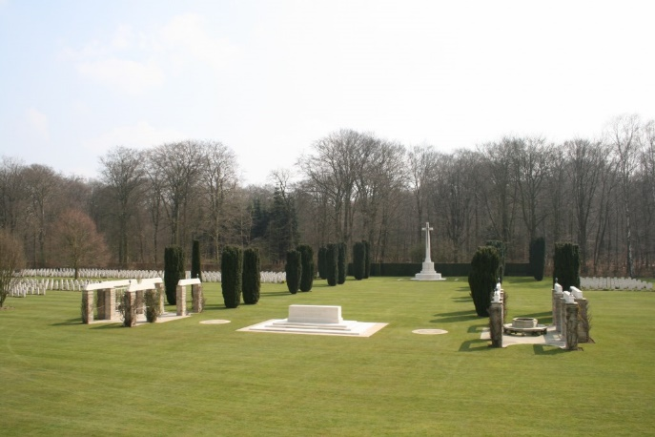  West Lothian Courier 11th June 1943  Bents Airman Missing – Mr and Mrs Charles Wilson, 57 Garden City, Bents, have received a telegram intimating that their son, Pilot Officer Alex B P Wilson, had failed to return after a recent operational flight over Germany. A letter has now been received but contains no further news of him. Alex was a member of Glasgow City Police, when he answered the call, and previous to that he was employed at Foulshiels Colliery  West Lothian Courier 6th November 1942  Bents Man now Air Navigator - We show a photo of LAC A B Wilson, of 57 Garden City, Bents, West Lothian, who, as an RAF trainee has recently graduated as an Air Navigator and has received his observer’s wing at an observer School in Canada and is now ready to take his place with an Operational Squadron of the RAF. He received his raining at an air Observer school in Alberta under the training system of the British Commonwealth Air Training Plan.  Before joining the RAF, Wilson was a member of Glasgow Constabulary, prior to which he was employed at Foulshiels Colliery. His father works at Woodmuir Colliery.  West Lothian Courier 3rd December 1943  Stoneyburn Airman Killed – Mr and Mrs Charles Wilson, 54 Garden City, have received a letter from headquarters of the International Red Cross Committee stating that their son Flying Officer Alex Bell Peter Wilson, RAF, was buried in the north Cemetery, Westphalia, Germany, also that his comrades were buried in neighbouring graves.  Midlothian Advertiser 10th December 1943  Stoneyburn Airman’s death – Mr and Mrs Charles Wilson of 54 Garden City, Bents, have received a letter from the Headquarters of the International red Cross Committee, stating that their son, Flying Officer Alex Bell Wilson, RAF, was buried in a cemetery in Germany and also that comrades are buried in neighbouring graves.
2148003  Pte Alex Wilson 6th Btn North Staffordshire Rgt | PRIVATE ALEXANDER WILSON  Service Number: 2148003  Regiment & Unit/Ship  North Staffordshire Regiment 6th Bn.  Date of Death  Died 09 July 1944  Buried or commemorated at  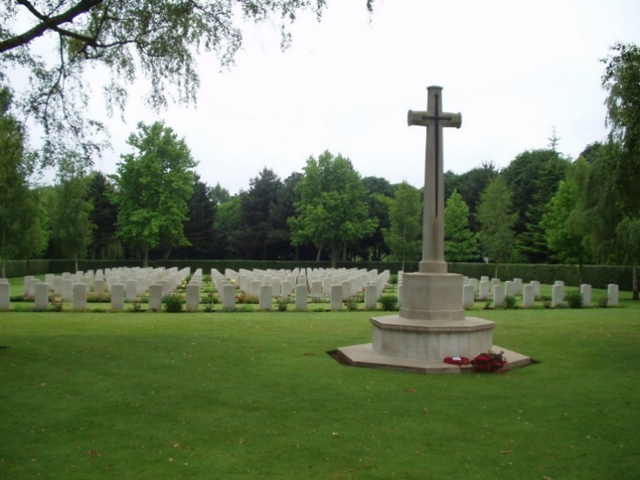  CAMBES-EN-PLAINE WAR CEMETERY Row F. 5.France  Country of Service United Kingdom  West Lothian Courier 28th July 1944  Stoneyburn Man Killed – Mrs Charles Wilson, 1 Muir Terrace, Stoneyburn, has received official information that her son Alex has been killed in action in France on 8th July. He was 33 years of age andl leaves a widow and two children who reside in Edinburgh. For some time previous to joining up he was employed in Loganlea Colliery and was well known in the district.  Midlothian Advertiser 4th August 1944  Stoneyburn Man Killed – Mrs Charles Wilson 1 Muir Terrace, Stoneyburn has recently received official information that her son Alex, has been killed in action in France on 8th July. He was 33 years of age and leaves a widow and two children who reside in Edinburgh. For some time, previous to joining up, he was employed in Loganlea Colliery and was well-known in the district

Stoneyburn & Bents War Memorial WW2

Those Not on the War Memorial & Those Who Served

James Aitchison Hamilton  Royal Navy  Helen K Clarkson | JAMES AITCHISON HAMILTON – HELEN K CLARKSON  West Lothian Courier 16th March 1945  Marriage – Hamilton – Clarkson – On 9th March 1945 at the Church of Scotland Blackburn, by the Rev D H Tweeddale, James Aitchison (Royal Navy) second son of Mr and Mrs A Hamilton, 15 Cuthill Crescent, Stoneyburn, to Helen Kerr (Nellie) eldest daughter of Mr and Mrs G Clarkson, 124 Riddochhill Road, Blackburn, West Lothian
1558916  Flight Sgt David Allan  50 Sqdn RAF  POW Germany | DAVID ALLAN  First Name: David Surname: Allan  DOB: 15/01/1921  Resided Town: West Lothian  Resided County: Scotland  Fate: Taken as Prisoner of War on 25/02/1943  Information:  Was imprisoned in the following camps: 344 – from 06/03/1943 till 22/01/1945, 8A – from 05/02/1945 till 10/02/1945, Duoerstat Brickwork – from 13/03/1945 till 20/03/1945, Brunswick – from 26/03/1945 till 10/04/1945. He was at the following work camp: Brunswick – from 26/03/1945 till 10/04/1945 as Railway Repairs.  Rank: Flight Sergeant  Service Number:1558916  Duty Location: Nurnberg  Service: Royal Air Force  Regiment: 50 Squadron  Resided Town: Stalag 344, Lamsdorf  Nationality: British  Resided Country: Poland  Fate: Prisoner of War  Information: POW No. 27560  Rank: Flight Sergeant  Service Number: 1558916  West Lothian Courier 4th May 1945  Stoneyburn – POW Home – Flight Lieut D Allan, RAF, son of Mr and Mrs George Allan, 9 Gardner Terrace Stoneyburn returned home last week. He was shot down on 28th February 1943 and was 2 years and 2 months in captivity. When captured along with other prisoners he was marched 700 miles from camp to camp. He was liberated on April 21st and flown home to this country. Arrangements are being made to give him a welcome home.  Midlothian Advertiser 11th May 1945  Stoneyburn Airman Home – Lieut D Allan of the RAF, son of Mrs and Mrs George Allan 9 Garden Terrace, Stoneyburn has arrived home safe, he was shot down on 26th February 1943. He was marched for 700 miles. The allies liberated him on 21st April.  Midlothian Advertiser 11th May 1945  Stoneyburn Prisoners of War Entertained – About 200 persons sat down to a knife and fork tea at the Welfare Hall when Pte James Strickland and flight Lieutenant D Allan were entertained. The platform friends were introduced by Mrs R Walker and included Mr and Mrs Hardy, Dr and Mrs Sherry and Mr Weir a former headmaster of Stoneyburn School who had a hearty reception. After tea there was an enjoyable musical programme followed by dancing to music by the Lothian Quartette  Midlothian Advertiser 11th May 1945  Airman Home from Germany – Flight Lieutenant D Allan, RAF, son of Mr and Mrs George Allan, 9 Gardner Terrace, Stoneyburn returned home recently. He was shot down on 26th February 1943 and was 2 years and 2 months in captivity. When captured with other prisoner he was marched 700 miles from camp to camp. He was liberated on April 21st and flown home to this country.
3058418 Pte Alexander Anderson  Seaforth Highlander  POW Germany | ALEXANDER ANDERSON  Camp No. 11B POW No. 140501  Surname Anderson Forename/Initials A.  Rank Pte. Army No 3058418  Record Office No 16  Record office Name Infantry Record Office, Perth.  Camp Type STALAG Camp Location Fallingbostel.  Regiment The Seaforth Highlanders.  Reported missing 18th July 1940  21 2 1941 reported detained in France  POW in Italy P.O.W. Camp number 73, Fossoli of Carpi near Modena, postal mark number 3300  1943 Stalag 11b, Fallingbostel  Resided Country: Germany  Fate: Prisoner of War  Information: POW No. 140501  4th Battalion:  1940: The Battalion was part of the BEF and of the 152 Brigade, 51st (Highland) Division.  Midlothian Advertiser 7th January 1944  Anderson – In loving memory of our dear father and grand-dad William Anderson, accidentally killed at work on January 6th 1942  Our thought drift back to days gone past  Life goes on but memory lasts  Inserted by his daughters, son in law and grandchildren 18 Main Terrace, Stoneyburn  Also Sandy POW  West Lothian Courier 27th April 1945  Returned POW – Pte Alex Anderson, Seaforth Highlanders son of the late William Anderson, 13 King Street, West Calder arrived home at his sister’s Mrs Alex Moffat, 18 Muir Terrace, Stoneyburn on Saturday, He was called up in July 1939, and went to France in January 1940 and as captured at St Valery on 12 June 1940. He escaped on 26th June 1940 and was recaptured by the Italians and taken to Italy and was there till the Italians capitulated in September 1943 when he was taken by the Germans to Stalag XI. While a prisoner he worked in the iron ore mines, starting at 4m with only a drink of weak coffee and small piece of bread daily as rations. He was freed by the Americans on 11th April and flown to Brussels and then down to England in a Stirling bomber. Before joining up he was employed as a miner in Westwood shale Pit. He looks well and fit despite his experiences.  Midlothian Advertiser 4th May 1945  Prisoner of War Home – Pte Alex Anderson, Seaforth Highlanders, son of the late William Anderson, 13 King Street, West Calder, arrived home at his sister’s Mrs Alex Moffat, 18 Muir Terrace, Stoneyburn on Saturday. He was called up in July 1939, went to France in January 1940, and was captured at St Valery on 12th June 1940. He escaped on 26th June 1940 and was recaptured by the Italians and taken to Italy and was there till the Italians capitulated in September 1943, when he was taken by the Germans to Stalag X1  While a prisoner he worked in the iron ore mines, starting at 4am with only a drink of weak coffee and a small piece of bread daily as rations. He was freed by the Americans on 11th April, and flown to Brussels and then flown to England in a Stirling bomber  Before joining up he was employed as a miner in Westwood shale Pit. He looks well and fit despite his experiences.  Midlothian Advertiser 11th May 1945  Returned Prisoners of War – On Wednesday evening of last week a company of 200 met in the Polytechnic Hall to welcome home 6 district soldiers who had been prisoners of war in Germany. They were Ptes John Easton, J MacCabe, John Porter, Harburn, John Walker, Addiewell, Alex Anderson, Stoneyburn and Alevia Tipaldi.  Mrs Toner presided and extended a very hearty welcome home to the soldiers. They were all very glad to see them safe home again after the hard time they had spent in Germany. The big surrender of the Germans showed that Victory Day was now not far off. She hoped all present would spend a very happy evening.  An excellent tea was then served; all the eatables having been kindly provided by the ladies.  An enjoyable musical programme followed; the artistes were Mrs Russell, Mrs Forrester, Miss Kennedy, Mr Pryde, Mr Steele, and Master Billy Ross with Miss Chalmers as accompanist.  All the artistes met with very hearty reception. Mr Pirrie was present with his pipes and played the soldiers into the hall at the opening of the meeting. They can in for hearty cheers as they entered.  Ms toner said while they were glad to have the lads’ safe home, they should honour the memory of those who had given their lives for our safety and a minute’s silence was observed by the company.  Each of the soldiers was presented with £5.  In moving a vote of thanks to Mrs Toner, Mr Alex McCallum referred to the fine work she was doing on behalf of the returned prisoners of war and the Welcome Home Fund  After the social the company engaged in dancing to the music by the Locarno Dance Band, with Mr Scott Edgar as MC
Margaret Finlay Barr  Nathan Gibson Cunningham  RASC | MARGARET FINLAY BARR – NATHAN GIBSON CUNNINGHAM  West Lothian Courier 7th November 1941  Cunningham – Barr – At Stoneyburn Church on 31st October by the Rev George Fraser, MA, Nathan Gibson Cunningham, RASC, youngest son of Mr and Mrs Thomas Cunningham, 27 Gloag Place, West Calder to Margaret Finlay Barr, youngest daughter of Mr and Mrs John Barr, 11 Cannop Crescent, Bents, Bathgate.
LAC W Bishop  RAF | W BISHOP  West Lothian Courier 28th April 1944  Airman’s Brave Deed – Dived among Bombs and threw Incendiary Clear – A brave deed by W Bishop RAF, was reported recently in the newspapers and has been entered in the records of his squadron. At a certain station, something went wrong with a bomber as it was about to take off and most of its bomb load fell on the runway. All the incediarys were heaped together and in their midst was a 400 lb bomb.  An incendiary began to smoke and LAC Bishop dived in among the bombs, seized the smoking incendiary ran 20 or 30 yards and threw it clear. He was modest and showed little concern for his own safety.  Though his wife is at present in Innerlethen, Bishop himself belongs to this area and his parents live at Auchinhard.  He was a member of the Stoneyburn Boy Scouts and before joining the RAF was assistant Scoutmaster. We congratulate him on his prompt and plucky action.  Midlothian Advertiser 28th April 1944  Brave Act – Mr William Bishop’s name will go down in the records of his Squadron in the RAF., recently a Lancaster bomber had difficulty in taking off, and most of its bombs fell on the concrete. Among the heap of incendiaries was a 4000 pounder. Seeing an incendiary smouldering William bishop lifted it and rant with it 20 or 30 yards before throwing it where it would do no harm, His parents live at Auchenhard, Stoneyburn. He was a member of the local Boy Scouts before joining up being Assistant Scoutmaster  (Almost 100 William Bishop’s in the RAF – can’t identify)
P/KX 109256  Stoker 1st Class John Butler  Royal Navy  HMS Repulse | JOHN BUTLER  First Name: John Surname: Butler  Nationality: British  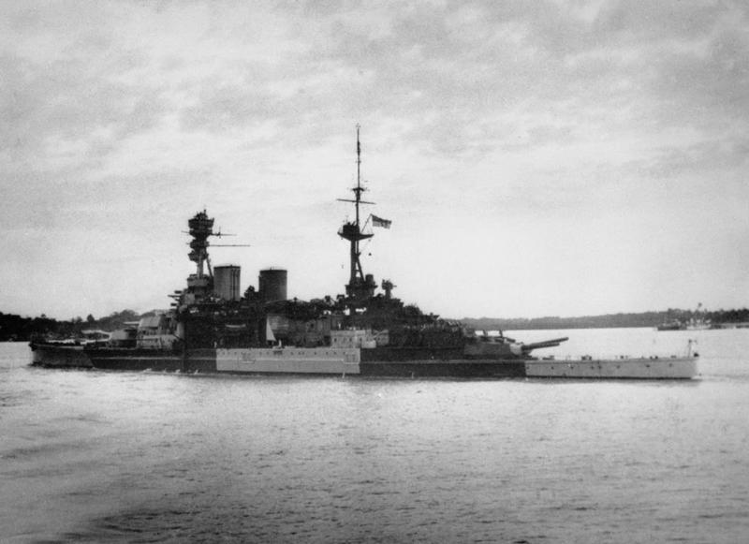  Date of Death: 10/12/1941  Information: Son of Thomas and Margaret Butler, of Portobello, Edinburgh  Rank: Stoker 1st Class Service Number: P/KX 109256  Service: Royal Navy Ship: HMS Repulse  Commemorated:  HMS Repulse Taken by Adams W L G (Captain), Commanding Officer, HMS Corinthian  Panel 54, Column 3 Portsmouth Naval Memorial, Hampshire, United Kingdom  West Lothian Courier 23rd January 1942  Stoneyburn Sailor Drowned – Mr and Mrs Thomas Butler, 53 Cuthill Crescent, Stoneyburn, have received official notification that their son John was drowned when the Repulse was sunk. He was 29 years of age and was a miner in Foulshiels Colliery before joining the Navy at the beginning of the war. He had been on two different ships which have been destroyed.  Midlothian Advertiser 30th January 1942  Stoneyburn Sailor Drowned – Mr and Mrs Thomas Butler, 53 Cuthill Crescent, Stoneyburn, have received official notification that their son John was drowned when the Repulse was sunk. He was 20 years of age, and was a miner in Foulshiels Colliery before joining the Navy at the beginning of the war. He has been on two different ships which have been destroyed.  (Repulse and her consort, the battleship Prince of Wales, were sunk by Japanese aircraft on 10 December 1941 when they attempted to intercept landings in British Malaya.)
Agnes Cherry | AGNES CHERRY  West Lothian Courier 20th August 1943  Blackout Offence – Agnes Cherry, 111 Old Rows, Stoneyburn, pleaded guilty by letter to a blackout offence during the hours of darkness and a penalty of £1 was imposed with the alternative of seven days imprisonment.
CJX142524  Petty Officer William Heron Chisholm  Orp Sokol  DSM  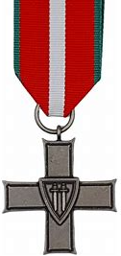    Polish Cross | WILIAM HERON CHISHOLM  Incident Date: 1942  Rank: Temporary Acting Petty Officer Telegraphist  Additional Information: Conferred by the President of the Polish Republic Polish Cross of Valour  Service: Royal Navy  Service Number:  CJX142524  Award Details:  Awarded for Actions, patrols, raids carried out by HM Submarines  Gazette Info:  https://www.thegazette.co.uk/London/issue/36602/supplement/3237  Gazette Date: 11/07/1944  Gazette Page: 3237  Service: Royal Navy  Regiment: Orp Sokol  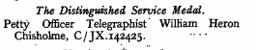  West Lothian Courier 2nd June 1944  DFM for Bents Airman – Flight Sgt Robert Andrew Christie, whose parents reside at 19 Lighton Terrace, Bents, received the Distinguished Flying Medal in a list of RAF awards to personnel who have completed in various capacities many successsful operations against the enemy in which they have displayed high skill, fortitude and devotion to duty. Flt Sgt Christie was born in Bents and will be 21 years of age next month. He is to be married on Saturday. Before enlisting he was employed at Loganlea Coliliety. He is now a flying instructor.  West Lothian Courier 2nd March 1945  Two Stoneyburn Men Decorated by King  At the recent investiture held at Buckingham Palace, two Stoneyburn men were among the number decorated.  Mr William Chisholm, 64 Stoneyburn, a Wireless Telegraphist and Petty Officer received the DFM for bravery while serving in a Polish submarine. This is his second decoration for bravery and devotion to duty, the previous one being a Polish distinction. His father, Mr William Chisholm, travelled to London and saw his son decorated.  Mr Robert Christie, 19 Lighton Terrace, was a Sergeant in the RAF when he won the DFM. He has now been promoted to Warrant Officer. He won his decoration for bravery and devotion to duty while flying over Germany. He is married and his home address is 6 Albert Street, Harrogate, Yorkshire. His mother travelled to London and saw the decoration being pinned on by His Majesty, the King.  Both recipients are former pupils of Stoneyburn Public School and were born and brought up in the village  Midlothian Advertiser 2nd March 1945  Stoneyburn – Decorated – William Chisholm of 64 Stoneyburn travelled to Buckingham Palace to see his son receive the DSM. He is Petty officer in the Royal Navy and was attached to the Polish Submarine “Sokol”. He received the Polish Cross some time ago
1559084  Flight Sgt Robert Andrew Christie DFM  101 Sqdn RAFVR | ROBERT ANDREW CHRISTIE  First Name: Robert Andrew Surname: Christie  Rank: Flight Sergeant  Service Number: 1559084  Gazette Date: 23/05/1944  Gazette Page: 2350  Service: Royal Air Force Volunteer Reserve  Squadron/Unit: 101 Squadron  https://www.thegazette.co.uk/London/issue/36525/supplement/2350  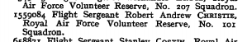  West Lothian Courier 11th February 1944  Back to Unit – Robert Christie, youngest son of Mr and Mrs Robert Christie, Bents, who was recently home on leave has now returned to his unit in England He has had 30 flights over Germany and is now taking a course on instructorship. He is still under 20 years of age. His brother George is on the ground staff of the RAF.  Linlithgow Gazette 26th May 1944  DFM for Bathgate Airman – Flight Sgt Robert Andrew Christie, RAFVR of No 101 Squadron, a native of Bathgate, received the Distinguished Flying Medal in a list of RAF awards to personnel who have completed, in various capacities many successful operations against the enemy in which they have displayed high skill, fortitude and devotions to duty. Flt Sgt Christie was born at Bathgate, and his home is at Stoneyburn. He was a labourer before enlisting in 1941 and is now an air bomber.  West Lothian Courier 5th January 1945  Awards for Gallantry – In all branches of the fighting services Bathgate’s sons have continued to distinguish themselves and from time to time we have had to record lists of men, wounded, missing and prisoners of war as well as quite a number who have made the supreme sacrifice  For having completed many successful operations against the enemy in which he displayed high skill and fortitude Flight Sgt Robert Andrew Christie, RAFVR a native of Bathgate whose home is at Stoneyburn was awarded the DFM  West Lothian Courier 2nd March 1945  Two Stoneyburn Men Decorated by King  At the recent investiture held at Buckingham Palace, two Stoneyburn men were among the number decorated.  Mr William Chisholm, 64 Stoneyburn, a Wireless Telegraphist and Petty Officer received the DSM for bravery while serving in a Polish submarine. This is his second decoration for bravery and devotion to duty, the previous one being a Polish distinction. His father, Mr William Chisholm, travelled to London and saw his son decorated.  Mr Robert Christie, 19 Lighton Terrace, was a Sergeant in the RAF when he won the DFM. He has now been promoted to Warrant Officer. He won his decoration for bravery and devotion to duty while flying over Germany. He is married and his home address is 6 Albert Street, Harrogate, Yorkshire. His mother travelled to London and saw the decoration being pinned on by His Majesty, the King.  Both recipients are former pupils of Stoneyburn Public School and were born and brought up in the village
2365838 Signalman Archie Cowan  Royal Corps of Signals  POW Germany | ARCHIE COWAN  Date of Action:  21/06/1942  Fate: Missing  Incident Details: Reported to War Office Casualty Section for the 24 hours ending at 09:00.  Incident Date: 07/08/1942  Information: Casualty List No. 896.  Rank: Signalman  Service Number: 2365838  Duty Location: Western Desert  Fate: Prisoner of War in Italy  Information: P.O.W. Camp number 65, Cressina (Bari),(Also listed as Gravina Altamura), postal mark number 3450  Further Information: Record Office number: 10  Rank: Signalman  Service Number: 2365838  Duty Location: Italy  Resided Town: Stalag 17b, Gneixendorf  Resided Country: Austria  Fate: Prisoner of War  Information: POW No. 154788  West Lothian Courier 31st July 1942  Stoneyburn Mr and Mrs Archibald Cowan, 38 Cuthill Terrace, Stoneyburn, have received official intimation that their son Archie, Royal Corps of Signals, is reported missing in the Middle East. He was employed on the surface at Foulshiels Colliery before joining up.  Midlothian Advertiser 7th August 1942  Missing and Prisoner – Mr and Mrs Archibald Cowan, 38 Cuthill Terrace, Stoneyburn have received official intimation that their son Archie, Royal Corps of Signals is reported missing in the Middle East. He was employed on the surface at Foulshiels Colliery before joining up.  Midlothian Advertiser 28th August 1942  Prisoner of War – Mr and Mrs Cowan of 38 Cuthill Terrace, have received word that their son Archibald, previously reported missing is a prisoner of war in Italian hands.  West Lothian Courier 28th August 1942  Stoneyburn Soldier a Prisoner – Mr and Mrs Archibald Cowan 36 Cuthill Terrace, Stoneyburn, have received a letter and also a postcard from their son Archie, Royal Corps of Signals, who was previously posted missing, saying that he is now a prisoner of war in Italy. The correspondence is dated 14th July.  West Lothian Courier 18th May 1945  Repatriated prisoners of War – So far six prisoners of war have arrived home from prison camps. We have already mentioned two already and the other four are Pte Alex Thomson, Gordon Highlanders, 76 Old Rows, Stoneyburn who arrived home on Saturday night, A member of the famous 51st Division, Pte William Paton, RAMC, Cuthill Crescent, Stoneyburn who arrived home on Sunday night was captured in Crete and transferred to Germany, Archie Cowan, Cuthill Crescent, Stoneyburn who arrive home on Tuesday morning was captured by Italians, Cpl D Cummings, Queens Own Cameron Highlanders son in law of Mr and Mrs C Wilson, 57 Garden City, Bents, captured at Tobruk when it fell the first time to the Italians, he arrived on Saturday. All are home for the usual 42 days.  Midlothian Advertiser 15th June 1945  Stoneyburn – Welcome Home Social – A social and dance was held in the Welfare Hall on Thursday evening to welcome home Cpl Thomson. After an excellent tea a musical programme was carried out. Messrs Thomson, Fairley, Cowan and Paton, four returned prisoners of war were each presented with £10 and members of the Forces received 5/- each. A very happy evening was rounded off with dancing at which the Lothian Quintette provided the music and James Irving was MC  West Lothian Courier 15th June 1945  Pte Archibald Cowan, Signal Corps and Mr and Mrs Cowan, 38 Cuthill Terrace, Stoneyburn desire to thank Mrs Walker her Committee, the friends and neighbours of Stoneyburn and the SPOW Association (Bathgate Branch) for great kindness shown to him (Pte Cowan) on his return home from Italy.  West Lothian Courier 15th June 1945  Stoneyburn Ex-Prisoners of War Entertained – A very happy time was spent in the Welfare hall on Thursday evening at a function organised to entertain other four ex-prisoners of war. Cpl Alex Thomson, Pte Bruce Fairley, Pte Archie Cowan, and Pte William Paton, who had returned home from Germany. Mr Weir presided over a company of over 300. After a knife and fork tea had been partaken of a musical programme was sustained and included songs by Mr McPake, Mrs Owens, Mrs Brown and duets by Mrs Young and Mr Richard Black, musical selections by Messrs William Black and Richard Black and songs by Cpl Thomson. Miss Henderson accompanied the artistes at the piano. Each of the artistes had a great reception had to respond to encores. Mr Weir presented to each ex POW the sum of £10 and each of the men made a suitable reply. Every one of HM Forces home on leave received 5s. A dance followed to music supplied by the Lothian Quartette and the duties of MC were carried through by Mr James Irving.
7919114 Trooper Peter Connell  3rd County of London Yeomanry | PETER CONNELL  First Name: P Surname: Connell  Incident Details: Reported to War Office Casualty Section for the 48 hours ending at 09.00.  Incident Date: 19/01/1942  Information: Casualty List No. 724. Previously reported Missing now not Missing. Casualty List No??? 24/11/1941, Surname Connel.  Rank: Trooper  Service Number: 7919114  Duty Location:  Western Desert  Service:  British Army  Regiment:  3 County Of London Yeomanry  West Lothian Courier 23rd January 1942  Stoneyburn Missing Men Safe – Mr and Mrs Pat Connell, 24 Auchenhard Terrace, Stoneyburn, have received official notice that their son Peter is now safe and well. He had previously been posted missing in the Middle East and the news was very welcome. Peter was a hairdresser prior to joining up. He served in the County of London Yeomanry.  Midlothian Advertiser 30th January 1942  Stoneyburn Missing Men Safe – Mr and Mrs Pat Connell, 24 Auchenhard Terrace, Stoneyburn have received official notice that their son Peter, is now safe and well. He had previously been posted missing in the Middle East, and the news was very welcome. Peter was a hairdresser prior to joining up. He served in the County of London Yeomanry
Sapper Milson Gifford Cross  Royal Engineers  Mary Roy Barr | MILSON GIFFORD CROSS – MARY ROY BARR  West Lothian Courier 24th April 1942  Cross – Barr – At the Church of Scotland, Stoneyburn on 16th April 1942, by the Rev George Fraser, MA Milson Gifford, Royal Engineers, second son of Mr and Mrs Peter Cross, 19 Calderhall Crescent, East Calder to Mary Roy, fourth daughter of John Barr, JP and Mrs Barr, 11 Cannop Crescent, Bents, Bathgate.  Midlothian Advertiser 29th October 1943  Cross – At the SMP Edinburgh on 20th October, to Sapper Milson Cross and Mrs Cross (Molly Barr), 11 Cannop Crescent, Bents, a son (Still Born).
Miss Molly Barr | MOLLY BARR  Midlothian Advertiser 8th May 1942  Stoneyburn – Presentations – On the occasion of her recent marriage Miss Molly Barr, was presented by the staff of Stoneyburn Church Sunday School with a beautiful crystal cake stand. Rev G Fraser, MA who made the presentation, made reference to the local service Miss Barr had given to the School and also to many other church organisations. Miss Barr replied with a few suitable words. The staff also sent to Miss Betty McWhinnie a book gift in recognition of the fact that she is the first local lady member of the Sunday School teachers to join his Majesty’s forces
2937887 LCpl D Cumming  QO Cameron Highlanders  POW Italy | D CUMMING  First Name: D Surname: Cumming  Fate: Prisoner of War  Incident Details: Reported to the War Office Casualty Section for the 24 hours ending at 09:00. Incident Date: 27/10/1942  Information: Casualty List No. 965. Original source quotes "Prisoner of War (Previously reported as Missing)". Then, "The following was previously shown on Casualty List No. 943 as Missing believed Prisoner of War, 21/06/1942".  Rank: (Unpaid) Lance Corporal Service Number: 2937887  Duty Location: Western Desert  First Name: D Surname: Cumming  Fate: Prisoner of War in Italy  Information: P.O.W. Camp number 70 Monturano (Parma), postal mark number 3300  Further Information: Record Office number: 16  Rank: Lance Corporal Service Number: 2937887  Duty Location: Italy  Service: British Army  Primary Unit: Cameron Highlanders  West Lothian Courier 18th May 1945  Repatriated prisoners of War – So far six prisoners of war have arrived home from prison camps. We have already mentioned two already and the other four are Pte Alex Thomson, Gordon Highlanders, 76 Old Rows, Stoneyburn who arrived home on Saturday night, A member of the famous 51st Division, Pte William Paton, RAMC, Cuthill Crescent, Stoneyburn who arrived home on Sunday night was captured in Crete and transferred to Germany, Archie Cowan, Cuthill Crescent, Stoneyburn who arrive home on Tuesday morning was captured by Italians, Cpl D Cummings, Queens Own Cameron Highlanders son in law of Mr and Mrs C Wilson, 57 Garden City, Bents, captured at Tobruk when it fell the first time to the Italians, he arrived on Saturday. All are home for the usual 42 days.
Cpl Jean Reston Reid Currie  ATS  Sgt Keith Alan Francis  REME | JEAN RESTON REID CURRIE – KEITH ALAN FRANCIS  West Lothian Courier 7th July 1944  Francis – Currie – St Stoneyburn Church on 1st July, 1944, by the Rev George Fraser, MA, Sgt Keith Alan, REME, only son of Mr and Mrs H G Francis, Otford, Knole, Luton Beds, to Cpl Jean Reston Reid, (ATS) youngest daughter of the late Robert Currie and Mrs Joan Currie, Bents Cottage, Bents.  West Lothian Courier 7th July 1944  Stoneyburn Wedding – A pretty wedding took place in Stoneyburn Church on Saturday, the contracting parties being Sgt Keith Alan Francis, REME, only son of Mr and Mrs H G Francis, Otford Knole, Luton, Beds, and Cpl Jean Renton Reid Currie, ATS, youngest daughter of the late Mr Robert Currie and of Mrs Joan Currie, Bents Cottage, Bents. The ceremony was perfomed by the Rev G Fraser, MA. The bride, who presented a charming figure was attired in a Roosevelt Gown of oyster satin. The bride was attended by Miss Margaret Laing, Bridesmaid and Miss Joan Holgate, trainbearer, neice of the bride. Mr Peter Currie brother of the bride was groomsman.
Eliza Colquhoun Donaldson  Hugh Dinwoodie  Royal Engineers | ELIZA COLQUHOUN DONALDSON – HUGH DINWOODIE  West Lothian Courier 15th October 1943  Lang-Donaldson – At the Manse, Stoneyburn on September 28th 1943, by the Rev George Fraser, MA, Hugh Dinwoodie (Royal Engineers), eldest son of Mr and Mrs Hugh Lang, 3 Ludovic Square, Johnstone, Renfrewshire to Eliza Colquhoun, younger daughter of Mrs Donaldson, 22 Garden City, Bents.
306357 Cpl James Graham Donaldson  Royal Scots | JAMES GRAHAM DONALDSON  First Name: J G Surname: Donaldson  Date of Action: 18/04/1944  Fate: Wounded  Incident Details:  Reported to War Office Casualty Branch for the 24 hours ending at 09:00.  Incident Date: 13/05/1944  Information:  Casualty List No. 1445.  Rank: Corporal  Service Number: 3063575  Duty Location: Burma  Regiment: Royal Scots Battalion: 1st Battalion  West Lothian Courier 19th May 1944  Bents Soldier Wounded – Mrs Donaldson, 22 Garden City, Bents, has received official information that her son, Cpl James Graham Donaldson, The Royal Scots has been wounded in Burma in April and is in hospital. He has a bayoonet wound in the arm. Before joiningup he was an insurance agent in Slamannan.  Midlothian Advertiser 26th May 1944  Local War Casualties – Cpl James Graham Donaldson, son of Mrs Donaldson, 22 Garden City, Bents, is notified as having been wounded in the arm in Burma.
1773125  Pte Bruce Fairley  282 Battery, 88 Heavy Anti-Aircraft Rgt  Royal Artillery  POW Italy then Germany | BRUCE FAIRLEY  Fate: Prisoner of War (Previously reported as Missing)  Incident Details: Reported to War Office Casualty Section for the 24 hours ending at 09:00. Incident Date: 10/09/1942  Information: Casualty List No. 925. Previously shown on Casualty List No. 889 as Missing, 20/06/1942.  Rank: Gunner Service Number: 1773125  Duty Location: Cyrenaica  Service: British Army Regiment: Royal Artillery  Secondary Unit: 88 Heavy Anti-Aircraft Regiment  Other Regimental information: 282 Battery  Fate: Prisoner of War in Italy  Information: P.O.W. Camp number 54, Passo Corese/ Fara in Sabina (Roma), postal mark number 3300  Further Information: Record Office number: 43  Rank: Gunner Service Number: 1773125  Duty Location: Italy  Resided Town: Stalag 4d/Z, Annaburg  Resided Country: Germany  Fate: Prisoner of War moved to Germany  Information: POW No. 248972 The suffix Z indicates a branch camp of the main camp.  Rank: Gunner Service Number: 1773125  West Lothian Courier 31st July 1942  Stoneyburn soldiers Missing – Mrs Thomas Paton 39 Cuthill Crescent, Stoneyburn, has received official intimation that her brother, Bruce Fairley, RA is reported missing at Tobruk. He was employed at Foulshiels Colliery prior to joining up.  Midlothian Advertiser 7th August 1942  Missing and Prisoner – Mrs Thomas Paton, 39 Cuthill Crescent, Stoneyburn has received official intimation that her brother, Bruce Fairley, RA, is reported missing at Tobruk. He was employed at Foulshiels Colliery prior to joining up.  Midlothian Advertiser 4th^{th} September 1942  Stoneyburn Prisoner of War – Official intimation as now been received that Pte Bruce Fairley, previously reported missing in the Middle East is a prisoner of war.  Midlothian Advertiser 15th June 1945  Stoneyburn – Welcome Home Social – A social and dance was held in the Welfare Hall on Thursday evening to welcome home Cpl Thomson. After an excellent tea a musical programme was carried out. Messrs Thomson, Fairley, Cowan and Paton, four returned prisoners of war were each presented with £10 and members of the Forces received 5/- each. A very happy evening was rounded off with dancing at which the Lothian Quintette provided the music and James Irving was MC  West Lothian Courier 15th June 1945  Stoneyburn Ex-Prisoners of War Entertained – A very happy time was spent in the Welfare hall on Thursday evening at a function organised to entertain other four ex-prisoners of war. Cpl Alex Thomson, Pte Bruce Fairley, Pte Archie Cowan, and Pte William Paton, who had returned home from Germany. Mr Weir presided over a company of over 300. After a knife and fork tea had been partaken of a musical programme was sustained and included songs by Mr McPake, Mrs Owens, Mrs Brown and duets by Mrs Young and Mr Richard Black, musical selections by Messrs William Black and Richard Black and songs by Cpl Thomson. Miss Henderson accompanied the artistes at the piano. Each of the artistes had a great reception had to respond to encores. Mr Weir presented to each ex POW the sum of £10 and each of the men made a suitable reply. Every one of HM Forces home on leave received 5s. A dance followed to music supplied by the Lothian Quartette and the duties of MC were carried through by Mr James Irving.
William Gardner | WILLIAM GARDNER  West Lothian Courier 2nd June 1944  Gardner –In loving memory of my dear husband and daddy William Gardner, who was killed on 30th May 1943.  Thy voice is now silent, thy heart is now cold  Where thy smile and thy welcome oft met us of old  We miss thee and mourn thee in silence unseen  And dwell on the memories of joys that have been  Inserted by his loving wife and daughter 4 Muir Terrace, Stoneyburn.  West Lothian Courier 1st June 1945  Gardner – In loving memory of my dear husband and my dear daddy, William Gardner, who was killed on 30th May 1941.  The years are swiftly passing by  but still we don’t forget  and in the hearts that loved you well  your memory lingers yet  Inserted by loving wife and daughter 4 Muir Terrace, Stoneyburn  Can’t locate any serviceman of this name with this date of death both of the death dates…….1941/1943
104535 Flying Officer Alexander Gerrie  RAFVR  44 Squadron | FLYING OFFICER ALEXANDER GERRIE  Service Number: 104535  Regiment & Unit/Ship  Royal Air Force Volunteer Reserve 44 Sqdn.  Date of Death  Died 17 April 1942 Age 23 years old  Buried or commemorated at  BEAUMONT-LE-ROGER COMMUNAL CEMETERY  Grave 13. France  Country of Service United Kingdom  Additional Info  Son of James Scroggie Gerrie and Jessie Davidson Gerrie, of Edinburgh.  Personal Inscription  HE JETTISONED HIS UNSPENT YOUTH;  A PRINCELY PRICE TO GIVE  First Name: Alexander Surname: Gerrie  DOB: Circa 1919 Age: 23  Nationality: British Date of Death: 17/04/1942  Information: Son Of James Scroggie Gerrie And Jessie Davidson Gerrie, Of Edinburgh.  Rank: Flying Officer Service Number: 104535  Service: Royal Air Force Volunteer Reserve  Regiment: Royal Air Force Volunteer Reserve Battalion: 44 Squadron  Midlothian Advertiser 24th April 1942  Stoneyburn Local Airman Missing – Mr James Gerrie, Kirkhill, has received sad news that his son Flying Officer Alexander Gerrie of the RAF is missing in a raid over enemy territory. Prior to joining the RAF, Mr Gerrie was in the Civil Service in London. He proved himself a very efficient officer and we hope news may yet be received that he is safe.  (The family lived in Addiwell at some point and Alex is named on the West Calder War Memorial)
14383645  Pte John Gray  6th Btn Black Watch | PRIVATE JOHN GIBB GRAY  Service Number: 14383645  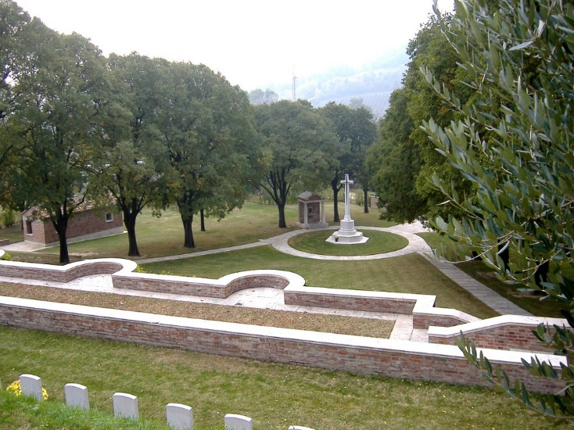  Regiment & Unit/Ship  Black Watch (Royal Highlanders) 6th Bn.  Date of Death  Died 14 September 1944 Age 31 years old  Buried or commemorated at  GRADARA WAR CEMETERY I, B, 59. Italy  Country of Service United Kingdom  Additional Info  Son of James and Margaret Gray; husband of Mary Gray, of Addiewell, Midlothian.  Personal Inscription  "SHELTERED IN THE ROCK OF AGES" HIS WIFE AND SON FATHER AND MOTHER  West Lothian Courier 21st September 1945  Gray – In loving memory of my dear husband John Gray, killed in Italy 14th September, 1944  Though I smile and seem carefree  There’s no one misses you more than me  Inserted by his wife and son Jim, 3 Cuthill Crescent, Stoneyburn
James Halbert  RAF | JAMES HALBERT  West Lothian Courier 14th September 1945  Stoneyburn Social and Dance – A social and dance as held in the Welfare Hall in honour of James Halbert, late of the RAF. Mrs Richard Moore presided over a company of 300. After tea Mrs Moore paid a tribute to Mr Halberts, and asked him on behalf of the people of Stoneyburn and Bents, to accept a gift from them. She had the great pleasure in presenting the sum of £30 to Mr Halberts. Miss Lumsden with two of her pupils, Miss Sadie Moore and Miss Daisy Gilchrist, entertained the company to some fine dancing. Songs were rendered by Mrs W Wynne, and Mr Robert Kerr, an accordion solo by Mr J Russell, and a piano solo by Mrs H Haggarty. When the social drew to a close, Mrs Moore thanks the committee for their splendind work, and Mr Maxwell Dougan moved a vote of thanks to Mrs Moore. A few hours dancing followed to the music of Findlay’s Band. Mr J Irvine was MC.  Can’t trace this chap
Signaller George Halliday  Royal Corps of Signals | GEORGE HALLIDAY  West Lothian Courier 12th January 1945  Stoneyburn – Home on Leave – Signaller George Halliday, son of Mr and Mrs H Halliday, Cannop Crescent arrived home on Saturday from the Western Front. He landed in France on D-Day and has been attached to an infantry brigade all through the campaigns in France, Belgium, and Holland. He also took part in the attack on Le Harve. He is very fit and is expecting to enjoy his leave.  Midlothian Advertiser 19th January 1945  Home on leave – Signaller George Halliday, son of Mr and Mrs Halliday, Cannop Crescent, Bents, has arrived home on leave from Europe. He landed in France on D-Day and has been attached to an Infantry Brigade. He feels fit and hopes to enjoy his leave.
Bernard Hampson  Home Guard | BERNARD HAMPSON  West Lothian Courier 20th August 1943  Home Guardsman Fined A penalty of £2 with the alternative of twenty days imprisonment was imposed on Bernard Hampson, miner, 79 Cuthill Crescent, Stoneyburn who pleaded guilty by letter to having failed to do Home Guard duty on two occasions.
Thomas Hampson  Home Guard | THOMAS HAMPSON  West Lothian Courier 20th August 1943  Home Guardsman Fined – Thomas Hampson, miner, 72 Cuthill Crescent, Stoneyburn, pleaded guilty by letter to having on three occasions failed to do home Guard duty.  A penalty to £3 was imposed with the alternative of 20 days imprisonment.
Andrew Harkness  Home Guard | ANDREW HARKNESS  West Lothian Courier 20th August 1943  Home Guardsman Fined A similar penalty was imposed on Andrew Harkness, miner, 109 Old Rows, Stoneyburn and Samuel Redmond, miner 119 Cuthill Crescent, Stoneyburn for having failed to do Home Guard duty on two occasions
Gunner William Irving  40th Bty, 14th LAA Rgt, Royal Artillery | WILLIAM IRVING  Midlothian Advertiser 4th May 1945  Stoneyburn – returned Territorials – Pte W Irving son of Mr and Mrs Irving, 87 Cuthill Crescent and Sgt James Lawson, son of Mr and Mrs R Lawson, Johnston Terrace, arrived home on Friday night after a period of service in Italy.  West Lothian Courier 18th May 1945  Mr and Mrs William Irving, 87 Cuthill Crescent, Stoneyburn desires to thank all friends and neighbours for their cordial welcome extended to their son Pte Irving on his return home from service in Italy.  West Lothian Courier 18th May 1945  Stoneyburn Territorials Home – Pte William Irving, 87 Cuthill Crescent, son of Mr and Mrs Irving, and LB J Lawson, Johnstone Terrace, son of Mr and Mrs Robert Lawson, both members of Bathgate Terriers arrive home on Friday night after 4 years fighting in North Africa and Italy. All are looking well and are looking forward to enjoying their well-earned rest.
Sgt David Smith Lawson  RAF  LACW Lilias MacNab | DAVID SMITH LAWSON  West Lothian Courier 26th January 1945  Marriage Lawson – MacNab – At Dundee on the 17th January, 1945, David Smith Lawson (Sgt RAF) third son of Mr and Mrs Lawson, 19 Stoneyburn, West Lothian, to Lilias Balmer (LACW) eldest daughter of Mr and Mrs MacNab, The Garage, Culdees Castle, Muthill, Perthshire.
L/Bombardier  J Lawson  40th Bty, 14 LAA Royal Artillery | J LAWSON  JAMES MORRISON LAWSON  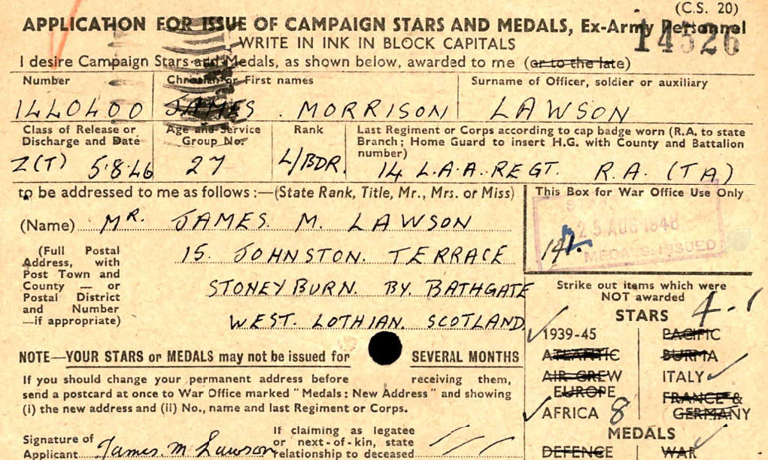  Name James Morrison Lawson  Rank Lance Bombardier  Award Date 25 Aug 1948  Discharge Date 5 Aug 1946  Applicant's Delivery Address 15 Johnston Terrace Stoneyburn By Bathgate West Lothian Scotland  Service Group Number 27  Class of Release Z (T)  Service Number 1440400  Regiment 14 L. A. A Regt. R. A (Ta)  Stars/Medals Issued 1939-45; Africa; Italy  Midlothian Advertiser 4th May 1945  Stoneyburn – returned Territorials – Pte W Irving son of Mr and Mrs Irving, 87 Cuthill Crescent and Sgt James Lawson, son of Mr and Mrs R Lawson, Johnston Terrace, arrived home on Friday night after a period of service in Italy.  West Lothian Courier 18th May 1945  Stoneyburn Territorials Home – Pte William Irving, 87 Cuthill Crescent, son of Mr and Mrs Irving, and LB J Lawson, Johnstone Terrace, son of Mr and Mrs Robert Lawson, both members of Bathgate Terriers arrive home on Friday night after 4 years fighting in North Africa and Italy. All are looking well and are looking forward to enjoying their well-earned rest.
Trooper D McCall  Scottish Horse | D MCCALL  West Lothian Courier 16th June 1944  McColl – At RSMMP, Edinburgh, on 8th June, to Jean (nee Tweedie), wife of D McColl (Stoneyburn) Scottish Horse, a daughter. Both Well.
John McKinney | JOHN MCKINNEY  West Lothian Courier 17th March 1944  Pretty Wedding – On Thursday the wedding took place in the Welfare Hall, Stoneyburn of John McKinney, elder son of Mr and Mrs James McKinney, Cuthill Crescent, Stoneyburn, and Elizabeth Donachie, elder daughter of Mr Peter and the late Mrs Donachie, Auchenhard Terrace, Stoneyburn. The bride who wore a dress of white figured taffeta and a long white tulle veil, was given away by her grandfather, Mr John Irvine. Her bouquet was of arum lilies. There were three bridesmaids in attendance. Mrs Mary MacLean, cousin of the bride, who wore a dress of blue taffeta with headdress of blue lace; Miss Lena Donachie, the bride’s sister, and Miss Betty Miller, the bride’s cousin, whose dresses were of pink silk ornamented with blue. Their bouquets were of red roses. The two trainbearers, Miss Betty McKinney, sister of the bridegroom and Miss Sadie Irvine, cousin of the bride, were attired in blue taffeta ornamented with pink. Mr Flynn, cousin of the bridegroom was groomsman. The Reg George Fraser, MA officiated. The reception was held in the Welfare hall about 300 guests being present.
Pte David McMillan  Black Watch | DAVID MCMILLAN  (can’t find him in the Black Watch)  West Lothian Courier 26th December 1941  Soldier Wounded – Mr and Mrs McMillan, 31 Garden City, Bents, have received intimation that their son David has been wounded in action in Libya. He has been in the Middle East for over a year and took part in the evacuation of Crete.  West Lothian Courier 12th January 1945  Stoneyburn - Home on leave - Pte David McMillan, Black Watch, son of Mr and Mrs Robert McMillan, 31 Garden City, arrived home on Tuesday after being away for over four years. He has served in North Africa, Crete, Tobruk, India and Burma. He is in good health.  Midlothian Advertiser 19th January 1945  Home on Leave – Pre David McMillan, Black Watch, son of Mr and Mrs McMillan, 31 Garden City, Bents is home on leave. He has been abroad in North Africa, Crete, India, and Burma for 4.5 years. He feels fit and well and hopes to enjoy his leave.
Alison Hardie MacMillan  LCpl Frederick Charles Sharpe | ALISON HARDIE MACMILLAN – FREDERICK CHARLES SHARPE  West Lothian Courier 12th December 1941  Sharpe – MacMillan – At Stoneyburn Church on December 6th 1941, by the Rev G Fraser, L/Cpl Frederick Charles Sharpe, youngest son of Mr and Mrs E J Sharpe, Newcastle on Tyne, to Alison Hardie, eldest daughter of Mr and Mrs B G MacMillan, Bents.
Miss Betty McWhinnie  HM Forces | BETTY MCWHINNIE  Midlothian Advertiser 8th May 1942  Stoneyburn – Presentations – On the occasion of her recent marriage Miss Molly Barr, was presented by the staff of Stoneyburn Church Sunday School with a beautiful crystal cake stand. Rev G Fraser, MA who made the presentation, made reference to the local service Miss Barr had given to the School and also to many other church organisations. Miss Barr replied with a few suitable words. The staff also sent to Miss Betty McWhinnie a book gift in recognition of the fact that she is the first local lady member of the Sunday School teachers to join his Majesty’s forces
1493873 Sgt Samuel V Menzies  Royal Artillery  61 Anti-Tank Rgt | SAMUEL V MENZIES  First Name: S V Surname: Menzies  Date of Action: 20/07/1943  Fate: Wounded  Incident Details: Reported to War Office Casualty Branch for the 24 hours ending at 09:00.  Incident Date: 31/08/1943  Information: Casualty List No. 1226.  Rank: Acting Serjeant  Service Number: 1493873  Duty Location: Sicily  Service: British Army  Regiment: Royal Artillery Secondary Unit: 61 Anti Tank Regiment  Midlothian Advertiser 26th February 1943  Stoneyburn – Brothers Meet – Mrs Mary Menzies of 3 Main Street, has received letters from both of her sons, Wallace and Sammy who are serving with the RA in the Middle East. In their letters they tell of how they met in the main Street of Tripoli for the first time in three years.  West Lothian Courier 2nd April 1943  Stoneyburn Brothers meet in Tripoli – Mrs M Menzies, 3 Main Street, Stoneyburn, has received airgraph letters from her two sons, Sgt Samuel V Menzies, RA and Bombardier Wallace Menzies, RA stating that they met each other in Tripoli. The brother had not seen each other for three years.  In his letter, Bombardier W Menzies states – “I met Sammy yesterday and he looks find and is in good health – I spent a few hours with him, He got a bigger surprise than I did, for I found out where he was, so I was looking out for him and we met on the street. I saw him first and walked up to within a couple of feet from him before he knew me. It’s the first we saw of each other for three years. Although Sam has changed a bit, I knew him right away. We have arranged to meet again on Saturday if it is possible, I also met Alex Thomson, tell his mother he looks fine.”  Sgt Menzies writes – “You will be glad to hear that I have met Wallace, I was walking down the main street of Tripoli when he came across to me. You can imagine my surprise when I saw who it was, as I never even though I would be lucky enough to see him out here. He is looking fine – the three years out here haven’t altered him much….. I hadn’t much time with him as he was only in Tripoli for a day, but I hope to see him again soon. I was also talking to the fellow Thomson.”  West Lothian Courier 6th August 1943  Stoneyburn Soldier Wounded – Mrs J Menzies, 3 Main Street, Stoneyburn, has received a letter from her son Sgt S V Menzies, who is in hospital in Sicily stating he has been wounded in the left hip. He has been four years in the army.
1440402 LCpl Wallace Menzies  Royal Artillery   | WALLACE MENZIES  First Name: W Surname: Menzies  Rank: Bombardier  Service Number: 1440402  Authority: A.O. 119/46  Authority Date: 1946  Service: British Army  Primary Unit: Royal Artillery  Secondary Unit: Light Anti-Aircraft  Long Service Good Conduct Medal  Midlothian Advertiser 26th February 1943  Stoneyburn – Brothers Meet – Mrs Mary Menzies of 3 Main Street, has received letters from both of her sons, Wallace and Sammy who are serving with the RA in the Middle East. In their letters they tell of how they met in the Main Street of Tripoli for the first time in three years.  West Lothian Courier 2nd April 1943  Stoneyburn Brothers meet in Tripoli – Mrs M Menzies, 3 Main Street, Stoneyburn, has received airgraph letters from her two sons, Sgt Samuel V Menzies, RA and Bombardier Wallace Menzies, RA stating that they met each other in Tripoli. The brother had not seen each other for three years.  In his letter, Bombardier W Menzies states – “I met Sammy yesterday and he looks find and is in good health – I spent a few hours with him, He got a bigger surprise than I did, for I found out where he was, so I was looking out for him and we met on the street. I saw him first and walked up to within a couple of feet from him before he knew me. It’s the first we saw of each other for three years. Although Sam has changed a bit, I knew him right away. We have arranged to meet again on Saturday if it is possible, I also met Alex Thomson, tell his mother he looks fine.”  Sgt Menzies writes – “You will be glad to hear that I have met Wallace, I was walking down the main street of Tripoli when he came across to me. You can imagine my surprise when I saw who it was, as I never even though I would be lucky enough to see him out here. He is looking fine – the three years out here haven’t altered him much….. I hadn’t much time with him as he was only in Tripoli for a day, but I hope to see him again soon. I was also talking to the fellow Thomson.”  West Lothian Courier 15th December 1944  Home on Leave – LCpl Wallace Menzies, whose mother resides at 2 Main Street Stoneyburn arrived home on leave over a week ago. His leave lasts until New Year festivities are over. He has been in the Middle East for 4 years.
Pte Thomas Morris  Home Guard | THOMAS MORRIS  Midlothian Advertiser 9th July 1943  Whitburn – Home Guard Fined – For failing to do Home Guard duty a fine of £5 or 30 days imprisonment was imposed at Linlithgow Sheriff Court on Tuesday on Andrew Hannah, miner, 47 West Main Street, Whitburn and Thomas Morris, miner, 22 Strathie Terrace Stoneyburn. For a similar offence, Hugh Beattie, miner, 4 Bank Street, Whitburn was fined £3 or ten days imprisonment, and William Gavin Miner, 45 Empire Street, Whitburn, was fined £2 or ten days.
1537249 Gunner  Thomas Murray  4th Ulster Regt  LAA  Royal Artillery | THOMAS MURRAY  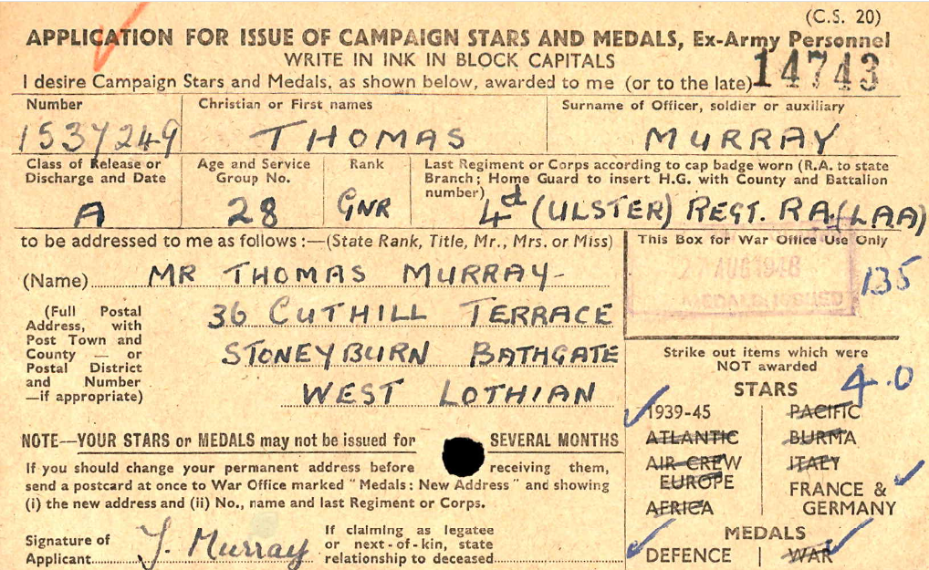  Name Thomas Murray  Rank Gunner  Award Date 27 Aug 1948  Applicant's Delivery Address  36 Cuthill Terrace Stoneyburn Bathgate West Lothian  Service Group Number 28  Class of Release A  Service Number 1537249  Regiment 4th (Ulster) Regt. R. (Laa)  Stars/Medals Issued 1939-45; France & Germany; Defence
Christina Reid Orr  William Bell | CHRISTINA REID ORR – WILLIAM BELL  West Lothian Courier 6th March 1942  Hope – Orr – At Lesser Hall, Stoneyburn on the 28th February, by the Rev George Fraser, MA, William Bell, son the late Mr R B Hope and Mrs Hope, 33 Restalrig (?) Drive, Hillington, Glasgow to Christina Reid, eldest daughter of Mr and Mrs James Orr, 3 Muir Terrace, Stoneyburn, Bride and Bridegroom serving in HM Forces.
7360335 Pte William Paton  RAMC  POW Germany | WILLIAM PATON  Fate: Prisoner of War  Incident Details: Reported to War Office Casualty Section for the 48 hours ending at 09:00. Incident Date: 22/09/1941  Information:  Casualty List No.623. Previously shown on Casualty List No.562 as Missing.  Resided Town: Stalag 7a, Moosburg (Isar)  Nationality: British  Fate: Prisoner of War  Information: POW No.17075  West Lothian Courier 23rd January 1942  Stoneyburn Prisoner of War – Mr and Mrs David Paton, 12 Cuthill Terrace, Stoneyburn has been notified that their son William, RAMC, is a prisoner of war in Germany. Before joining up he was a miner in Loganlea Colliery.  West Lothian Courier 24th March 1944  Stoneyburn man a Prisoner – Miss Paton, St Quentin’s, has received a postcard from her brother William who is a prisoner in Japanese hands in Thailand. He was employed in Jamaica when he joined up and was taken prisoner when Singapore fell. He writes saying he is well.  Midlothian Advertiser 4th May 1945  Stoneyburn – Prisoners of War Home – Pte Alex Thomson, son of Mr and Mrs Thomson, Old Rows, Stoneyburn, returned home on Saturday from a German prison camp. He was serving with the 51st Highland Division when taken prisoner and was in prison for 12 weeks. Pte William Paton, RAMC son of Mr and Mrs D Paton, 6 Cuthill Crescent, arrived home on Sunday night after being a prisoner for four years in Crete.  Midlothian Advertiser 18th May 1945  Prisoner of War Home - Pte William Paton, RAMC son of Mr and Mrs D Paton, 6 Cuthill Crescent, arrived home on Sunday night after being a prisoner for four years in Crete.  West Lothian Courier 18th May 1945  Repatriated prisoners of War – So far six prisoners of war have arrived home from prison camps. We have already mentioned two already and the other four are Pte Alex Thomson, Gordon Highlanders, 76 Old Rows, Stoneyburn who arrived home on Saturday night, A member of the famous 51st Division, Pte William Paton, RAMC, Cuthill Crescent, Stoneyburn who arrived home on Sunday night was captured in Crete and transferred to Germany, Archie Cowan, Cuthill Crescent, Stoneyburn who arrive home on Tuesday morning was captured by Italians, Cpl D Cummings, Queens Own Cameron Highlanders son in law of Mr and Mrs C Wilson, 57 Garden City, Bents, captured at Tobruk when it fell the first time to the Italians, he arrived on Saturday. All are home for the usual 42 days.  Midlothian Advertiser 15th June 1945  Stoneyburn – Welcome Home Social – A social and dance was held in the Welfare Hall on Thursday evening to welcome home Cpl Thomson. After an excellent tea a musical programme was carried out. Messrs Thomson, Fairley, Cowan and Paton, four returned prisoners of war were each presented with £10 and members of the Forces received 5/- each. A very happy evening was rounded off with dancing at which the Lothian Quintette provided the music and James Irving was MC  West Lothian Courier 15th June 1945  Stoneyburn Ex-Prisoners of War Entertained – A very happy time was spent in the Welfare hall on Thursday evening at a function organised to entertain other four ex-prisoners of war. Cpl Alex Thomson, Pte Bruce Fairley, Pte Archie Cowan, and Pte William Paton, who had returned home from Germany. Mr Weir presided over a company of over 300. After a knife and fork tea had been partaken of a musical programme was sustained and included songs by Mr McPake, Mrs Owens, Mrs Brown and duets by Mrs Young and Mr Richard Black, musical selections by Messrs William Black and Richard Black and songs by Cpl Thomson. Miss Henderson accompanied the artistes at the piano. Each of the artistes had a great reception had to respond to encores. Mr Weir presented to each ex POW the sum of £10 and each of the men made a suitable reply. Every one of HM Forces home on leave received 5s. A dance followed to music supplied by the Lothian Quartette and the duties of MC were carried through by Mr James Irving.  Midlothian Advertiser 5th October 1945  Prisoner of War Safe – Stoneyburn - Miss Lily Paton, St Quentin’s Place has received information that her brother William Paton is safe and well and hopes to be home soon. He is in Australia. He was captured at Singapore.
Christina Younger Kerr Raeburn  Ernest William Boyd Hart  Royal Canadians | CHRISTINA YOUNGER KERR RAEBURN – ERNEST WILLIAM B HART  West Lothian Courier 19th June 1942  Hart – Raeburn – At Stoneyburn Church on 12th June 1942, by the Rev George Fraser MA, Ernest William Boyd, AB , RCV, elder son of Mr and Mrs Sidney Hart, Niagara Falls, Ontario, to Christina younger Kerr, younger daughter of Mr and Mrs Robert Raeburn, 24 Johnston Terrace, Stoneyburn.
1562213 LAC William Redpath  RAF | WILLIAM REDPATH  First Name: William Surname: Redpath  Information: They enlisted in Edinburgh. They joined after May 1941.  More Information: Militia  Service Number: 1562213  Service: Royal Air Force  Primary Unit: Royal Air Force  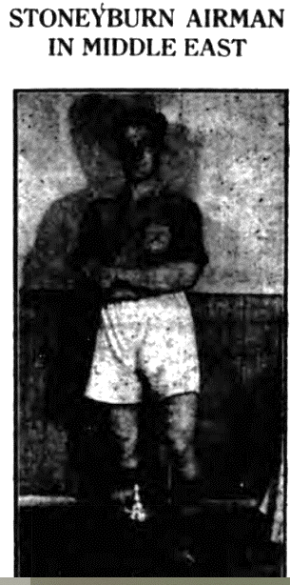  West Lothian Courier 28th January 1944  The above is a photograph of LAC William Redpath (22 (RAF), son of Mr and Mrs Robert Redpath, Bain’s Buildings, Stoneyburn. He volunteered for the RAF in April 1941 and has been in the Middle East for two years. A well-known footballer, he played at right half back for the Polkemmet Juniors before joining the RAF. His football talents gained him place in the famous Wanderers team – pick of the Service players in the Middle East – for whom he has played for two seasons. The Wanderers have successfully toured Palestine and Syria, playing the best teams and “Bill” along with other well-known players had nobly upheld the tradition of Scottish football. He has been selected to play for the Wanderers again an Egyptian football Association representative X1. The game will be played at Cairo’s Alamein Club a well laid out ground presented to the Forces of the United Nations and the people of Egypt in commemoration of the Alamein victory.  Midlothian Advertiser 4th February 1944  Stoneyburn ME Footballer – Mr and Mrs Redpath of Blair’s Buildings, have received a letter from their son LAC Redpath (22) of the RAF in which he says that he is playing football regularly in the Middle East. He played right half back for Polkemmet Juniors before joining the RAF in April 1941. He is to play against the Egyptian FA at Alamein Club, which is a modern enclosure presented by the people of Egypt to the United Nations in honour of the Alamein Victory
774859 Trooper Robert Scotland  4th/7th Royal Dragoon Guards  Royal Armoured Corps | 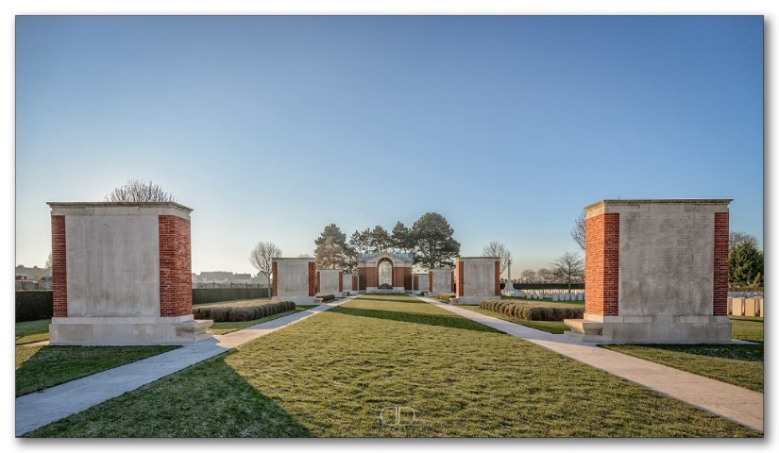  TROOPER ROBERT SCOTLAND  Service Number: 774859  Regiment & Unit/Ship  Royal Armoured Corps  4th/7th Royal Dragoon Guards  Date of Death Died 19 May 1940 Age 30 years old  Buried or commemorated at  DUNKIRK MEMORIAL Column 2. France  Country of Service United Kingdom  Additional Info  Son of Benjaman and Mary Ellen Winifred Scotland; husband of Catherine Scotland, of Stoneyburn, West Lothian.
824892 Sgt William Sargent  Royal Artillery  5 HAA Rgt  POW Japan | SERJEANT WILLIAM HORACE GEORGE SARGENT  Service Number: 824892  Regiment & Unit/Ship Royal Artillery 5 H.A.A. Regt.  Date of Death  Died 04 March 1944 Age 34 years old  Buried or commemorated at  YOKOHAMA WAR CEMETERY Brit. Sec. F. C. 2. Japan  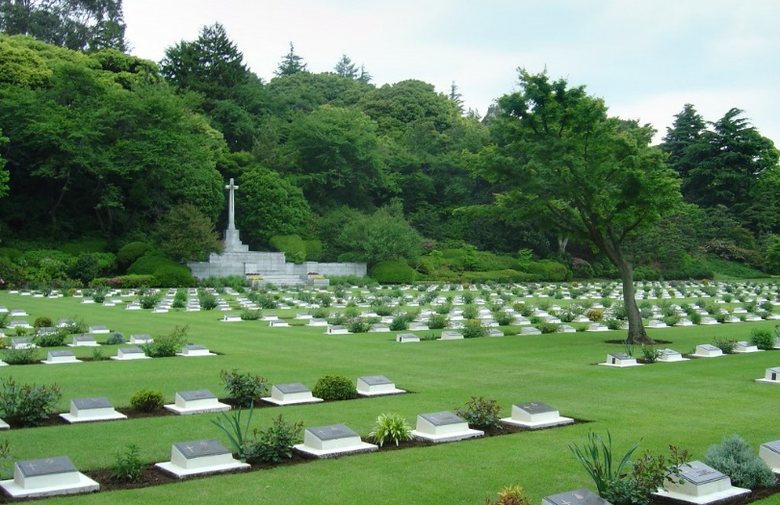  Country of Service United Kingdom  First Name: William Horace George Surname: Sargent  DOB: 23/05/1910 Birth Town: Borough Green  Nationality: British  Date of Death: 04/03/1944  Fate: Died from beriberi and colitis  Date of Capture: 25/12/1941  Information: 4th draft to Tokyo and Ito  Rank: Sergeant  POW Camp: Shamshuipo Other POW Camps: Osaka 12  Service Number: 824892  Duty Location: Hong Kong  Next Of Kin: Wife: Mrs Sargent, 76 Cuthill Crescent, Stoneyburn  Service: British Army  Primary Unit: Royal Artillery Secondary Unit: 5 Anti-Aircraft Regiment  West Lothian Courier 11th June 1943  Stoneyburn Soldier a Prisoner – Mrs Sargent has received word that her husband Sgt William Sargent, RA, is a prisoner of war in Hong King. He is in good health. Mrs Sargent is a daughter of Mr and Mrs James Morris, Cuthill Crescent, Stoneyburn.
A/105855  Francis Steele  Algonquin Rgt  RCIC | LANCE SERGEANT CLIFFORD FRANCIS STEELE  Service Number: A/105855  Regiment & Unit/Ship Algonquin Regiment, R.C.I.C.  Date of Death Died 21 October 1944 Age 21 years old  Buried or commemorated at  SCHOONSELHOF CEMETERY III. J. 8. Belgium  Country of Service Canadian  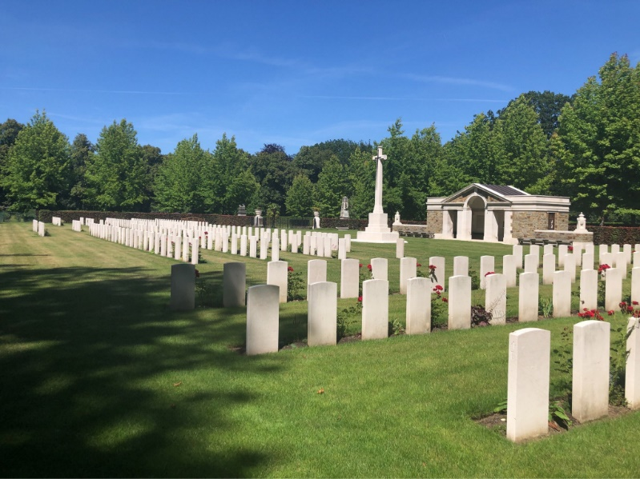  Additional Info Son of Alfred Henry Steele, and of Harriet Ann Steele, of Campbellville, Ontario, Canada.  Personal Inscription  WHILE YOU LIE IN PEACE, DEAR CLIFFORD, YOUR MEMORY WE SHALL ALWAYS KEEP  Midlothian Advertiser 26th October 1945  In proud and loving memory of Francis Steele (Franky), who made the supreme sacrifice in Holland October, 1944.  Greater love hath no man than this,  That he lay down his life for his friends  Inserted by Mrs Duncan and family, Bents, West Calder.  This is the only Francis Steele who died in Oct 1944
3058433 Pte James McM Strickland  4th Btn Seaforth Highlanders POW Germany | JAMES MCM STRICKLAND  Camp No. 9C  POW No. 725  Surname Strickland  Forename/Initials J. McM.  Rank Pte.  Army No 3058433  Record Office No 16  Record office Name Infantry Record Office, Perth.  Camp Type STALAG  Camp Location Muhlhausen.  Regiment The Seaforth Highlanders.  Reported missing on the 5th Sept 1940, reported as POW 5th Sept 1940  1945 Release POW No 725 Stalag 9C Malhausen  4th Battalion:  1940: The Battalion was part of the BEF and of the 152 Brigade, 51st (Highland) Division.  Midlothian Advertiser 20th April 1945  Stoneyburn – Home from Germany – Pte J Strickland, Seaforth Highlanders, son of Mr David Strickland, 64 Cuthill Crescent who has been a prisoner of War in Germany for four years came home on Saturday  West Lothian Courier 20th April 1945  Stoneyburn POW Home - Pte James Strickland, Seaforth Highlanders son of Mr David Strickland, 64 Cuthill Crescent, arrived home on Saturday night. The first telegram received on Wednesday stated,- “ arrived Wales, home soon.” He was a prisoner of war for 4 years 10 months. Preparations were made in his home neighbourhood to give him a welcome as he was expected to arrive on Friday and flags and bunting were hung out, but he sent a wire from Edinburgh on Saturday morning stating that he had arrived there. He had travelled from Cardiff on Friday and had sent the day resting in Edinburgh. His welcome home on Saturday evening lost nothing by his late arrival. During the time he was a prisoner he worked in sugar factories and a salt mine and later as an orderly in a British and American officers’ hospital. He was called up on 15th July 1939 and went to France on 28th February 1940 and was taken a prisoner on 4th June. He was liberated by the American 3rd Army on 2nd April 1945 and was flown in an America Liberator to South Wales. Before joining up he worked in Foulshiels Colliery. He has two brothers who are serving in Italy. Arrangements are well in hand to have a welcome home dance etc for him. He is on 42 days leave and looks fit and well  Midlothian Advertiser 11th May 1945  Prisoners of War entertained – About 300 persons sat down to a knife and fork tea in the Welfare Hall when Pte James Strickland and Flight Lieut D Allan were entertained. The platform friends were introduced by Mrs R Walker and included Mr and Mrs Hatley. Dr and Mrs Sherry and Mr Weir a former headmaster of Stoneyburn School who had a hearty reception. After tea, there was an enjoyable musical programmed followed by dancing to ,music by the Lothian Quartette.
2880101 Pte Alex Thomson  Gordon Highlanders  POW Germany | ALEX THOMSON GORDON  Camp No. 344 POW No. 16790  Surname Thomson Forename/Initials A. W.  Rank Pte. Army No 2880101  Record Office No 16  Record office Name Infantry Record Office, Perth.  Camp Type STALAG  Camp Location Lamsdorf.  Regiment The Gordon Highlanders.  West Lothian Courier 2nd April 1943  Stoneyburn Brothers meet in Tripoli – Mrs M Menzies, 3 Main Street, Stoneyburn, has received airgraph letters from her two sons, Sgt Samuel V Menzies, RA and Bombardier Wallace Menzies, RA stating that they met each other in Tripoli. The brother had not seen each other for three years.  In his letter, Bombardier W Menzies states – “I met Sammy yesterday and he looks find and is in good health – I spent a few hours with him, He got a bigger surprise than I did, for I found out where he was, so I was looking out for him and we met on the street. I saw him first and walked up to within a couple of feet from him before he knew me. It’s the first we saw of each other for three years. Although Sam has changed a bit, I knew him right away. We have arranged to meet again on Saturday if it is possible, I also met Alex Thomson, tell his mother he looks fine.”  Sgt Menzies writes – “You will be glad to hear that I have met Wallace, I was walking down the main street of Tripoli when he came across to me. You can imagine my surprise when I saw who it was, as I never even though I would be lucky enough to see him out here. He is looking fine – the three years out here haven’t altered him much….. I hadn’t much time with him as he was only in Tripoli for a day, but I hope to see him again soon. I was also talking to the fellow Thomson.”  Midlothian Advertiser 24th March 1944  Stoneyburn - POW Miss Paton has received a post card from her brother who has been a POW in Japanese hands in Thailand for 2.5 years. He joined up in Jamaica and was taken prisoner in Singapore.  West Lothian Courier 30th June 1944  Stoneyburn Soldier Wounded – Mr and Mrs Thomson, 16 Stoneyburn, have received official notification that their son LCpl Alex Thomson, Gordon Highlanders has arrived in an hospital in England. He was wounded in NE Europe. Before joining up, over four years ago, he was empoyed at Foulshiels Colliery.  Midlothian Advertiser 14th July 1944  Stoneyburn Soldier wounded – Mr and Mrs Thomson, 16 Stoneyburn, have received official notification that their son, LCpl Alex Thomson, Gordon Highlanders has arrived in a hospital in England. He was wounded in N E Europe. Before joining the Army over four years ago, he was employed at Foulshiels Colliery.  Midlothian Advertiser 20th April 1945  Stoneyburn – A Prisoner – Mr and Mrs Thompson 76 Stoneyburn, received official information that their son Alex was a prisoner of war. He was missing eight months ago.  West Lothian Courier 27th April 1945  Stoneyburn Soldier a Prisoner – Mr and Mrs Thomson 76 Stoneyburn, have received intimation that their son Alex, is now definitely a prisoner of war. He was the 51st Division and was reported missing eight weeks ago.  Midlothian Advertiser 4th May 1945  Stoneyburn – Prisoners of War Home – Pte Alex Thomson, son of Mr and Mrs Thomson, Old Rows, Stoneyburn, returned home on Saturday from a German prison camp. He was serving with the 51st Highland Division when taken prisoner and was in prison for 12 weeks. Pte William Paton, RAMC son of Mr and Mrs D Paton, 6 Cuthill Crescent, arrived home on Sunday night after being a prisoner for four years in Crete.  Midlothian Advertiser 18th May 1945  Prisoner of War Home – Pte Alex Thomson, son of Mr and Mrs Thomson, Old Rows, Stoneyburn returned home on Saturday from a German prison camp. He was serving with the 51st Highland Division when taken prisoner and was in prison for 12 weeks.  West Lothian Courier 18th May 1945  Repatriated prisoners of War – So far six prisoners of war have arrived home from prison camps. We have already mentioned two already and the other four are Pte Alex Thomson, Gordon Highlanders, 76 Old Rows, Stoneyburn who arrived home on Saturday night, A member of the famous 51st Division, Pte William Paton, RAMC, Cuthill Crescent, Stoneyburn who arrived home on Sunday night was captured in Crete and transferred to Germany, Archie Cowan, Cuthill Crescent, Stoneyburn who arrive home on Tuesday morning was captured by Italians, Cpl D Cummings, Queens Own Cameron Highlanders son in law of Mr and Mrs C Wilson, 57 Garden City, Bents, captured at Tobruk when it fell the first time to the Italians, he arrived on Saturday. All are home for the usual 42 days.  Midlothian Advertiser 15th June 1945  Stoneyburn – Welcome Home Social – A social and dance was held in the Welfare Hall on Thursday evening to welcome home Cpl Thomson. After an excellent tea a musical programme was carried out. Messrs Thomson, Fairley, Cowan and Paton, four returned prisoners of war were each presented with £10 and members of the Forces received 5/- each. A very happy evening was rounded off with dancing at which the Lothian Quintette provided the music and James Irving was MC  West Lothian Courier 15th June 1945  Corporal Alex Thomson, Gordon Highlanders and Mr and Mrs Thomson 76 Old Rows Stoneyburn, desire to thank Mrs Walker and her committee and all friends and neighbours for the wonderful welcome and kindness shown to him Cpl Alex Thomson on his return home from Germany.  West Lothian Courier 15th June 1945  Stoneyburn Ex-Prisoners of War Entertained – A very happy time was spent in the Welfare hall on Thursday evening at a function organised to entertain other four ex-prisoners of war. Cpl Alex Thomson, Pte Bruce Fairley, Pte Archie Cowan, and Pte William Paton, who had returned home from Germany. Mr Weir presided over a company of over 300. After a knife and fork tea had been partaken of a musical programme was sustained and included songs by Mr McPake, Mrs Owens, Mrs Brown and duets by Mrs Young and Mr Richard Black, musical selections by Messrs William Black and Richard Black and songs by Cpl Thomson. Miss Henderson accompanied the artistes at the piano. Each of the artistes had a great reception had to respond to encores. Mr Weir presented to each ex POW the sum of £10 and each of the men made a suitable reply. Every one of HM Forces home on leave received 5s. A dance followed to music supplied by the Lothian Quartette and the duties of MC were carried through by Mr James Irving.
SRN Peterina S Thomson | PETERINA S THOMSON  West Lothian Courier 27th July 1945  Thomson – In loving memory of our dear daughter and dear sister Petrina S Thomson SRN who died 31st July 1944  We have lost, but Heaven has gained  One of the best the earth contained  Peacefully sleeping, free from pain  We would not wake her to suffer again  Our thoughts go back to days gone past  Life moves on, but memories last.  Inserted by her father, mother, sister, and brother, 23 Cuthill Crescent, Stoneyburn  (haven’t located her as yet in Nursing Records)
Pte Timmins | TIMMINS  West Lothian Courier 31st December 1943  Stoneyburn WVS Social – The member of the WVS and friends met in a social capacity in the ARP Hall on Thursday night, when approximately 100 sat down to a knife and fork tea, presided over by Mrs Haggerty. Mrs Haggerty extended a welcome to all present and said they had as an honoured guest Sgt Samuel Menzies, accompanied by his wife, who was home on leave from the Middle East. A choir of WVS members sang several Christmas numbers and songs were rendered by Miss Dodson, Sgt Menzies and Mr Haggerty while Mr and Mrs Haggerty sang a duet. Miss Yeardley gave several readings. An address on the work of the WVS was given by Dr Sherry. A dance followed to music supplied by the Locarno Band, when the duties of MC were capably carried out by Dr Sherry. Pte Timmons, another Middle East soldier home on leave with his wife came in during the evening. The singing of the National Anthem brought a pleasant evening to a close.
Agnes (Nancy) Walker  WRNS  LAC Maurice R Hutchison RAF | AGNES WALKER – MAURINCE R HUTCHISON  West Lothian Courier 15th June 1945  Hutchison – Walker – At Stoneyburn on 5th June 1945 by the Rev George Fraser, LAC Maurice Robert Hutchison, RAF only son of Mr and Mrs Peter Hutchison, Dumfries to Agnes (Nancy) Walker, WRNS, only daughter of Mr and Mrs John Walker, Stoneyburn
Flight Sgt Robert Walker, RAF  AC J Anderson RAF  Cpl Peter Turnbull  RAF | ROBERT WALKER – J ANDERSON – PETER TURNSBULL  West Lothian Courier 12th January 1945  Stoneyburn Golden Wedding – Mr and Mrs Robert Walker, 19 Muir Terrace, Stoneyburn, celebrated their golden wedding in the Church Hall on Monday, when members of their family and friends were present. Mr Walker was born in Majoribanks Street, Bathgate in 1871, and attended Bathgate Academy and later Addiewell Public School he started work in Addiewell Works and later went to Peebles as apprentice blacksmith and then to Haywood Gas Company. During his stay in Haywood he was secretary of Haywood Wanderers Football Club. When Haywood works closed down he went to Foulshiels Colliery Stoneburn where he worked until he retired three years ago. He is a Past Master of Lodge St John 1186. Mrs Walker was born at 61 Front Street, Mossend, in 1871, she is the last surviving member of the Ellis family who were prominently connected with Mossend Swifts FC. The couple were marrid at 22 Front Street on January 1st 1895 and took up house in Haywood and since then have resided within a few miles of their first home. Of a family of 3 sons and 3 daughters, two daughters and one son survive. There are three grandchildren. At the celebrations Mr John Barr, JP presided. The toast to Mr and Mrs Walker was given by the Rev George Fraser, MA and replied to by their son Flight Sgt Robert Walker, RAF. The toast to the Forces was given by Mr Barr and replied to by Aircraftsman J Anderson RAF, nephew and Cpl Peter Turnbull RAF son in law. They received many telegrams and letter of conratulations. A very happy time was spent.
3059360 LCpl James Wilson, 2nd Btn Royal Scots  POW Japan | JAMES WILSON – Royal Scots  First Name: J Surname: Wilson  Date of Action: 25/12/1941 Fate: Missing  Incident Details: Reported to War Office Casualty Section for the 48 hours ending at 09.00. Incident Date: 19/01/1942  Information: Casualty List No. 724.  Rank: Private Service Number: 3059360  Duty Location: Hong Kong  Service: British Army Regiment: Royal Scots Battalion: 2nd Battalion  First Name: J Surname: Wilson  Fate: Prisoner of War (Previously reported as Missing)  Incident Details: Reported to War Office Casualty Section for the 24 hours ending at 09:00.  Incident Date: 07/08/1942  Information:  Casualty List No. 896. Previously shown on Casualty List No. 724 as Missing, Rank Private, 25/12/1941.  Rank: Lance Corporal Service Number: 3059360  Duty Location: Hong Kong  Service: British Army Regiment: Royal Scots Battalion: 2nd Battalion  Fate: Prisoner of War (Previously reported as Missing)  Incident Details: Reported to War Office Casualty Section for the 24 hours ending at 09:00.  Incident Date: 07/08/1942  Information: Casualty List No. 896. Previously shown on Casualty List No. 724 as Missing, Rank Private, 25/12/1941.  Rank: Lance Corporal  Service Number: 3059360  Duty Location: Hong Kong  First Name: J Surname: Wilson  Incident Details: Reported to the War Office Casualty Branch for the 48 hours ended 09.00am. Incident Date: 08/10/1945  Information: Casualty List No. 1878. Previously shown on Casualty List No. 896 as reported Prisoner of War now Not Prisoner of War. Previous Theatre of War, Hong Kong.  Rank: Lance Corporal Service Number: 3059360  Service: British Army  Regiment: Royal Scots  Battalion: 2nd Battalion  First Name: James Surname: Wilson  DOB: 01/11/1918 Birth Town: Stoneyburn, Scotland  Nationality: British  Date of Capture: 25/12/1941 Date of Liberation: 10/09/1945  Information: Lisbon Maru  Rank: Lance Corporal  POW Camp: Shamshuipo  Other POW Camps: Osaka 7b  Service Number:3059360  Next Of Kin: Parents: Thomas & Margarite Wilson, 41 Cuthill Crescent, Stoneyburn  West Lothian Courier 23rd January 1942  Mr and Mrs Thomas Wilson, 42 Cuthill Crescent, Stoneyburn, have received official intimation that their son James (23), The Royal Scots, has been posted missing in Hong Kong. He joined up three years ago. Prior to joining up he was employed at Loganlea Colliery.  West Lothian Courier 24th July 1942  Stoneyburn Prisoner – Mr and Mrs Thomas Wilson, 42 Cuthill Crescent, Stoneyburn, has received official intimation that their son, Pte James Wilson, The Royal Scots, is a prisoner of war in Japanese hands. He had been in Hong Kong for over two years. Previous to joining the Army he was employed at Loganlea Colliery.  West Lothian Courier 21st May 1943  Stoneyburn Prisoner of War – Mr and Mrs Thomas Wilson, 42 Cuthill Crescent, Stoneyburn have received a postcard from their son James, the Royal Scots, who was taken a prisoner at Hong Kong. The postcard says he is in very good health. This is the first word Mr and Mrs Wilson Have received from their son.  Midlothian Advertiser 28th May 1943  Prisoner of War – Mr and Mrs Thomas Wilson, 42 Cuthill Crescent, Stoneyburn, have received a post card from their son James, The Royal Scots, who was taken a prisoner at Hong Kong. The postcard says he is in very good health. This is the first word Mr and Mrs Wilson have received from their son.  West Lothian Courier 7th January 1944  Stoneyburn Soldier Prisoner – Mr and Mrs T Wilson, 42 Cuthill Crescent, Stoneyburn, have received a letter from their son James, who is a prisoner in Japanese hands at Osaka Camp. He says he is in good health and is working. He buys cigarettes and other odd things from a canteen in the camp. There is also a library which has been started by the prisoners When taken prisoner he was serving with the Royal Scots at Hong Kong.  Midlothian Advertiser 14th January 1944  Stoneyburn POW – Mr and Mrs T Wilson of 42 Cuthill Crescent have received a letter from their son James. He is a prisoner of war with the Japanese in Osaka Camp. He writes that he is in good health and that he is working and reads a lot. He was serving with the Royal Scots at Hong Kong when captured.  West Lothian Courier 29th December 1944  Letter from Pisoner of War – Mrs Thomas Wilson, 42 Cuthill Crescent, Stoneyburn, has received a letter dated 1-5-44 from her son Cpl James Wilson, The Royal Scots, who is a prisoner of war in Osaka Camp, Japan. In the letter he says he is fit and well,. He was taken prisoner when the Haps took Hong Kong on Christmas Day 1941.  West Lothian Courier 28th September 1945  Stoneyburn POW Liberated – Mr and Mrs Thomas Wilson, 43 Cuthill Crescent, Stoneyburn, have received a telegram from their son LCpl James Wilson, the Royal Scots, stating that he has been liberated. He has arrived in Australia, is safe and well, and hopes to be home soon. He was captured at Hong Kong on Christmas Day 1941  Midlothian Advertiser 5th October 1945  Sotneyburn Prisoner of War – Mr and Mrs T Wilson, Cuthill Crescent, were greatly relieved last week when they received a telegram from their son LCpl James Wilson stating that he had arrived in Australia safe and well  Midlothian Advertiser 16th November 1945  Prisoner of War Home – Cpl J Wilson of the Royal Scots and son of Mr and Mrs Wilson, Stoneyburn, who was a prisoner of war in Japaneses hands since Christmas 1941, arrive home safely. When the ship he was in was sunk he was in the water for 11 hours before he reached the Chinese coast. Later he endured many hardships.

Stoneyburn & Bents War Memorial WW2

War & Village News

Red Cross Parcel Labels | West Lothian Courier 10th January 1941  All next of kin of Scottish prisoners of war are asked to send their names to the Scottish branch, British Red Cross Society if they have not yet received personal Parcels labels.  Names should be sent to either the Prisoners of War Department, Scottish Red Cross, 111 Douglas Street, Glasgow, or to their local County Branches.  In the near future the Scottish Branch British Red Cross Society will deal with all personal parcels and will issue the necessary labels to next of kin. In order to assist in this issue of these labels the following information is required;-  Prisoners Regimental Number, Rank, names, Initials, Unit, Prison Number, Prison Camp Number. A statement as to whether the prisoner is married or single and their own name address and relationship to the prisoner.  West Lothian Courier 10th January 1941  In view of the difficulties caused by enemy air attack on English cities and also to avoid Road and Rail travel with its consequent delay, as far as possible, the Scottish Red Cross has decided to buy as much as it can in Scotland of the foodstuffs required for parcels despatched from Scottish Red Cross Packing Centres.  It is considered fitting, too, that Scottish manufacturers should get the chance of supplying the food which will be sent to prison camps from the Scottish Centres.  West Lothian Courier 15th August 1941  Prisoners of War – it appears now that prisoners of war taken in Greece have been taken to Germany and that prisoners in Crete are in course of being transported thither. There are believed to be about 8,000 prisoners taken in Greece and about 13,000 taken in Crete.  In view of the serious shortage of food in Germany and the chaotic conditions generally, the War Organisations of the British Red Cross at once placed the sum of £10,000 at the disposal of the British Ambassador at Ankara, and a further £5,000 at the disposal of the International Red Cross Committee for the purpose of buying supplies locally in order to supplement the immediate requirements of the prisoner in Greece.  The Red Cross Commission in the Middle East has also been asked to assist in the task of supplying these prisoners with food and other necessities until their transfer to Germany which it is believed will not be long delayed. The International Red Cross in Geneva is endeavouring to make special arrangements for the transit of 2,000 food parcels from Geneva for sick and wounded prisoners known to be in Greece.  Address Not Known  Next of kin who know that their relative is a prisoner of war, but who do not know his prisoner of war number and/or his camp address should sent their letters c/o Agence Centrale des Prisoniers de Guerre.  From the Camps  Letters from the prison camps speak of letters and parcels arriving frequently; many men say that the Red Cross parcels come in at the rate of one each per week, while in another case a prisoner reports that he got three food parcels from the Red Cross in one week. These letters make it clear that the situation as regards food in the prison camps is immeasurably improved, thanks to the Red Cross food parcels, the contents of which never fail to give satisfaction.  A letter from Stalag IX dated 16th May says –Since my last PC of the 6th May have received 15 letters from you all. Thousand thanks for wonderful parcel received. Tom is not with me now but understand is well and has done very well for Red Cross parcels for months now. We have had part of one for past three weeks. Coffee is issued at 6:45 and a parade held at 7:45 but many of my boys are unable to attend, I have over 350. Morning taken up with various little jobs as we medicals look after the English in camp; afternoon few odd jobs and a game of bridge before evening meal at 5 of bread, marg. or grease jam or black sausage (sometimes both) and coffee. Soup at noon, wonderful suppers produced from Red Cross boxes marvellous cakes from odds and ends baked in mess tins under ash box of fire.  There is a cheery ring also to the letter written by a prisoner in Stalag XX1 B H/23, dated 11th May  I have just finished a cup of tea after my dinner with some biscuits followed by a Gold Flake cigarette. It certainly gives you a good feeling. If I carry on like this, I don’t think I shall come home. We now received one Red Cross parcel between two every week and we feel like lords.”  Food for the mind as well as for the body is also being sent by the Red Cross as witness this extract from Stalag V111B dated 25th May –  I am pretty well off for books here, as the Red Cross and German people send us many books. We received two Red Cross parcels each on Thursday and there is another Monday. The Red Cross tell me you contribute. Keep it up. It’s a food cause though it makes no difference to my parcels.”  Personal parcels are arriving safely too, many of the letters state. This extract comes from one written by a prisoner in Stalag XX A (7) dated 1st May –  I have received another parcel from ????? which was in good order and the chocolates and chewing gum were very nice and the socks and pullover and also the brown shirt. I have also had some more good parcels from the Red Cross, so thinks are certainly looking up. I forgot to tell you that we are getting cigarettes from the Red Cross every month, so don’t worry.  West Lothian Courier 26th December 1941  Special requisitions despatched by the Scottish Red Cross include 65,000 garments for prisoners of war; 35,000 bandages and dressings for the Polish Forces in Russia; 8,000 garments and over 1,000,000 bandages and dressing to relieve air raid distress in England.  Since last June, bundles and packages of hospital garments, bandages, and dressings have been going to the Middle East, India and other stations from the Scottish Red Cross, and 732 hae now been sent. This means that about 46000 garments and 500,000 bandages and dressing have been sent.  Letters of thanks from the Middle East and Indian Stations, which have received these bundles, show how acceptable the supplies are, and praise warmly the quality of work and materials which goes to their making.
War Weapons Week | West Lothian Courier 2nd May 1941  West Lothian War Weapons Week – total of £447,260 - Interesting Analysis by Mr J I Peggie, Registrar  Beginning with the siren at 3pm on Saturday 19th April and ending on the same familiar note at 10pm on Saturday 26th, this campaign found the citizens of the county from Fauldhouse to South Queensferry, very much on the alert for surely no county effort has ever met with such signal success  The objective was fixed at £150,000 a sum which was reached at half-time. The second half saw the total mounting rapidly and finally the magnificent sum of £445,251, 2s 3d fell to be chronicled. Shades of bursting thermometers of even the most optimistic, Ex-provost Simpson must feel extremely proud of having led his team, well-organised and energetic to the highest degree to this ultimate goal.  The county as already told, was divided into ten areas and these in turn were subdivided in most cases into districts. The area secretaries were really the backbone of the movement and Messrs Thom, Dea, Mason, George, Shiel, Easton, Milligan, Tully, Williamson and Semple are due the thanks of the Executive for their unrelenting and successful efforts. It may be opportune to give a table showing area totals at this stage.  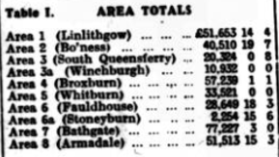  The above reveals a grant total of £373, 826 7s 8d and with a county addition from bigger investments of £71,424 15we reach the final figure of £445,251 2s 8d. the county figure includes a late allocation from the Prudential Assurance Co, Ltd, of £34,300 in the following manner:  Bathgate 16,200  Whitburn 4,200  Armadale 2,500  Fauldhouse 3,600  Stoneyburn 600,  Broxburn 4,700  Winchburgh 300  Linlithgow and Philpstoun 2,300  Additional Investments – Subsequent to his report being compiled an investment of £2000 from the Pearl Assurance Co Ltd, allocated as follows;- Bathgate £1000, Broxburn, £500. And Whitburn £500 and a small investment of £9 have been intimated bring the grand total up to £477,760 2s 8d
RAF & WAAF | West Lothian Courier 15th August 1941  The WAAF have always worn their hair short enough to clear their pale blue collars. This is necessary for a smart appearance in uniform and short hair is easier to keep tidy. Although the origin of a new fashion is always mysterious it is believed that leaders of hair styles have lately been casting a calculating and admiring eye in the direction of the WAAF.  West Lothian Courier 29th August 1941  A Bomber’s Exploit – And the Crew Sang!  The captain of one of our 4 motor heavy bombers – a Scotsman who won the DFM as a sergeant and has since been awarded the DFC as a flying officer, tells the story of an exciting night operation which illustrates the team spirit of a bomber crew.  Just after they had dropped their bombs on a German target the rear gunner telephoned his captain to warn him there was a fighter on their tail.  I soon knew he was right” said the captain, because shells and tracer bullets came whizzing over. One shell hit and stopped the starboard engine. Another exploded near the navigators seat, and one went through the Astro dome above my head.  The rear gunner, I knew would be defending us, and there was a good chance of driving the fighter off because we’ve got a deadly sting in our tail. We should have had the German first if he hadn’t suddenly dived out of the clouds.  The rear gunner called back, he’s coming at us again. The fighter had flown over and returned to the other side, Shells and bullets were piecing the bomber. The captain found it difficult to manoeuvre because the rudder had jammed. Then the enemy broke away, either because he had exhausted his ammunition or because he had been hit.  It was only then that the gunner telephone that he had been wounded. The first burst from the fighter had hit him in the left arm and also grazed his forehead, blood making it impossible for him to see with one eye. I made for the nearest cloud, and a cloud has never seems so far away continued the Captain. The navigator set me a course and we made straight for home.  Then another of the four engines cut when there were still 120 miles to go, and only 100 gallons of petrol were left.  The navigator kept saying, everything will be all right. We always get back.  But with the rudder and elevators damaged, petrol getting low and two useless engines, things looked black. The wireless operation sent out an SOS in case they had to come down on the sea.  When the outlook was most dismal the crew started singing; “We’d be far better off in a home” and “Are you happy in your work?”  Said the Captain, you couldn’t feel worried with a crew like that.  But skilful piloting brought the bomber to the nearest English aerodrome. Then only one wheel would come down and that was punctured by anti-aircraft fire. The aircraft landed without further injury and the rear gunner is recovering quickly.  This was the captains 39th operational flight. His navigator had been with him on 30 of them.
War Pensions | West Lothian Courier 5th September 1941  Parents of men killed on active service who are receiving pensions for the loss of their sons, are having those pensions received consequent on the new income concessions granted by Sir Walter Womersley, Minister of Pensions.  An official of the Ministry said on Wednesday – “The concessions will operate from last month in the appropriate cases. Where new pensions are being awarded, they will come under the new scale at once and some have already been awarded on that basis. The other cases are already under review.  West Lothian Courier 24th October 1941  Improved Allowances to Dependents of Service Men – We would like to draw special attention to a paragraph in Mr George Mather’s Parliamentary Notes this week. The paragraph deals with improved allowances to dependents of Service men and women and is of special important to these dependents and should receive their attention. The principle of the new system is the rent, rates, instalment payments, insurance premiums and other fixed liabilities will now be ascertained, and a sum paid to cover them in full; then on top of that the serving man’s wife will received 16s per week for herself and 3s for each child of school age to provide food and clothing. That is a distinct advance on the present position, but care should be taken by those entitled to these allowances to apply on the proper forms.  West Lothian Courier 24th October 1941  Deceased Soldiers’ Estates – The following has been received for publication from the War Office, London, SW1  In the list of sums of money due to the estates of deceased soldiers published in the “London Gazette” recently there appears the sum of £4 7s 6d due to the estate of Pte G Johnston (alias Thompson) Kings Own Scottish Borderers, which has been undisposed of since 1940. Applications from persons supposing themselves entitled to the money as next of kin of the above named soldier should be addressed to the Under-Secretary of State, the War Office, London, SW1 and marked outside “Effects.”
Warship Week | West Lothian Courier 30th January 1942  West Lothian Warship Week takes place on May 23-30 and the target is £210,000, sufficient to pay for the hull of a destroyer. If the authorities approve the destroyer will be named “Wallace.”  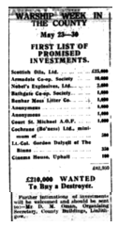  West Lothian Courier 24th April 1942  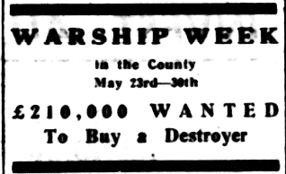  West Lothian Courier 8th May 1942  West Calder Co-Op’s Investment – West Calder Co-operative Society have agreed to invest £20,000 in Government securities during Warship Week in Midlothian. West Lothian and Lanarkshire. The sum  has been allocated as follows:-  Midlothian £12.500  West Lothian £5,500  Lanarkshire £2000  The sums have been spread over the various districts where the Society does trade as follows;-  Midlothian  West Calder £6,500  East Calder £1,200  Midcalder £500  Addiewell £1,100  Pumpherston £3,200  West Lothian  Stoneyburn £1,300  Blackburn £1,500  Livingston Station £900  Uphall £1,450  Philpstoun £350  Lanarkshire  Forth £1,700  Tarbrax £300  West Lothian Courier 29th May 1942  Warship Week – Amount Already Reached £388,033 - £500,000 Now the Target  West Lothian Warship Week is already an assured success. The figures announced last night speak for themselves. The campaign has been entered into with a fine spirit of enthusiasm all over the county and the daily returns have afforded conclusive evidence that every town and village is determined to contribute its full share towards raising a total which will rebound to the credit of West Lothian. The objective is now £500,000. To achieve this result much will depend on the two remaining days of the campaign, but we anticipate that every effort will be put forth to reach the desired result.  We received a good lead from Midlothian Warship Week, when they more than doubled their target of £250,000 and it appears that the people of West Lothian are about to follow the example of their near neighbours. Credit is due to large and small investors alike; indeed, all classes in the community have responded well to the appeal. When the figure come to be analysed, we have no doubt that the results will show that the school in the County, the Street Savings Groups in the county and the purchasers of Savings Certificate in Banks, Post Offices, and Selling Centres investors in the Post Office Savings Bank and in the Trustee Savings Bank in Bathgate and the general body of small investors have contributed in an extraordinary degree to the success achieved. Let all the workers in this county effort go all out for the half-million and thus show the extent of our appreciation of the work of our navy and of all those who go down to the sea in ships and risk their lives for our sakes.  West Lothian Courier 29th May 1942  Colonel Robertson, VC at Stoneyburn – The opening ceremony in connection with Warship Week in Stoneyburn was performed by Colonel Robertson, VC, OBE, JP, in the playground of the Public School on Friday evening last. He was accompanied by Mr James Wright, WS, DL Chairman of the County Savings Committee. Ex-provost Simpson, Bathgate, Mr D McL Oman, Secretary of the County Savings Committee, Mr J Fisher, Head of Stoneyburn Civil Defence, Councillor Haggerty, JP and Mr W W Tully, FEIS, organiser of Stoneyburn Warship Week.  Col Robertson addressed the assembled Civil Defence personnel and Youth Organisations and congratulated them on the good work they were doing.  Mr Wright extended the good wishes of the Savings Committee and paid tribute to the large assembly.  Col Robertson and party inspected the various Services which included the Stoneyburn Home Guard, supported by contingents from Addiwell and Whitburn, Home Guard Cadets, ATC, ARP, Wardens, Decontamination Squad, NFS, first Aid workers, girl Guides, Boy Scouts and Women’s Emergency Relief Organisation.  The parade, led by Stoneyburn Home Guard, marched via Main Street, to Garden City and Bents, Whitburn Silver Band an West Calder Pipe Band were in attendance. On returning the salute was taken by Col Robertson opposite the Putting Green.  The platform party was afterwards entertained to supper.  An outstanding feature of the proceedings was the excellent exhibition of work by scholars in the Hall of the public School. The various exhibits of art, writing, English, sewing, cookery, woodwork and poster work were artistically displayed and attracted considerable attention. The pupils re to be congratulated on their meritorious work. Two of the more striking exhibitions which caught the eye at a glance were the model sampan from Hong Kong and a replica of the Mayflower.  The School Savings Association is remaining open all this week and so far, Mr Tully, headmaster, has been kept very busy, contributions from adults being well to the fore.  West Lothian Courier 5th June 1942  Area Total  Target Amount Realised  Armadale 20,766 39,451 17s 6d  Blackridge 7,371 8,566 14s 6d  Westfield 1,419 5,539 17s 0d  Bathgate 35,166 101,346 2s 5d  Blackburn 6,027 8,438 10s 0d  Livingston 8,062 6,441 18s 0d  Torphichen 1,755 1,847 12s 0d  Bo'ness 46,728 70,798 14s 8d  Linlithgow 17,181 98,496 4s 8d  Broxburn 22,698 33,445 2s 10d  Ecclesmachan 624 4,505 19s 6d  Uphall 5,547 27,105 6s 11d  Queensferry 7,395 19,164 3s 6d  Dalmeny 3,666 2,947 2s 6d  Winchburgh 4,188 10,796 1s 0d  Kirkliston 2,094 8,633 5s 8d  Whitburn 18,246 42,257 7s 8d  Fauldhouse 15,171 43,257 15s 0d  Stoneyburn 8,277 9,418 12s 6d  £226,998 £543,046 17s 4d  West Lothian Courier 5th June 1942  West Lothian Warship Week – Final Grand Total £547,540 – A magnificent Result  The result of West Lothian Warship Week has exceeded all expectations. The final total amounts to £547,540, a very substantial sum over the half million final target. The County total per head of population is £7 4s, compared with £5 17s 6d per head during War Weapons Week 1941. This is an achievement of which the County may well be proud. It reflects great credit on the Chairman, Secretary and member of the Executive Committee who were responsible for the organisation of this campaign and the local secretaries in all areas of the county and the many men and women who worked along with them to bring about this remarkable result. Figures showing how the money came in are given below. The table showing the amount per head in each town and village has yet been prepared and this also applies to the table sowing the amount raised by each Street Savings Group in the County, but these figures will no doubt be made public later.  One feature of the statistics shows clearly the extraordinary support given by the small investor. Last year, £92,718 was invested in National Savings Certificates, and £1122 in Savings stamps a total of £93,840 as compared with £98,593 in Warship Week, an increase of £4,753. The Post Office savings Bank deposits also show a large increase compared with last year.  The agricultural industry has good reason to be congratulated on the amount accruing from that source, the total being £36,915 of which £15,805 10s was invested in the northern part of the county. All the schools in the county have also done splendidly and show an increase of 77 per cent over last year’s figure for business done. We trust that the Savings Movement, which has been so well supported in this county effort will continue to expand and become a greater power for good in the lives of the people, and that saving, and lending will become a popular habit and hobby on the part of all classes of the community.
Increased Pension Rates | West Lothian Courier 6th February 1942  Increased Pension Rates – Men, widows, and Children – Some details of the new increased pensions in respect of war-disabled men and widows and children became known on Wednesday. Increases are;-  100% disablement pension, private soldier from 34/2 to 37/6  Wife’s allowance payable in addition to disablement pension for husband, first child from 6/3 to 7/1, for second and each other eligible child from 5/- to 5s 5d.  Widow of Private soldier, if under 40 and if she has no children eligible for allowances or is not incapable of self-support from 15/6 to 17/6  Widow of private soldier who is 40 or over or a widow whatever her age, who has children eligible for allowances of widow incapable of self-support from 22/6 to 25/-.  Increases in additional allowances for children of widows are First child from 8/6 to 09/6, second child from 6/3 to 7/-, third and each other eligible child from 5/- to 5/6.  Orphans from 10/- to 11/-.  The rises which are in proportion to increased living costs, will take effect form the first pay day this month. Although some adjustments may not be made until the end of March, arrears will be paid in all cases from the first pay day of February.
Shale Miners Help Russia | Midlothian Advertiser 1st May 1942  Shale Miners Help Russia – A collection taken at the various pay offices of the Scottish Oils Ltd, in aid of the nation Union of Labour’s help for Russia fund was realised a sum of £236 1s 6d.  A cheque for this amount has been forwarded by Bailie W Nellies, General Secretary of the National union of Shale Miners, and Oil Workers to Mr William Elgar, General Secretary of the Scottish Trades Union Congress. It is to be noted that the staff of Scottish Oils Ltd, have very generously contributed to this sum.
Fall of Tobruk | Midlothian Advertiser 26th June 1942  Serious reverse in Libya – We wrote last week that there were dangerous possibilities in Libya, but no one was prepared to the shattering news which came through on Sunday that Tobruk had fallen and 25,000 of our men were prisoners. We have been clearly outgeneralled and the need for the clear brain and experience of General Wavell to meet a General of Rommel’s cunning and capacity is evident. It is doubtless true that the enemy were superior in tanks, gun power and anti-tank weapons, but how long is this state of affairs to endure. Our men are first-class, and we should be able give them the tools now.
Tanks for Attack | West Lothian Courier 10th July 1942  Tanks for Attack – Scottish Savings Committee’s New Plan  The Scottish Savings Committee have issued a memorandum on their new Tank Plan which will operated over a period of 10 weeks from August 3rd to October 10th.  The slogan of the plan is “Tanks for Attack.” It calls for an increase of at least 20% in small savings on the Warship Week totals of Scottish Savings Committee areas. As a reward it offers to each successful area the honour of having the name of the Area Committee and of Savings Groups in the area which have done outstanding work in the Campaign placed on a plaque affixed to a tank or tanks.  “Tanks for Attack” will provide a stimulus to small savings and in particular to Savings Groups of all kinds. It is a valuable adjunct to the Street Group Drive which commences on 20th July.  The Committee can imagine no more attractive incentive to a Savings Group than the knowledge that a British Tank fighting somewhere in the forefront of the battle may be bearing the Group’s name  West Lothian Courier 4th September 1942  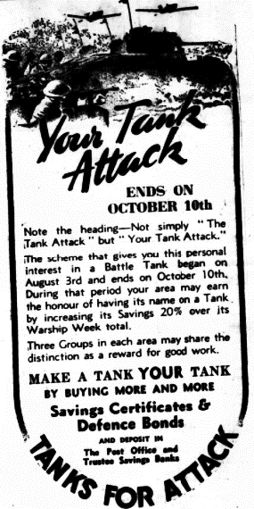  The Battle of the Tanks – Our country is calling for a very good effort on the part of the small savers to raise, during the period from 3rd August till 10th October, substantial sums for the provision of tanks.  The target for the county of West Lothian is close on £200,000 and this has to be realised from the sale of National Savings Certificates, Defence Bonds, and deposits in Trustee and Post Office Savings Banks.  Join your nearest Street Savings Group, if you are not already a member or any Savings Association connected with your place of employment. Do your bit and put in a bit to help to pay for the tanks.  West Lothian Courier 2nd October 1942  Tanks for Attack – With one week only to go in the “Tanks for Attack” Scheme, West Lothian is far below its target figure of £196,000.  Those with the cash to spare should invest in Defence and Savings Bonds and Savings Certificates. Savings Stamps are not counted in the Scheme so those with Stamps should have them converted into Certificates or deposited in Savings Banks.
Home Guard Social | West Lothian Courier 11th December 1942  Stoneyburn Home Guard Social – the members of the local Home Guard held a social in their headquarters on Saturday night, when a company of 100 was presided over by Lieut Boyd. An excellent tea was provided after which a social hour was spend during which songs were sung by Lieut Boyd, LCpl Harte, Mrs Smith, Pte W Carmichael, Miss Lily Forrest, Pte Norman Richardson, Pte George Halliday, Pte Andrew Harkness. During the evening Sgt Hannah presented Lieut Boyd and 2nd Lieut Matchet with officer’s badges. Both officers returned thanks. At the dance which followed, to the strains of the Locarno Band, LCpl Wilson made an efficient MC. A most enjoyable evening was spent.
Scottish Oils | Midlothian Advertiser 30th October 1942  For Men in the Forces – the director of Scottish Oils Ltd, are sending a gift of £1 to each of the employees in the Forces as a Christmas gift.
Warship Week  HMS Wallace  West Lothian’s Adopted Destroyer | West Lothian Courier 1st January 1943  West Lothian’s ready and generous response to the appeal on behalf of the ship’s company of the county’s adopted destroyer HMS Wallace, has called forth grateful acknowledgement by the ship’s commander. Commander Heywood Lonsdale give the assurance that they will be able to do a great deal of good with the money subscribed. This gesture sponsored by the County War Savings Committee has certainly been the means of forging an interesting link between the County and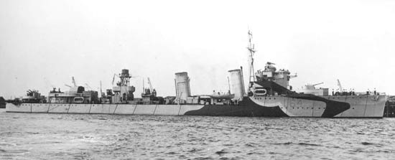 HMS Wallace, which should grow closer and stronger with continued contact I feel sure that the good wishes for the coming year sent on behalf of the ship’s company will be reciprocated by the people of West Lothian.
Stoneyburn Wounded entertained. | West Lothian Courier 29th January 1943  Stoneyburn wounded Entertained – A party of thirty wounded from a nearby military hospital were entertained in the ARP Hall on Wednesday evening by Stoneyburn and Bents WRI.  After a welcome had been given to all present tea was served by the Committee. The tables were beautifully arranged and laden with an abundance of good thing to ear generously provided by the members of the WRI. After full justice had been done to the tea the tables were cleared and the entertainment commended with the Rural Choir rendering “ye Banks and Braes.” Mr Blaik accompanied at the piano. Solos rendered by Messrs Wynne and Boyd, Ptes R Brannan, and Clements, Sapper Speirs and Cpl McEwan were greatly appreciated. Master Ian Campbell was a great attraction and provided amusement with his songs, patter and dancing. Margo Adamson and Ena Elliot, two charming little dancers gave a delightful display of Highland and Tap dancing. Music for the dance during the evening was kindly supplied by Messrs P Currie and J Murray, Mrs Black acted as MC. A present handed in by Mrs Paterson was won by Pte McDonald. Pte Brannan, the holder of a lucky ticket, received 50 cigarettes.  Each soldier was presented with a packet of cigarettes, Mrs Allan, vice president, proposed a vote of thanks to all who had helped in any way to make the evening such a great success. The Committee also thanked Mrs Elliot for lending piano, Mrs Campbell and Mr Blaik, pianists, Mrs Adamson and Mr Murray, accordionists. Mr Currie, violinist, Mr Fisher for the use of the ARP Hall, Mr Reid, for arranging hall, and Mr Pow for transport. Pte Brannan thanked the WRI for the very pleasant evening, the wounded had spent. The evening was brought to a close by singing Auld Lang Syne and God Save the King.
Out Where the Big Guns Boom | West Lothian Courier 29th January 1943  Out Where the Big Guns Boom – A Christian Soldier’s Testimony  I have a charm for each alarm  Out where the big guns boom,  When the shadows fall like a closing pall  Over, a yawning tomb,  ‘Tis my Saviour dear, who whispers cheer  When near the death-clouds look,  And I must stand true, as he’d have me do  Out where the big guns boom  Refrain  Out, where the guns are booming lads  And red death haunts the line  When the battle clouds are looming lads  A wondrous peace is mine  A quiet voice steels thy courage lads  Beneath sound of doom  And I must stand true, as he’d have me do  Out where the big guns boom.  My hope soars high when the troubled sky  Seems full of death and gloom  When the war-Gods grim, chant their hateful hymn  Out where the big guns boom  For the chart says clear, he is always near  And it seem to cheer me so  For I oft drink deep while my comrades sleep  From the Word he left below.  I think of his blood poured forth in flood  To save my soul from doom  And I sleep at peace in my old valise  Out where the big guns boom  For well I know in weal or woe  My Lord will see me through  Let me just stand fast while the storm will last  And do as he’d have me do  L Y Ewan  2nd Black Watch.
Home Guard Burns Supper | West Lothian Courier 5th February 1943  Stoneyburn Home Guard – Burns Supper – Lieut Boyd presided over a most enjoyable “Nicht wi’ Burns” which was held in the Home Guard HW on Saturday.  The Haggis held aloft by Cpl Wilson was piped in by piper Drummond and then addressed by the chairman, who also gave the Selkirk Grace. Having dined magnificently, the Company sang heartily “there was a lad. The following toasts were proposed – “The King”, Lieut Boyd; “the Imperial Forces”, Sgt Hannah; “the Lassies,” Cpl Richardson; “the Immoral memory” was eloquently proposed by Lieut Gibson and Piper Drummond Played “Lochaber No More.”  Captain W C Forsyth, Bathgate replied to the Toast, “The Imperial Forces” and later brought down the house with his fund of stories. Another guest, from the Cadet Force, was 2nd Lieut Blake of the Stoneyburn Platoon which took part in the long and excellent programme of entertainment.  LCpl Abbott entertained the company with accordion selections and Burns songs were rendered by Sgt Haggarty, Cpl Scoular, LCpls Duncan Harte and Pte W Abbott, T Abbott, A Smith, A Richardson, W Richardson and J Hood.  A very enjoyable evening was spent.
8th Army Casualties | West Lothian Courier 19th March 1943  Around the County News – Nearly 2000 men of the Eighth Army are back in Britain as casualties of the campaigns of Egypt and Africa. Six of them will never see again, and another has lost both his legs, but the majority are already able to move about and are in good spirits. It is fine to know that so many of our gallant lads are making a good recovery.
Mid Scotland Canal  Forth Road Bridge Scheme | West Lothian Courier 23rd April 1943  Renewed interest is being aroused in the Mid Scotland canal proposed to link up the Forth and the Clyde. Among other bodies, the Scottish Conservatives are interesting themselves in the matter and they seem determined to push the Panama project as it has been called, as one of the major public works that should be carried out after the war. A sub-committee of members of Parliament under the chairmanship of Sir John Graham Kerr, has been appointed to draft a practical scheme for submission to the Government. Scotland’s Industrial Council appointment some months ago the Secretary of State for Scotland are also giving this scheme their attention so that the prospects of a mid-Scotland canal being given priority in post war plans seems to be good. It is hoped, however, in the East of Scotland that the Forth Road Bridge scheme which is in an advanced stage of preparation will be proceeded with in advance of the big ship canal proposal.  West Lothian Courier 8th October 1943  Those interested in the construction of a mid-Scotland canal from the Forth to the Clyde would be disappointed at the statement of the Duke of Montrose at the meeting of the Scottish Liberal Federation in Edinburgh on Wednesday. The Duke said he had raised the question of the canal in Parliament about a month ago when the matter was remitted to a Special Committee. “You may take it” he added, “that there is no intention of dealing with the canal for many years to come.” It appears that the question of airfields in Scotland for cross-Atlantic traffic is taking a prior place in the consideration of the transport authorities.
Church Bells to Ring Again | West Lothian Courier 23rd April 1943  The Church bells are to ring again to summon worshipper to church on Sundays. Apparently, the announcement has been received with great satisfaction by all sections of the community but whether it will add to the attendance in our churches remains to be seen. More than the ringing of the church bells is needed, I am afraid to get the people to come to church in larger numbers. Still the indications are that more interest than ever in the work of the church and all that it stands for, is being taken by people in many departments of life.
Women in Home Guard | West Lothian Courier 23rd April 1943  Women between 18 and 65 are now eligible for Home Guard. Preference will be given to those over 45 or not eligible for other work. I think that grandma is going to have a better chance than ever to do her bit in this war and more than likely she will not hesitate about doing it. Before long we may see her going on duty with the Home Guard at the weekends, displaying her badge and with a khaki apron on, ready for anything.  West Lothian Courier 23rd April 1943  Women in the Home Guard – To be Admitted for Non-Combatant Work  Sir James Grigg, Secretary for War, told Dr Summerskill (Lab) in Commons on Tuesday that it had been decided that a limited number of women, proportionate to the strength of the Home Guard, might be nominated for service as auxiliaries with the Home Guard to perform non-combatant  duties such as clerical work, cooking and driving. Women between 18 and 65 will be eligible.  Instructions had been issued to battalion commanders to give preference to those over 45 or those not eligible for other work.  Women nominated would wear a badge brooch. It would not be possible to exempt such women from any other form of full time or part time services.  Commanders had been instructed whenever possible to make use of existing women’s organisations. He acknowledged the valuable and devoted service they had performed.  Asked if uniform would be issued, St James said, No, they will not.”
Parcels for POW’s | West Lothian Courier 23rd April 1943  Parcels for Prisoners of War – Pilferages at the Ports – In the House of Commons, Mr Mathers asked the Postmaster General whether, in view of the large number of pilferages from parcels sent by relatives to British prisoners of war, especially tobacco parcels, before leaving this country, he will authorise the omission of the special Inland Revenue label which declared the contents and thus attracts the attention of persons committing the offences?  The Postmaster General (Captain Crookshank) – I have no evidence that pilferages from parcels sent by relatives of British prisoners of war occur on any appreciable scale before despatch from this country. Parcels of tobacco despatched through a holder of a censorship permit are exported on drawback or our of bond and in accordance with the normal procedure for parcels so exported the Customs Regulations require the exported to affix a distinctive label which carries no indication of the contents of the parcel.  Mr Mathers asked the Parliamentary Secretary to the Ministry of War Transport whether he is taking any special steps to stop pilfering at the ports from parcels addressed to British prisoners of war and from lifeboat supplies for the succour of shipwrecked mariners as reported at the annual meeting of the Liverpool Steamship Association, a copy of which has been sent to him?  Mr Noel Baker – I regret that pilfering in the posts has increased since the beginning of the war, and that it has included thefts from parcels addressed to British prisoners of war, and from the supplies provided in the lifeboats on ocean going ships. I agree with the authors of the annual report of the Liverpool Steamship Owner’s Association when they say that such theft is as serious as looting. My noble Friend, and my right honourable friend the Secretary of State for the Home Department have already taken vigorous steps to ensure that the various authorities of the port shall work closely together to combat this evil. I can assure my Hon Friend that the whole matter is kept constantly under review and that all such cases as those to which he refers will be closely followed up.  Linlithgow Gazette 18th August 1944  Parcels for POW In Germany – The Postmaster General announces that, in view of the continued interruption in occupied France next of kin and permit parcels for prisoners of war in Germany cannot be forwarded to their destination. As there is already an accumulation of parcels in this country and en route no good purpose will be served by the posting of further parcels until conditions become more favourable and the Postmaster General, therefore strongly advises the public to refrain from posting next of kin parcels or giving orders to permit holders for the dispatch of tobacco, cigarettes, books etc. A further announcement will be made when parcels can usefully again be sent.
“Wings for Victory”  Campaign | Midlothian Advertiser 28th May 1943  Stoneyburn & Bents “Wings for Victory” Parade – Every effort is being made to encourage the people of Stoneyburn and Bents to reach their quota of £9650. Arrangements for the special week beginning 29th May are well in hand and include a parade of Military, Civil Defence and Youth Organisations, and an exhibition of work in the Hall of the Public School. The parade augmented by contingents of the RAF and WAAF with mobile exhibits will be inspected by Wing Commander Lewis in front of the public School, on Monday 31st May at 7pm.  West Lothian Courier 28th May 1943  Around the County – By Special Courier  The Wings for Victory campaign promises to be as successful as Warships Week last year when £547,540 was raised in West Lothian. Indeed, judging the by the various encouraging reports from districts in the County, it would not surprise me if that grand total was exceeded by a substantial amount. The Chairman, Mr James Wright was right then he said that the Committee looking to the small investors who accounted for about one half of the grand total last year, to endeavour to make themselves responsible for three quarters of the whole amount raised in Wings for Victory” week. With everyone doing his and her bit, it can be done and the half million exceeded.  A number of bombs will be exhibited in various parts of the County on which the public will be invited to stick savings stamps of various values. Later on these bombs will be returned to the RAF to drop over Berlin. Another way for the public to make a free gift to the Treasury and to send their compliments to Hitler. Slap the stamps on. The RAF will do the posting!  If we raise over half a million in the County, we should be able to purchase a considerable force of bombers of the latest type and fighters to accompany them, all fully equipped ready for service. The RAF need more planes. We’ll buy them. We must not let them down.  West Lothian Courier 28th May 1943  Speed the Winning Wings  By A M Bisset  West Lothian’s calling, calling,  Calling to you and me,  ‘Tis a slogan clear, enthralling –  “Speed, Speed the victory.”  The lads who in the ether  Have heroes proved and kings,  Cry “Send to us a feather  To speed the winning wings.”  They hate you – how they hate you –    The blood stained German crew,  They’ve sworn to exterminate you,  And they’d love to do it too,  But our lads whate’er the weather  Make them think of other things,  So you must provide the feather,  To speed the winning wings.  For the grand old land that bore you,  For your wives and children dear,  For the flag of freedom o’er you,  For the lads who guard you here,  Let us pull our weight together,  With the will that victory brings,  And let each provide a feather,  to speed the winning wings.  All your joys will be completer,  And jauntier your stride,  Sounder your sleep and sweeter,  Safer your own fireside,  You’ll feel happier altogether,  When the peal of victory rings,  That you furnished one small feather  To speed the winning wings.  West Lothian Courier 4th June 1943  Opening Ceremony at Stoneyburn – The “Wings for Victory” Week was inaugurated in Stoneyburn on Monday evening with a parade of RAF and WAAF contingents with mobile exhibits. Home Guard, Army Cadet Force, Air Training Corps, Youth organisations, Civil Defence Services, NFS, WVS and Rest Centre Workers. The personnel assembled at the Public School playground and after being marshalled into processional order, marched through the village headed by West Calder Pipe Band. Owing to unfavourable conditions the route was cut short and no doubt many Bents people would be disappointed at not seeing the parade.  On the return journey the salute was taken opposite the Putting Green by Wind Commander Lewis, RAF, who was accompanied at the saluting base by Mr James Wright, chairman of West Lothian Savings Comm ittee and Mr Andrew Simpson, Deputy Chairman, Councillor R Haggarty and Mr W W Tully, President and Secretary respectively of the local Savings Committee and Mr James Fisher, Secretary of the local CD Services. Before dismissal in the playground Wing Commander Lewis expressed his great pleasure with the turn-out which was regarded as the biggest Stoneyburn has ever had and complimented the personnel on their smartness and military bearing. Mr Tully thanked the public for their support and mentioned that up to date almost £3,000 had been obtained during the two days of the campaign. He thanked Wing Commander Lewis for his services.  The RAF and WAAF contingent were entertained to a light supper and also the platform party and visitors all of whom had an opportunity of looking through the excellent exhibition of school-work. This exhibition which commenced yesterday will again be open to the public today (Friday) from 2 to 8pm and is well worth a visit.  Midlothian Advertiser 4th June 1943  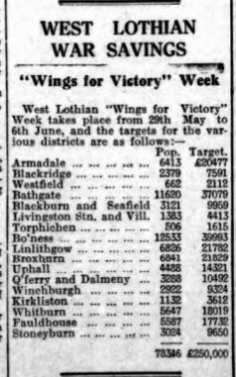  Stoneyburn & Bents Parade – there was a well-staged “Wings for Victory” parade in Stoneyburn on Monday evening. The parade consisted of ATC, ACF, Civil Defence, WF Services, WVS, Rest Centre Workers, Youth Organisations headed by West Calder Pipe Band. Wing Commander Lewis took the salute and on the platform with him were Mr Wright, and Ex-Provost Simpson from Bathgate, Councillor Richard Haggarty, JP and Mr Tully.  West Lothian Courier 11th June 1943  Stoneyburn – School Exhibition – One of the most popular attractions in Stoneyburn in connection with Victory Week was provided in the public School. The large gymnasium was used to house an exhibition of schoolwork connected with every class from youngest infants to the post Primary. Tables all round the hall held specimens of handiwork of all types such as clay modelling, weaving, cardboard work, book binding, while on the walls were displayed a large number of hand drawn posters bearing mostly original slogans were the work of the older pupils. The literary efforts of these pupils – poems printed and bound in booklet form by themselves proved also a source of income to the RAF gift fund, for a charge was made for the privilege of reading them. Nearby the tanks and model aeroplanes all suitably painted and camouflaged gave an indication of the work of the technical department. The needlework display of all classes and the Cookery and Laundry section were much admired. A most interesting feature was the exhibit of well over 100 photographs of former pupils all doing their bit for King and Country in the present struggle. An additional room was necessary to hold a most interesting display of exhibits from Allied Countries. These articles were much admired and in most cases were of undoubted value.  West Lothian Courier 11th June 1943  Targets and District Totals  Target Total  Armadale 20477 41814 6 6  Blackridge 7391 8683 14 0  Westfield 2112 13305 15 3  Bathgate 37079 111004 15 0  Blackburn 9959 6706 8 6  Livingston Stn 4413 5586 2 6  Torphichen 1615 4960 11 9  Bo’ness 39983 55782 13 5  Linlithgow 21829 106427 18 6  Broxburn 21829 36018 14 11  Uphall 14321 34480 6 5  Queensferry 10492 19749 2 2  Winchburgh 9324 9537 18 10  Kirkliston 3612 9537 12 6  Whitburn 18019 33389 2 11  Fauldhouse 17732 36015 14 4  Stoneyburn 9650 11668 9 6  Total .. .. .. .. .. .. .. .. .. .. .. .. £556591 7 1  Linlithgow Gazette 11th June 1943  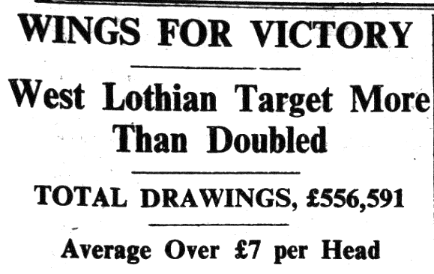  West Lothian Courier 11th June 1943  Stoneyburn’s Effort – it is a source of much gratification to the whole Stoneyburn district that the objective of £9650 has resulted in a final amount of £11,328. Without the helpof the larger industrial firms that usually give so much help to many places in the country, it has always been realised that only the most strenuous efforts locally would result in success. With an allocation of £1700 from West Calder Co-operative Society and two or three handsome investments from good friends of the village, a good start was made. During the week money in small amounts kept pouring in through the Post Office, the schools and by the efforts of the Street Group workers involving many people in heavy clerical work and loner hours. Almost two thirds of the total was derived from such sources. When on Friday night it was broadcast that only £200 was required to reach the target the answer to the challenge was almost £2000.  Midlothian Advertiser 11th June 1943  Stoneyburn – Wings for Victory – The people of Stoneyburn invested the sum of £11,269 during West Lothian’s Wings for Victory Week.  Midlothian Advertiser 18th June 1943  Stoneyburn Wings for Victory – The full result of the Wings for victory week has been announced. By the local effort the sum of over £40 has been sent to Mr Oman, country Savings secretary to be donated to the RAF Benevolent Fund. The sum was arrived at in the following manner- £11 from public collection, £5 from ARP, £1 from Terraces, £30 from an exhibition of work held in the Public School.
Miracle of the Spitfire | Midlothian Advertiser 7th May 1943  The Miracle of the Spitfire – those who saw the great picture “The First of the Few” at one of the local Picture houses last week, could not fail to be impressed b the heroism of the inventor of the Spitfire. From a visit to Germany Mr Mitchell realised the peril we were in from thousands of German bombers. His genius in planning the Spitfire was only equalled by his heroic struggle to get it manufactured in time to save us in the Battle of Britain. Overtaxing his strength by long hours at the factory he gave his life for his country. There have been many heroic deeds in this war and among these Mr Mitchell must always take a high and honoured place.
The Red Cross and Parcels for Prisoners of War | Midlothian Advertiser 7th May 1943  West Lothian Prisoners of War – owing to the misfortunes of war over 250 men from West Lothian are prisoners of war in Germany or Italy. The food parcels, which cost 10/- each, and which are sent weekly to these men, represent a very considerable expense. The needs of these men must be met regularly and £125 per week, or £500 per month or £6500 per annum is the substantial sum required to meet the cost of such parcels. It takes £400,000 a year to meet the cost of food parcels sent to all Scottish Prisoners of War. This is a considerable drain on the funds of the Scottish Red Cross, and they would like each county to support as far as possible its own prisoners. The need must be regularly met, and consequently a regular income must be assisted.  West Lothian Courier 7th January 1944  The Red Cross and Parcels for Prisoners of War – A tremendous amount of late has been done by way of raising money in the county for Red Cross prisoners of war parcels, and a great deal of praise has come the way of the Red Cross from repatriated prisoners of war who spoke very highly indeed of those parcels. For the benefit of those who contribute towards the cost of providing parcels, Mr F C H Thom, Hon, Secy of the County Branch of the Red Cross, supplies a list of the articles that each parcel contains and here is the list :-  1 tin Midlothian oar meal  1 tin boiled beef, carrots and dumplings  1 tin meat roll  1 tin apple pudding  1 tin Rowantree cocoa,  1 tin nestles condensed milk  1 tin Grade 1 Salmon  1 tin dried egg  1 tin strawberry or other jam  1 pkt of tea  1 pkt of sugar  Half pound tin margarine  1 tin cheese  1 tine Healthy Life biscuits  Quarter pound block chocolate  1 pkt sweets and  1 cake soap  Acknowledgement of the enormous debt of gratitude we owe to the Swiss people for their help in connection with the distribution of Red Cross parcels and other work was made by Mr Thom at a recent gathering. Mr Thom said all the money that was given by the public, all the work of the Scottish Branch would go for nothing if it were not for the International Red Cross Committee at Geneva which was entirely Swiss. They were the vital link between us and our prisoners. Their offices in Geneva had overflowed into every important town in Switzerland, and the number of workers ran into thousands most of whom gave their services voluntarily. There was no belligerent country without its representative and it was impossible overrate the value of the painstaking work these representatives did in bettering the lot of prisoners of war everywhere.  This must not be taken as disparagement of many other agencies which devoted their efforts to the same cause, i.e., the International YMCA etc., but the brunt of the work fell on the International Red Cross Committee because they were the official body recognised by most governments in the world to supervise the carrying out of the International Convention. In conclusion he said – “When peace comes again let us never forget what the Swiss have done to help us in our time of trouble and let us help the prisoners now all we can to make their task easier.”
New Ration Books | Midlothian Advertiser 4th June 1943  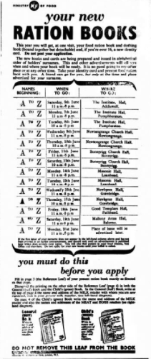
Rose Hip Collection | West Lothian Courier 11th June 1943  Rose Hip Collection – The West Lothian County Committee are planning well ahead for the collection of rose hips under the Scottish Medicinal Plants Scheme. Last year two and a half tons were collected, mostly by school children and this amount may easily be surpassed if good weather prevails when the hips are ready, which is usually from late August until the end of October.  The Committee do not intend to collect foxgloves leaves as they have no drying facilities. Nettles will not be dealt with either this season.  The rose hips are manufactured into that extremely palatable syrup, rich in Vitamin C which many have been drawing through the various vitamin centres. Normally children obtain this vitamin from oranges and other fruits. The rose hips make good this deficiency.  When to Collect – It is known that the vitamin content of the hips is at its best from the time when they just begin to change colour until they are fully red. This process normally commences in late August or early September. Collection should cease when the hips become soft, as the hips will then stand transportation. Wild or garden hips may be collected and should be gathered in in dry weather. It the hips are wet they should be spread out on a floor to dry. They should also be free from stalk and clean. Another point its, always ask a farmer for permission to collect hips from his property.  The Collection Centre at Airdrie has again been opened but local collectors should get in touch with Mrs Crichton, Castlepark, Philpstoun, President of the County committee, or Mrs John Ferguson, East Philpstoun, the Hon. Secretary, for further information as to supply of bags, despatch etc.  Payment is made to the County Committee at monthly intervals and the rate of payment this year is 2d per lb.
Shale Workers Contributions | West Lothian Courier 11th June 1943  Prisoners of War Fund – Shale workers’ Extra Contribution – In connection with the recent County Special appeal for increased financial support for the Prisoners of War fund, the employees of Scottish Oils, Ltd, have set a splendid example to all industrial workers and indeed to the employees of all concerns in West Lothian.  Shortly after the appeal was issued, Mr Robert Crichton, managing director of Scottish Oils approached the officials of the National Union of Shale Miners’ and oil Workers and suggested that the present weekly contribution of 2s per week deducted from the men’s wages for the County Red Cross Fund should be increased to 3d per week, the additional penny to be devoted to the Prisoners of War Fund. The Executive of the Union readily concurred to the suggestion and notice to this effect have been posted at the various mines and works.  The appeal, which had for its object the raising of sufficient money to meet the cost of parcels to prisoners of war belonging to the county has met with a gratifying response from any other quarters and it is hoped that the employees of other firms in the county will follow the generous lead given by the Shale Miners and Oil Workers.
Japanese POW Instructions | West Lothian Courier 30th July 1943  British Prisoners in Far East – 20,000 Communications Received – the Post Office announces that a further 20,000 postcards and letters from prisoners of war in Japanese hands have reached this country recently and have been delivered.  About nine-tenths of them bore Japanese characters that indicated they came from Malaya; the rest came from camps in Japan and Thailand.  Correspondence reached this country from Japan via Switzerland and Portugal and special arrangements were made by the Post Office for it to be brought here by air from Lisbon.  Linlithgow Gazette 30th July 1943  The news that the Japanese are insisting that letters from next of kin of prisoners must be typewritten is causing concern to those with no facilities for having this done. But they need not worry. The Red Cross has come to the rescue with a scheme whereby handwritten letters will be typewritten and forwarded. Profession typists have volunteered their services to help relieve the anxiety of both relatives and prisoners.  Letters to prisoners must be brief. The space allowed is both sides of an ordinary sheet of notepaper. Write legibly, preferably print what you have to say, and forward it with a plain sheet of notepaper and an envelope for use of the typist to the County Branch of the Red Cross, Sheriff Court Buildings, Linlithgow.  Put the letters “T.H” on the top left hand corner of the envelope to the county Branch and do not forget to stamp it. Put no enclosures in the letter and be sure to give full details of your own address as well as that of the prisoner. The correspondence is, of course, strictly confidential  West Lothian Courier 3rd September 1943  Japanese Prisoners of War – those who have relatives who are prisoners of war in the hands of the Japanese should note the Japanese authorities require that letters and postcards to prisoners of war and civilian internees in Japan and Japanese occupied territories be limited in future to 25 words and either typewritten or written clearly in block letters, the Postmaster general learns.  Letters and postcards posted from no on which do not comply may not be delivered by the Japanese authorities, who claim that the restrictions are necessary to simplfy the work of their censorship so that correspondence can be speeded up.  The British Red Cross announce that “We have no trouble at all in getting suplies and parcels tp prisoners of war in Germany and Italy but we have never been able to work out a satisfactory arrangement with Japan.”  It is reported that many of our prisoners of war in germany are still in chains and this must cause much anxiety to their relatives at home. Notwithstanding our praiseworthy efforts to help prisoners of war, wherever they may be, it is evident that in many cases they are having a very poor time  Linlithgow Gazette 24th September 1943  Prisoners of War in Japan – Letter Limited to 25 Words each fortnight.  Only letters and postcards may be sent to prisoners of war in Japan and in Japanese occupied territories. They should be posted in the ordinary way and no postage is needed. Correspondence should not be sent to the British Red Cross Society to be forwarded.  No enclosures of any kind are allowed in the letters and the use of homemade envelopes economy labels or adhesive paper is forbidden.  All these rules may sound rather restrictive, but they have been made in the interests of the prisoners themselves. They are necessary to simplify the work of censorship abroad.  In block Letters  Letters must be limited to 25 words, and these should either be typewritten or written clearly in block lettering. Again this is to assist the Japanese censors who are having difficulty in deciphering English handwriting in letters.  There is no air mail service and letters cannot be registered or insured. Letters of inquiry addressed to the Japanese Red Cross cannot be forwarded.  Be careful what you write in the letters and on the postcards. You must deal only with purely personal matters and no information of any kind that may be useful to the enemy should be given.  Instruction Leaflet  Only relatives and close friends should write, and any one family should not send more than one letter a fortnight.  Write your own name and address on the back of the envelope, but if you are in the forces do not put your official address. Give the civilian address of a relative or friend who would be willing to forward any replies.  It is very important to address the envelope correctly. Addresses may sound rather complicated, but full details are explained simply in a leaflet which of obtainable at post offices. Ask for a copy of leaflet P2337B. Follow instructions carefully.
Royal Air Force | Midlothian Advertiser 27th August 1943  How we Built up the Air Force – Two things saved the Royal Air Force from annihilation and defeat in the dark days of 1940. Those same two things bear it up and onwards today. The supreme factors on which all else rests are firstly the training, skill and spirit of the air and the ground crews, and secondly the technical excellence of the aircraft they fly.  The great problem with which the RAF was faced when war began was to build up a great Air Force on a very small foundation without the sacrifice of efficiency. Fortunately the foundation was really sound and been on designed for rapid expansion should the need ever arise. For instance, flying officers of all ranks were switched from one Command to another at regular intervals in peace time, so that the regular nucleus, when promoted to higher rank, would have a sound working knowledge of the problems involved in the operation of fighters, light, heavy and medium bombers, flying boats and Army Co-operation aircraft.
British & American Skill | Midlothian Advertiser 10th September 1943  British and American Skill – In our bombers there is evidence of Anglo American technical collaboration of the highest order. The new Mustang – which shares with the latest Spitfire the distinction of being one of the finest fighters in the world today, is powered with a Rolls Royce Merlin engine. We have a here a British engine urging forward an American aircraft at a speed at least as fast as any fighter. In the case of the Wellington bomber the position is reversed. The veteran British bomber has been given a new lease of life by the installation of American Pratt and Whitney twin wasp engines and so continue to drop its load of “block-busters” with deadly effect.  Fortress Bombers on their deep daylight raids carry with them British dinghies for the crew. Every member of the crew wears a British “Quick release” parachute which enables him to free himself at speed from the harness and scramble on to the rubber raft if he bales out over the water.
Letters for the Forces | Midlothian Advertiser 10th September 1943  Letters for the Forces – The GPO wishes to remind people, who, everyday post letters addressed to the British North African Force, or the West African Forces, stamped with 1/3 stamps, that there is no ordinary air mail service to those areas. To the BNAF there is the Airgraph Service (3d) and the Air Letter (6d). The 6d Air Letter Service is available to the West African Forces. There is no Airgraph service.
The War News | Midlothian Advertiser 10th September 1943  The War News – The news from Italy this week indicate that hard fighting lies ahead of the Allied troops when they advance northwards. The Germans will fight as stubbornly as they did in Sicily. They know that very fifty miles our men advance on the mainland brings our airmen nearer their vital factories and helps to give us control of the Adriatic with a jumping off ground for Albania. When the Eighth and Fifth Armies are able to line up together, we will be able to meet anything Germany can send against us. Until then we may have a very hard time. The news from Russian continue to be very heartening. Our Ally should, at the present rate of progress be able to reach the Dueiper before the rainy season sets in. If it is accomplished, it will rank as one of the greatest military feats of modern times.
Battle of Britain Sunday | West Lothian Courier 24th September 1943  Sunday first, is to be observed all over the country as “Battle of Britain” Sunday. The occasion will be marked by special services of commemoration and thanksgiving, which will be attended by the Home Guard and the various branches of the Civil Defence Services. It is fitting that tribute should be paid to the valiant achievements of the RAF and other services in successfully combating the onslaught made on this country three years ago by the German Luftwaffe, which, it was believed was intended as a prelude to an attempted invasion of our shores. In Bathgate and Armadale the services are to be held in the afternoon and at each a full muster of the Civil Defence personnel is expected.
Royal Observer Corps Women | Midlothian Advertiser 22nd October 1943  How Women help the RAF – Since this war began women have played a large part in the vital work of the Royal Observer Corps, upon whose information the tactics of the RAF so heavily depend.  Some of them are full time observers and some part time, and although there are women on Observer Posts the majority of them work in centres. Here they take a definite part in the running of the war by helping to keeep the RAF up to date with movements of every aircraft, hostile of friendly over the country.  It is fascinating work to which women are peculiarly adapted. Provided that she has a reasonably good eyesight and quick reactions a woman, blessed with nimble fingers makes a neat and quick plotter. Her main function in a ROC Centre is to receive through the head phones a running commentary on the course of aircraft given from Post sited over the countryside and coastline. She follows the course with counters on a table similar to those in use in fighter operations rooms. The information is immediately passed on to the RAF.  Linlithgow Gazette 7th January 1944  Aircraft in the Sky – work of Women in Observer Corps – since this war began women have played a large part in the vital work of the Royal Observer Corps, upon whose information the tactics of the RAF so heavily depend.  Some of them are full time observers and some part-time and, although there are women on observer posts the majority of them work in centres. Here they take a definite part in the running of the war by helping to keep the RAF up to date with movements of every aircraft, hostile or friendly over this country.  It is fascinating work to which women are peculiarly adapted. Provided that she has reasonably good eyesight and quick reactions, a woman blessed with nimble fingers make a neat and quick plotter. Her main function in a ROC centre is to receive through headphone a running commentary on the course of aircraft given from posts sited all over the countryside and coastline. She follows the course with counters on a table similar to those in use in fighter operations rooms. This information is immediately passed on to the RAF.  In the Battle – Such women rightly feel that they are in the battle and part of it. Many have husbands, sons and brothers in the RAF and feel that they are to some extent responsible for precious lives.  ROC posts and centres have been manned every second of the war. Nowadays while their sisters are in bed these women are keeping trace of each and every aircraft as it goes out to smite the Continent and as it returns. They quietly carry on with this vital and unobtrusive work often wondering rather fearfully if their own Tom or Bill is “up there.” The thrill of “homing a crippled bomber is worth it for itself alone, but when a grateful pilot gives his thanks in person as they often do, it is doubly so.  Many women observers have homes to keep up and husbands and children to tend, yet so great is their enthusiasm and sense of duty that their obligations to the Corps have never suffered because of this.  Decorative and homely – Over and above their sterling worth, women bring a decorative and homely atmosphere to the centres, which is useful when traffic is particularly heavy and tempers might quite understandably become frayed.  In the recent “Battle of Britain” parades throughout the country, the women of the ROC showed that they could be smart as well as efficient. People were impressed to see women observers swinging along in their neat blue battledress and berets looking as though they had been on a parade ground all their lives.  The motto of the ROC is “Forewarned is forearmed.” The RAF know how splendidly the Corps acts up to it and the women of the ROC deserve a very large slice of this recognition.
Homecoming of Repatriated Men | Midlothian Advertiser 29th October 1943  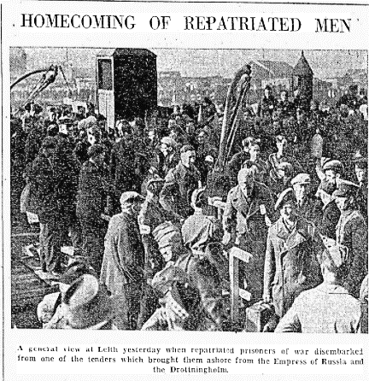  Home from Germany – Monday’s arrival at Leith of wounded prisoners of war from Germany produced remarkable scenes of rejoicing. Most of the men had been seriously wounded or were in other ways no longer fit for war service.  Stirring scenes were presented at the docks as each of the tenders came up the harbour. Piers and jetties were crowded with thousands of dock workers and other people and while cheering resounded through the area, the ex-prisoners and the spectators waved to each other excitedly. The strains of the KOSB pipes were heard, followed by the playing of popular airs by the band of the HLI and everyone seemed determined to eclipse any previous records in the matter of enthusiastic receptions. As soon as the men had had some refreshment at the docks they were taken to trains, ambulances or buses to hospitals or rest centres, where withing the next day or two they will be medically examined and the, if their condition permits, they will be sent home on leave for 28 days
Poppy Day | Linlithgow Gazette 5th November 1943  Saturday is Poppy Day;-  Once more the Flanders poppies red  Remind us of our glorious dead  Who fought to give us liberty  And rid the world of slavery,  From slavery to false faiths and creeds  They, sought to save us by their deed  Keep faith with them, it is their due  To bear the torch they handed you.
Christmas Delivery | West Lothian Courier 5th November 1943  The Postmaster-General announces that to secure the best chance of delivery before Christmas, letters to be sent by air mail to British prisoners of war and civilian internees in German hands should be posted as soon as possible and in any case, not later than November 12. The special air mail letter cards for prisoners of war, sold at Post Officers, price 3d each, should preferably be used.  As previously announced, Christmas and New Year greetings cards or calendars may not be sent to prisoners of war and civilian internees in enemy hands, but it is important not to send additional letters during the Christmas season in place of greetings cards.
Stoneyburn Children’s Party | West Lothian Courier 31st December 1943  Stoneyburn Children’s Party – the wives and children of soldiers in HM Services had their Christmas party under the auspices of War Charities Association in the ARP Hall on Saturday afternoon. The Hall was beautifully decorated for the occasion and the arrangements were carried through by Mr Moore, President and a committee of ladies, including Miss Paton, Secretary. After a splendid tea had been enjoyed, purveyed by the local baker, Mr Yuill, a programme of songs, dances, games etc was carried through by the children. The music for the dances etc, was played by the Locarno Band. Each child received the sum of 3s before going home.
Stoneyburn WVS Social | West Lothian Courier 31st December 1943  Stoneyburn WVS Social – The member of the WVS and friends met in a social capacity in the ARP Hall on Thursday night, when approximately 100 sat down to a knife and fork tea, presided over by Mrs Haggerty. Mrs Haggerty extended a welcome to all present and said they had as an honoured guest Sgt Samuel Menzies, accompanied by his wife, who was home on leave from the Middle East. A choir of WVS members sang several Christmas numbers and songs were rendered by Miss Dodson, Sgt Menzies and Mr Haggerty while Mr and Mrs Haggerty sang a duet. Miss Yeardley gave several readings. An address on the work of the WVS was given by Dr sherry. A dance followed to music supplied by the Locarno Band, when the duties of MC were capably carried out by Dr Sherry. Pte Timmons, another Middle East soldier home on leave with his wife came in during the evening. The singing of the National Anthem brought a pleasant evening to a close.
Salute the Soldier Campaign   | West Lothian Courier 28th January 1944  The “Salute the Soldier” Savings Campaign for 1944 has been decided will take place from June 3rd to 10th. The county target has also been fixed at £300,000. I suppose the county will be expected to double the target, as in former years. If that is to be accomplished we must all make a greater effort on this occasion. “Help our soldiers in the Field” will make a popular appeal at a time when the battle will most likely be reaching its climax and the sacrifices of our men will be great in the sight of all men. I believe the people of the county will rise to the occasion and show their gratitude in the practical manner desired.  West Lothian Courier 19th May 1944  Stoneyburn Salute the Soldier Campaign – Arrangements for Salute the Soldier Week are almost complete, and it is expected that the local target of £10,000 will be attained. There is promise of support from firms and individuals, but in the final effort the savings of small subscribers will be welcome and necessary. The district secretary, Mr Tully has arranged for a parade of military and Civil defence services, Cadets, ATC, WVS and youth organisations. In addition a detachment of the ATS will be present. The inspectrion will be carried out and the salute taken by Col Blair CBE, DSO who has kindly accepted an invitation to be present for that purpose.  West Lothian Courier 19th May 1944  Message from the Commander 51st Highland Division – Major General Wimberley, the late Commander of the 51st Highland Division sends the following message in support of the “Salute the Soldier” Campaign;-  “What could these men have done had they not even given the means with which to fight and the knowledge that there was a full cupbaord behind them from which to replenish. They could have done nothing – Modern war is expensive in the manuafacture, production and expentidature of equipment and weapons. Yet if we are to fight successfully, and fight successfully we will, we must have the sinews of war.  By saving money and lending these savings to the Nation, we help to provide our Fighting Service with machines, weapons, tools and muntions of war  For these reasons and there a host of others, I call upon you, the people of Scotland, to save your money and to lend it to his Majesty’s Government in the same generous way as Scotland has sent her sons to fight the King’s enemies.”  West Lothian Courier 26th May 1944  Salute the Soldier by A M Bisset  Where’er you be – across the sea,  Or Britain’s shores defending –  Our prayers for you, brave heart and true  Are night and day ascending  You blaze the way to victory  That no power can dispute you  The tyrant for your might shall know  So soldier, we salute you.  Through shot and shell in war’s wide hell  Danger and death disdaining  In lovely post on far flung coast  Untiring watch maintaining  The mountains steep, the jungles deep  Your valour makes all suit you  To proved your worth o’er all the earth  Brave Soldier, we salute you  Although ‘tis all return too small  For deeps of dauntless daring  Of nights and days of bloody frays  And hardships past comparing  For all you’ve done we’ve vowed each one  A fund to institute you  Commerorative, and give, give, give  With proud hearts to salute you.  West Lothian Courier 2nd June 1944  County and District Targets – The targets for the various districts is as follows;  Armadale 25,661  Blackridge 8,004  Westfield 2,257  Blackburn and Seafield 7,483  Livingston Station 5,415  Torphichen 1,882  Bo’ness 50,405  Broxburn 25,681  Uphall 15,279  South Queensferry 13,157  Winchburgh 10,134  Kirkliston 4,634  Whitburn 43,000  Fauldhouse 21,811  Stoneyburn 9,769  Bathgate’s original target was £47,622, now increased to £100,000  Linlithgow and District Target as originally 29,306, now increased to £20,000.  The large incestments promised now total almost this amount. The target for the county has accordingly been increased to £600,000
Good Work by ATS Girls | West Lothian Courier 4th February 1944  Good work by ATS Girls – it is revealed that 212,000 women are now serving in the ATS, recruiting for which has recently started again. Of these, nearly a third are “tradeswomen” who have qualified in a skilled trade and who are replacing or supplementing soldier craftsmen. Altogether there are 30 trades in the ATS. Many men of the Pay Corps and the RAOC have been replaced by women. There are now over 30,000 women engaged on clerical duties and keeping records of servicemen in various record offices. In order to keep in touch with overseas theatres of war and man vital communications, 4000 switchboard operators are helping the Royal Corps of Signals. In addition, there are 3000 women teleprinter operators and 9000 technical store women. They depend upon 4000 ATS cooks for their food. In the middle East, girls of the ATS are working with Jewish and Arab girls and maintain contact with the Polish women’s Service contingent which has been formed there. Besides the Middle East Station, there are over 200 ATS stationed in East Africa command. In the US it is disclosed 100 of the girls are working with the British Army Staff.
Salvage Roundup | West Lothian Courier 26th February 1943  The Value of Bones – of the bones that leave butchers’ shops, 50,000 tons are still being wasted annually by householders says the Ministry of Supply, announcing a 12 per cent decrease in the amount collected by local authorities during December.  Bones supply a valuable raw material for making glycerine – the basis of many explosives. They provided lubricating oil, camouflage paint, fertiliser for crops and feeding stuffs for pigs and poultry.  West Lothian Courier 17th March 1944  Salvage By Special Courier – thanks to the indomitable spirit of factory workers and to the zeal of housewives in providing raw materials through salvage, a formidable arsenal of offensive weapons has been established in this country. The great nationwide Salvage Round-up which is being carried out by local authorities with the help of the WVS during March is opportune and supremely vital. Housewives are being asked during this spring cleaning season to make a special search in cupboards, attics, lots, glory holes and drawers for all material that is good for salvage. Especially are paper cardboard, and rags needed, while the regular collection of bones must go on. Housewives who have done so fine a job in helping to establish the arsenal must now to the consummating task of proving replacements. They will not fail.  Linlithgow Gazette 16th July 1943  Housewives fire 20,000 AA Shells – the total number of bones collected from the households of Britain by Local Authorities since the beginning of the war is 35,806 tons. These bones yield;- 3580 tons of grease used in making sufficient cordite to fire 20,000 3.7 AS shells, plus 200 broadsides from a battleship’s 15in buns; 5370 tons of glue used in the manufacture of tanks, buns, shells, ships, camouflage, 1790 tons of feeding meal and bone meal to feed to 68000 pigs from birth till bacon-time. 16,110 tons of fertilizer for producing 1296, 000 tons of potatoes or wheat for 160,000,000 loaves. Impressive as these figures are the Supply Ministry state that there is still a serious loss of bones every year through being burnt, buried or thrown away. For this reason we having to employ valuable shipping space to import bones from India, the Argentine and elsewhere Every meat, game or poultry bone no matter how small should be given for salvage. Every bone if 100 per cent utilisable.  Linlithgow Gazette 29th April 1944  Why Fighters can Fly Farther – Bones are Needed to make Glue for Petrol Tanks – fighters and fighter bombers are playing an ever increasing part in the air war, flying large numbers of offensive sorties, escorting heavy bombers and providing an umbrella for land and sea forces engaged in operations in all parts of the world  Many of these long distance flying feats are made possible by extra petrol tanks which can be discarded if necessary, when the fuel in them has been used. They are made from special paper and need large quantities of glue in their manufacture.  HOUSEWIVES PART  For example, 18lb of glue goes into the construction of each 90 gallon tank which is fitted to a Thunderbolt – the glue from 4 tons of bones being required for each 120 tanks. Typhoons carry a smaller 45 gallon tank which requires 10 or 11lbs of glue  This is where housewives can play a big part. Every bone from meat, game or poultry should be used for salvage.  One chop-bone or its equivalent, from every household in the country would provide glue for 25,000 supplementary fuel tanks for Typhoons. The same quantity of bone from every person in the country would bring the figure up to 90,000.
Woman Land Workers | Linlithgow Gazette 14th April 1944  Women Land workers Honoured – Before the sale commenced badges for long and good service were presented to the following members of the Women’s Land Army:- four years’ service, Magdalene Allingham, Brunton Farm, Torphichen, and Agnes Reid, Cramond Brig Farm, Barnton.  Three years’ service – D Baillie, Barn House, Whitburn, and Mr Clark Moss-side, Bathgate. Two and a half years’ service, Jane Lindsay, Hillend, Winchburgh and R L Stutt, West Westerton, Blackridge. Two years’ service, L D Blues, Mosslea, Bathgate, H E Wade, West Westerton and M Lindsay Glendevon . One and half years’ service, C Sharp, Houston House, Uphall and E H Bell, Glendevon. One years’ service, M Connelly, Springfield, Armadale. Six months service, Hazel Arthur, Dalmeny Estate, A Boag Glendevon and I McLaughlan, Foxhall.
Work In POW Camps | Linlithgow Gazette 14th April 1944  Work in Prisoners of War Camps – referring to prisoners of war, Mr Kaye said the work of the Red Cross and the International YMCA dovetailed. Their offices were on opposite sides of the street at Geneva. There was no overlapping in their work, and they helped each other. Personal contact was made with prisoners and the hand of friendship meant more to prisoners that anything else. Some idea of what was done for them could be got from what was done for enemy prisoners in this country. Eighteen thousand Italian prisoners were found to be illiterate. War Officer permission was got to train 2000 of them as teachers and send them back to their camps to train the others. Today the number of illiterates was down to 1000.
Snowballing in East Africa | Linlithgow Gazette 21st April 1944  East Africans Enjoy snowballing – there is a small supply crisis in one region of the Middle East where snow has fallen recently and where East African Askari are now stationed. The Africans have never seen snow before and the demand for photographs of themselves sitting in the snow has completely swamped all sources of supply. A correspondent says the Askari were at first dismayed at the heavy fall of snow, but when their British officers and NOCO’s introduced them to snowballing, the soon lost their distaste for it. They became so proficient at the new game “mecheza” that they beat their junior officers in the pitched battle and completely routed men of the RASC who had challenged them.
1939-43 Star for POW’s | Linlithgow Gazette 2nd June 1944  1939-43 Star for POW – Mr Mather’s Question in Parliament – in the House of Commons last week Mr Mathers asked the Secretary of State for War the position as to the award of the ribbon of the 1939-43 Star to prisoners of war entitled to received it who are still in enemy hands; and will the ribbon be awarded in the same way to those who were captured at Dunkirk, St Valery etc, as it has been to those who got away.  Sir James Frigg, Individuals who took part in the operations in France at time between 10th May and 19th June 1940 are eligible for the 1939-43 Star. The question of sending the ribbon to prisoners in enemy hands is under consideration.
Polish Army | Linlithgow Gazette 2nd June 1944  Polish Army in Italy – the Polish Army now fighting in Italy under the name of the 2nd Army Corps is commanded by General Anders. Two divisions from this army, the Carpathian (Highland) and Kresowa (Border) took part in an attack on Cassino and Monastery Hill. The Polish Army was transferred from Palestine to Italy at the end of last year. This army is composed mostly of Polish refugees released from Russia in 1943. From 1000,000 men women and children, about 50,000 of these were incorporated in the new army they were trained by officers and men of the Carpathian Brigade, which was transferred from Tobruk after it’s liberation. Some officers and men of the 2nd Army Corps were sent out from Scotland. Many of these men are married to Scottish girls. The fight before Cassino was the most bloody on the whole front. The Poles suffered the heaviest losses of all the Allied Forces. However, they destroyed the flower of the German Army, the famous Paratroops division. This was the first time that the Pols had met the Germans on an equal footing thanks to the British and American equipment.  Linlithgow Gazette 18th August 1944  Poles from Britain – In Action Again in Normandy -the Polish Army trained in Britain, whose black should strap was a familiar sight in many a Scottish burgh or village has at last attained it’s heart’s desire. It has gone into action and since August the 8th is fighting in Normandy.  Shoulder to shoulder with the Canadian armour they roll into the German lines towards Falaise, forming part of the great encircling movement with which the Allied tank columns threaten to destroy or capture some 20 crack German divisions (approximately 200,000) men south west of Caen.  The sector on which the Poles are fighting is one of the toughest German positions in Normandy where the United Kingdom and Canadian troops have been fighting for may days against suborn opposition.  The Pole are proud to be put in such glorious company – here they feel that grant things can be done. Most of the men of this division which is composed of more than 7000 Poles who had fought in Poland in 1939 and more that 5000 from Russia and the Middle East and other Poles from almost all countries of the world, came to France. They fought actions covering the French retreat near Paris, and when France collapsed, they escaped again, some directly across the Channel. Some through North Africa or Spain where may spent months in internment.  Re-Organised in Scotland  The Division was reorganised in Scotland in 1942 and trained there for two years. During training the Poles became known as one of the finest armoured units in the British isles in competitive manoeuvres with other armoured groups.  It is commanded by General S Maczek, a dynamic military figure who commanded the only Polish armoured division in existence when the Germans invaded Poland.  In the BUP War Correspondent Ronald Clark’s own words; A little more than a day after their first actions stories of the Poles fighting ability are beginning to circulate among the Canadians a German filled wood was about to be attacked by a British unit, and the artillery tanks and infantry were all keyed up for what was about to be a sizeable attack.  A Polish Recce unit was sent out to obtain the latest information. They entered the wood, swept from one side to the other, and captured the feature before the attack started.  A second episode was when a Polish commander asked for the support of fairly heavy artillery before attacking one objective. Because of the exigencies of the situation no artillery could be laid on. “it does not matter, we will take it just the same,” the commander said. They did!
Rommel Badly Wounded | Linlithgow Gazette 4th August, 1944  Rommel Said to be Wounded – Rommel is seriously wounded, according to a captured German officer, Bill Downs, CBS commentator, broadcasting from Normandy on Sunday said that according to the German officer supposed to have been on the staff of the commander of the German Second Panzer Division, Rommel was in his headquarters at Lisieux near Caen when Allied bombers attacked the town. The headquarters were hit, and the German Field Marshall seriously wounded
The Cameron’s In Normandy | Linlithgow Gazette 18th August 1944  The Camerons in Normandy – the Cameron Highlanders have been fighting in Normandy since the earliest phase of the campaign. They were landed east of Arromaches, shortly after D Day and make their way to the left flank of the British line. By the 10th June they were in the Fontaine Henry area and were soon engaged in driving forward to capture high ground to the east in the direction of the well wooded village of Cambes on the road leading from the Caen Canal to Courseuiles.  Their formation lost no time in pressing home their advantage. By the 13th June, they had crossed the Caen Canal and the Orne and were heavily engaged at Chardonnerette, the nearest village to Caucelles on the road running north east from the town.  Bitter fighting was prolonged in this area and on the 23rd July the Camerons helped to capture Chardonnerette a gain of such importance that they were subjected to repeated powerful counter attacks during the next two days. In one of these actions the enemy used a large force of armour and no less than 15 of his tanks were destroyed.  The Camerons remained in the line during July and is the assault that developed on the 18th of the month took part in the attack which resulted in the capture of an important crossroads in the Bois de Bavent.
On Leave in the Holy Land | West Lothian Courier 25th August 1944  On Leave in the Holy Land – By West Lothian Soldier  Although home leave is forour boys in North Africa a thing difficult or impossible, a week in Palestine has been a not unacceptable substitute and many of the heroes of Norway and Tobruk and Alamein have availed themselves of the opportunity to visit scenes replete with significant history and hallowed associations. Here are some passsages from an account of a leave in the Holy Land as given by one of our West Lothian boys. He writes:-  On the journey as darkness came down passengers sprawled in cold attitudes on the hard wooden seats or even the floor of the carriages in vain attempts at sleep; but what of it? We were all going on leave. Wakeful, as dawn broke, the sun peeped over the horizon and I had my first impression of Palestine. Acres and acres of orange groves stretching on each side of the railway. It seems a land of green trees, after long months in Egpt and Cyrenaica, a welcome sight. Hedges of pricky pear and tall cypress divide the orange groves and serve as windbreaks to protect the developing fruit. The prickly pear fruit was ripe and showed brown and yellow among the thick fleshy leaves. Pleasant eating when you have learned to deal with the spins with which the skin of the pear is covered, and to be had for the picking in many places in Egpt and Palestine.  Detrained at Tel Aviv, we found it one of the modern of cities with fine, white building and broad streets with promenades, the blue water of the Mediaterranean washing its shotes. Adjoining the city is the small port of Jaffa – the “Joppa” of the Bible where the site of the house of Simon, the Tanner may be seen (Acts x 6). The official languages in el Aviv are Arabic, Hebrew and English, and many of the people speak two or even four or five languages, so that one is never at a loss to make oneself understood. It is an interesting experience to sit at one of the little open-air cafes and listen to the bable of strange tongues and watch the people in gay summer dress, sipping their iced drinks. The Tel Avivians claim incidentally to be the hardest drinkers of soft drinks in the world, and I can well believe it.  In the land of Fruit  From Tel Aviv the journey to Jesusalem was by road. In the days of Turkish rule this road was the haunt of highway robbers. Pilgrims on their way to the shrine were robbed outright or made to pay toll. Though the robberts have been suppressed there remain mementoes of those bad old days in the tin forts in which soldiers were quarted, which occupy rising grounds along the road. Orange and grape fruit groves and vineyards border the way and it is a common sight to see the watchman on a platform set of four high posts and canopied with branches and grass for protection from the sun, guarding the grapes from depradation. The county is in sharp contrast to the flat, uninteresting paddy fields of Egypt. In Palestine modern irrigation engines are used, in Egypt the ox-driven irrigation wheel or the Acrchimedeas wheel for the most part.  At Jerusalem  Jerusalem was reached fairly early in the forenoon, and my first real view of the city was from the top of Mount Scopas. The coach took me right to the top for the roads are very good here and the hill is not really steep. There, spread out before me was the City on the Hill with all its towers and minarets, domes and spires, and the old city wall prominent in the foreground. It is an impressive sight this city which is so steeped in history of mankind. I viewed it long and had pointed out to me many of its famous landmarks such as The dome of the rock, which is built on the site of Solomon’s temple; the Golden Gate, through which Christ passed many times, one of them the time when his path was strewn with palms. But the Golden Gate has been walled up by the Moselms in fear of Christ’s second coming. The long bare valley between Mount Scopus and Jerusalem is the Valley of Cedron and legend has it that it was in this valley that David met and defeated Goliath so long ago.  I crossed over to the eastern side of Mount Scopus and there spread out before me were miles and miles of bare hilly country as far as the eye could reach. Away on the horizon, barely visible through the haze were the Mountains of Moab and further south a long narrow shining ribbon peeping from the valleys was the River Jordon. Far away to the south a corner of the Dead Sea could just be seen between the hills. The wilderness before me was the Judean Desert in which Christ himself had wandered in the long ago. Nearby, and seemingly only a stone throw away, stood the Mount of Olives, and below it the Garden of Gethsemene. There is little doubt that I was looking on a scene which remains today much as it was nearly two thousand years ago – a sight which must have been famliar to the multitude which crowded upon Olivet in New Testament days.  In the Garden of Gethsemane  I visited the Garden of Gethsemane where a beautiful modern church stands – The Church of All Nations. It has tweleve domes and each has been dedicated by a particular nation. I went inside and saw the huge flat rock upon which Christ is said to have spent some of his last hours. Three magnificent paintings cover one wall. They are by Italian painters and depict familiar New Testament scenes.  On leaving the church, I was presented with two leaves from the olive trees which grow in the garden. These trees are certainly very old, and it is said that they might possibly have existed in Christ’s time. Even if they did not, it is at least reasonable to suppost that they are offsprings of the original olive trees.  My next excusrion took me to the town of Bethlehem which lies about five and a half miles south of Jerusalem. The road passed the ancient tomb of Rachel which I was allowd to enter. A few people were at prayer standing round the tomb itself.  In Bethlehem’s Holy City  Rachel’s tomb is revered by Christians, Jews and Moslems alike. Then on to Bethleham over the same way taken by the Three Wise Men as they followed the Star. A flock of sheep crossed the roadway and climed nimbly up one of the slopes followed by the shepherd who was dressed much as our childood picture has told us. It rather remined me of the Christmas hymn, “When humble shepherds watch their Flocks on Bethlehem’s Plains by Night..” Here was I looking across these same plains. I understand that on Christmas Eve hundreds of pilgrims travel this road singing carols on their way to the Church at Bethlehem. I should like very much to have heard them for it must be an impressive experience. Soon the Church at Bethlehem was reached, it is known as the “Church of the Nativity” and was originally built by Constantine in the year 330, but of course it has been much repaired and altered through the centuries. I entered through the tiny door which is so small that one has to stoop. I was first shown a small section of the original mosaic floor which is a foot or so below the leverl of the present floor. The mosaics of the old and new floors are almost identical. My guide then led me to the table itself. Here a silver star set into the floor is said to mark the actual birth place of Christ. It is surrounded by burning lamps with their candle like flames flickering in the dim light. Just a few yards from the Star is the manger in which the child was laid. It is now almost competely covered in marble, but I was able to touch a rough stone which lies across the manger and which is said to be in the same position as it was on that first Christmas Day. I felt my visit to this church a most impressive and certainly never to be forgotten experience. Here there seemed to be an indefinable atmosphere which seemed to be lacking in the any of the churches which I visited later. I passed out into the Courtyard where, on Christmas Eve, carols are sung in English. High above in the Tower I could see the Bells of Bethlehem which are broadcast to the world each Christmastide.  A little later I strolled thorugh the streets of Bethlehem and watched the strange crowds. The floiwng native dresses seemed all prt of the scene, but there was the usual strange mixture of the ancient and modern. Laden donkeys stepped among the modern motor cars and European dresses mixed with the robes of the natives.  On the Way to Calvary  Soon I was on my way back to Jerusalem and the first stop was made at the traditional site of Pilate’s Judgement Hall where Christ was condemned and outside of which he was given his Cross and began the awful journey to Calvary. My guide led me along the route which is supposed to have been taken by the crucifixion procession. It is known as the “Via Dolorosa” of “The Way of Suffering.” The various “Stations of the Cross” were pointed out to me. They are marked by tablets set in the walls and at each one a particular incident is supposed to have taken place. The Via Delorosa runs partly through the native suks or bazaars which form a long, narrow alley with open stalls piled with fruits and vegetables and goods of all kinds. Workshops there are, too, where one may see shoes and sandals actually being made in the open street. I think everything is sold in this market from the most ancient to the most modern of commodities. A water carrier with a bulging goatskin slung on his back passed on his way, the water dripping from the skin which seemed to be almost in it natural state, complete with four sewn-uo legs. The aroma from the spice and grain shops was almost overpowering and I confess that I hurried past them. So on I was led until the way was barred by a Greek convent which is built over the Eighth “Station” of the Cross. From here I proceeded to….  The “Church of the Holy Sepulchre“  Which is said to cover the actual site of Calvary and to contain the Holy Sepulchre itself. There has been much conroversy in recent times as to whether this is the true site, there is another which was discovered by General Gordon during the last war and, though time did not permit of a visit, descriptions and pictures certainly paint a more convincing picture than the impression I got from this Church. The Church of the Holy Sepulchre was badly damaged by an earthquake in 1927, and British Engineers have shored up the walls inside and out so that perhaps one’s first impression is rather disappointing. I entered and had pointed out to me the supposed site of the crucifixion and the sepulchre which I was not allowed to enter as repairs are still being carried out. Not far from the sepulchre is a flat slab of polished stone which is said to have been the stone on which the body of Christ was annointed before being placed in the tomb. But the fact that this is perhaps not at all the true site of Calvary and the Sepulchre rather detracts from the impression one would otherwise have gained. The same church contains millions of pounds worth of gold and jewellery – the gifts of mamy pilgrims throughout the years. But one cannot help but feel that so much wealth might be better applied to the furthering of Christiantiy of the alleviation of some of the poverty and suffering which is all too rife in the world today, and particularly so in the Middle East.  Jewels and God worth Millions  To give one instance, I saw two million pounds worth of jewels and gold in the form of necklaces, bangles, rings and brooches clustered most inartistically on a very dusty effigy of the Virgin Mary. In very many of the churches I visited one had the feeling tht advantage was being taken of visitors to extract from them as much money as possible and it seems a great pity that these places should have become commercialised as they so obviously have. One cannot help but recall the incident when Christ cast out the money changers from the Temple.  Later I paid a visit to the Pool of Bethesda where Christ cured the men who lay waiting on the angel to trouble the waters. One of the original colonades stands just outside the entrance with many fragments of other columns and pillars. Excavations are still going on and I was able to walk down the original steps to the pool itself and dip my fingers in the rain water which now fills it instead of the mineral waters of two thousand years ago. It was rather an awesome thought to recall that Christ himself had most probably trod those same steps.  The Wailing Wall  The Jewish Wailing Wall was the last place of interest I found time to visit. This wall is said to contain many of the original stones of Solomon’s temple and it is a place sacred to the Jews particularly, who congregate here and set up a tremendous wailing as they pray for something they want very much. Here I saw a woman teaching a very pretty little girl of five or six how to wail. She was dressed just like any small girl at home, but she was much more interested in the men in uniform than in wailing.  And so my visit to Jerusalem ended, and soon I was being carried along the modern highway to Tel Aviv with the sun sinking behind the rocky hills. It was a emorable visit, and much of it can never be forgotten. The ancient seem to rub shoulders with the modern in present day Jerusalem, though much remains as it has been for centuries. I thought it rather amusing to get the “V” for Victory sign from a small urchin standing in a dim alleyway in the Via Dolorosa, but I think that, that incident typifies present day Jerusalem; they are abreast of the times, and yet, in many respects their ways remain those of their forefathers.
51st Highland Division Returns to St Valery | Linlithgow Gazette 8th September 1944  The 51st Highland Division – Returns to St Valery – The 51st Division has taken St Valery-en-Caux. Thus, have the Highlanders wreaked a consummate vengeance for June 12th 1940, when at St Valery, the last fragments of the original Division since reconstituted into the present redoubtable formation laid down their arms and marched past their leader General Victor Fortune in the rain.  That original division went down fighting to the bitter end. It did not surrender until it had left its dead in every Norman field from the Somme to the little river Durdent from the Cambron Woods to the trees ringing the cemetery where the Black Watch stood at last at bay. The divisional artillery had not a round of ammunition left, and the formation was reduced to a few companies of exhausted riflemen with Bren guns in support surrounded by vastly superior enemy forces with artillery, armour and abundance of mortars and machine guns  The reconstituted 51st Division began to take its revenge in October 1942. It played a unsurpassed part in the victory at El Alamein in the pursuit across the desert in the smashing of the Mareth line, the storming of Wadi Akarit, and in the final actions of the campaign.  Later the Highlanders fought in Sicily, sharing in the severe fighting in the Dittaino area and capturing Biancavilla and Castiglione before the enemy surrendered.  From the early days of the Normandy campaign the Highlanders were in action on the left of the British Line. At St Honorine where one brigade destroyed 15 tanks in a single day, in the hard fighting in the Cotombelles area and in many fated actions as our left flank bulged and burst forth to overrun great enemy forces in the East, the 51st Division has upheld its noble traditions. Today it has crowed all with the capture of St Valery.
Canadian Forces | Linlithgow Gazette 29th September 1944  RCAF and Allied victory – Air Marshal Breadner, air officer commanding the RCAF Overseas, gave some figures on his recent return to Ottawa to illustrate the role of the RCAF in the Allied avalanche in Western Europe. The air marshal in disclosing that RCAF bombers are operating day and night from British bases said that RCAF Bomber Group established a new bomber command record during august flying 3,700 sorties and dropping 13000 tons of bombs. Mentioning the air victory of August 18, Air Marshall Breadner said Fighter Bomber Group of the Second Tactical Air Force, composed largely of Canadian wings, destroyed 1000 German vehicles in retreat, damaged another 1900 and destroyed or damaged 160 tanks. The Canadian pilots did this while leap-frogging across France closely supporting the British Second Army.  Linlithgow Gazette 20th October 1944  Canadians Accurate Gunning – during the recent breakthrough of the Gothic Line by Canadians in Italy says a Defence headquarters release the Loyal Edmonton Regiment was held up by a strongly defended church with a high spire serving as an observation post for Germans. The thin spire was difficult target for field artillery but not the 17 pounder anti-tank gun crew of L/Sgt Maurice McLaughlin, Oromocto NB. Ten accurately placed rounds on the target brought the tower crashing on the heads of the German defenders. Later the ground floor of the church was captured y infantry. The gun belonged to a composite troop under command of Lieut John T Wimble, Nova Scotia.
Air Attacks on Scotland | Linlithgow Gazette 20th October 1944  The official pronouncement regarding enemy air attacks on Scotland during the period 16th October 1939, to 29th February 1944, given us good cause to be thankful, and when compare our lot with that of places south of the Border we can well believe there is something in the saying “Scot free.”  For the SE district which comprises Edinburgh , Mid, East, and West Lothian, Selkirk, Peebles and Berwickshire, the official figures for the period are 634 high explosives and 17 parachute mines dropped. Damage was not considerable, though one attack resulted in a whisky store being gutted. Twenty nine people were killed, 59 were injured and detained in hospital and 190 were slightly injured. The last raid was on the Craigentinny district of Edinburgh on 6th August, 1942. The only town or village to be bombed in West Lothian was Broxburn, which was attacked on the night of 25th 26th June 1940. Edinburgh was raided on 12 occasions.
Hallowe’en in India | Linlithgow Gazette 29th December 1944  Hallowe’en in India – when one thousand Scotsmen perhaps in an optimistic frame of mind sing “Loch Lomond” it makes a lot of noise. In fact, several Scots who were in the New Empire Cinema in Calcutta on November 6th say that they saw the roof lift three inches. It was the Calcutta Burns Club’s 15th Annual Halloween concert and about £1000 was raised for Scottish Regimental charities. Services entertainers were well to the fore. There were two comedians, Sgt Jimmy Cruden of Glasgow the Black Watch and now ENSA and Sgt Jock Thomson of Dumfries, the Royal Engineers and now ENSA, just returned from the forward areas which he toured with The Mosquitos, show. Sgt John Coates who used to sing with the BBC Scottish Orchestra, Sgt Jock Brown whose accordion led the singing, and another community singing expert Major Andy Gemmell of the Presidency Battalion, Auxiliary Forces (India). After the concert there was a dance for which the Bengal Artillery and Calcutta Scottish Pipe Bands played.
VE Day | West Lothian Courier 11th May 1945  VE Day Victory Day – Rejoicings in the County – The people of the county like other people all over the world, expected VE day to be announced on Monday and they were kept in a state of suspense all day hoping that “at any moment” the welcome announcement would be made, the citizens began to make their preparation for rejoicing and for leave off work for the Cease Fire Holidays, but in the afternoon when they learned that VE Day was not to be announced till 3pm on Tuesday excitement died down.  Everywhere in the County the great news of Germany’s unconditional surrender to the Allies was received with thankfulness and feelings of relief and the rejoicings were carried on for the most part on Tuesday and Wednesday with decorum and restraint becoming the situation. Street decorations were on a moderate scale and consisted chiefly of flags and bunting, few bonfires were lit, church services were held in many towns and villages at which large numbers attended joining in giving thanks to the Almighty God for his great deliverance. Bands in many places entertained the people whilst the picture houses and dance halls were full to overflowing.
VE Day Celebrations | West Lothian Courier 11th May 1945  Celebrations at Stoneyburn – the victory celebrations at Stoneyburn have been going on since VE Day. Dances have been held in the Welfare Hall nightly, and bonfires to all the various districts of Stoneyburn and Bents have been lit and more are to follow. At some of the bonfires the effigy of Hitler was seen hanging by the neck and there were great cheers when he was burned down and fell into the fire.
County Territorials Home | West Lothian Courier 18th May 1945  County Territorial Home – Enthusiastic Midnight Receptions  Enthusiastic scenes were witnessed in various towns and villages in West Lothian late on Friday night and into the early hours of Saturday morning, when men of the 14th (West Lothian) LAA Regiment Royal Artillery, returned home after four and a half years campaigning in the Egyptian, Libyan and Italian theatres of war. During its long period of service overseas the Regiment took part in the victorious operations in North Africa distinguishing itself particularly in the long siege and successful defence of Tobruk and latterly was engaged in the Italian campaign which led to the defeat and surrender of the German armies in that theatre.  The men to the number of 175, belonging to the 40th Bathgate Battery, 39th Linlithgow battery and the 57th South Queensferry battery arrived by train in Edinburgh about 11pm on Friday and were conveyed by special SMT buses to their respective destinations the numbers being made up as follows: - Bathgate 30, Linlithgow 23, South Queensferry 22, Broxburn and Uphall 20, Winchburgh and Niddry 19, Whitburn 15, Kirkliston,12, Bo’ness 11, Armadale 5, Newbridge 6, Fauldhouse 5, Torphichen, Blackburn, Stoneyburn 5, and Livingston station 2. The men who looked bronzed and fit stated that they were on a month’s leave. They said they had been given an official assurance that they would not be sent to Burma.



