Stoneyburn War Memorial WW1
Those Named On the War Memorial

2656 Pte James Allan  2/10th Btn Royal Scots | JAMES ALLAN  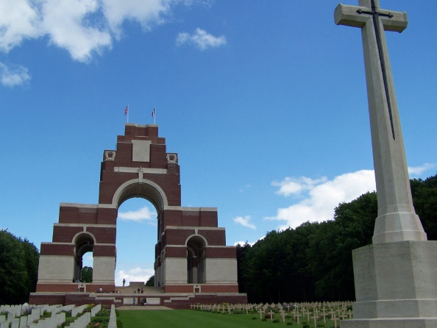  Era WW1  Surname ALLAN  Forename James  Rank Pte  Service number 2656  Decoration  Place of birth  Date of death 18 August 1916  Theatre of death F&F  Cause of death Killed in action  SNWM roll THE ROYAL SCOTS (LOTHIAN REGIMENT)  Unit name In or attached to THE ROYAL SCOTS  Other detail 2/10th Bn  Buried or commemorated at  THIEPVAL MEMORIAL Pier and Face 6 D and 7 D. France  Secondary Unit, Regiment  attd. 7th/8th Bn. King's Own Scottish Borderers  West Lothian Courier 6th October 1916  Stoneyburn Man Reported Missing – Information has been received by Mr John Allan, 56 Fifth Street Newtongrange (lately residing in Stoneyburn), that his brother Pte James Allan, Royal Scots (attached KOSB), who was reported missing is now reported killed in action. Before enlisting he was employed as a miner at Loganlea colliery.
620 Pte John Connell  Army Cyclist Corps formerly 6053 Royal Scots | JOHN CONNELL  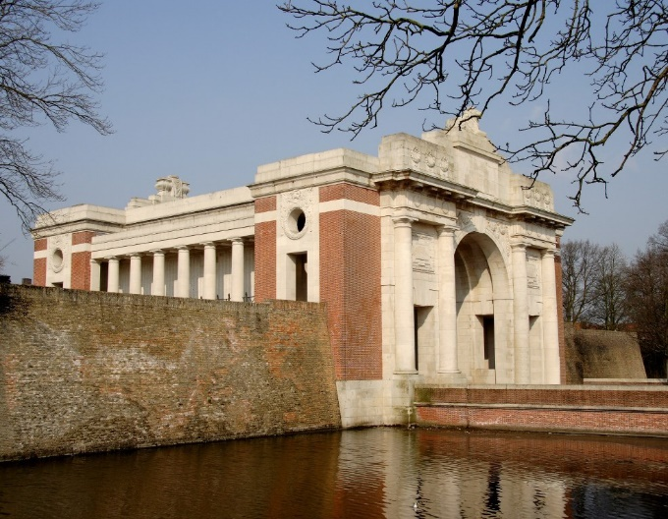  Era WW1  Surname CONNELL  Forename John  Rank Pte  Service number 620  Decoration  Place of birth Airdrie, Lanarkshire  Date of death 6 July 1915  Theatre of death F&F  Cause of death Killed in action  SNWM roll MISCELLANEOUS CYCLIST BATTALIONS  Unit name ARMY CYCLIST CORPS  Other detail formerly 6053 R. Scots.  First Name: John  Surname: Connell  Birth Town: Airdrie, Lanark  Resided Town: Fauldhouse, Linlithgowshire  Nationality: British  Date of Death: 06/07/1915  Fate: Killed in Action  Rank: Private Service Number: 620  Duty Location: France And Flanders  Service: British Army  Regiment: Army Cyclist Corps  Battalion: 4th Div Cyclist Coy  Buried or commemorated at  YPRES (MENIN GATE) MEMORIAL Panel 56. Belgium
William Thomson | WILLIAM THOMSON  Royal Scots – It’s been impossible to identify this man too many results none seem to be from this area. – No Newspaper reports to help.
5707 Sgt Thomas Walker MiD  Royal Scots  Latterly 307157  Royal Warwickshire Rgt  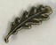 | THOMAS WALKER  Era WW1  Surname WALKER  Forename Thomas  Rank Sgt  Service number 5707  Decoration  Place of birth Whitburn Linlithgowshire  Date of death 6 September 1917  Theatre of death F&F  Cause of death Killed in action  SNWM roll THE ROYAL SCOTS (LOTHIAN REGIMENT)  Unit name In or attached to THE ROYAL SCOTS  Other detail latterly 307157 2/8th Bn The Royal Warwickshire Regt  Serjeant THOMAS WALKER  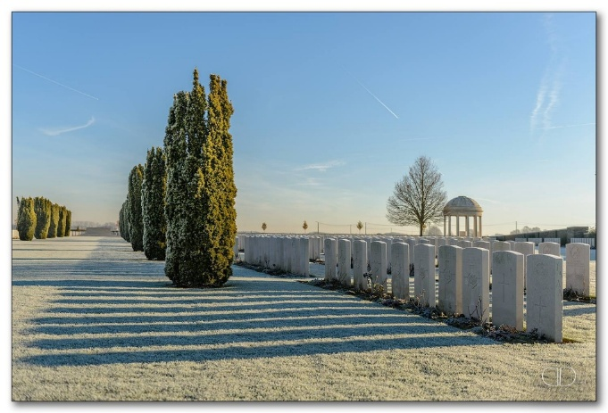  Service Number: 307157  Regiment & Unit/Ship  Royal Warwickshire Regiment  2nd/8th Bn.  Date of Death  Died 06 September 1917  Age 20 years old  Buried or commemorated at  BEDFORD HOUSE CEMETERY  Enclosure No.4 XIII. H. 10.  Belgium  Full Name Walker, T  Incident Details  War Office Daily List No.5394  Incident Date  19 Oct 1917  More Information  Entitled to wear a "Wound Stripe" as authorised under Army Order 204 of the 6th July 1916. The terms of this award being named on this list.  Rank Name  Sergeant  Service Number  307157  Casualty Listed As  Wounded and Missing  Next Of Kin Address Fauldhouse  Service British Army  Primary Unit Royal Warwickshire Regiment  Archive Reference NLS 1917_W List12  Conflict Period World War I  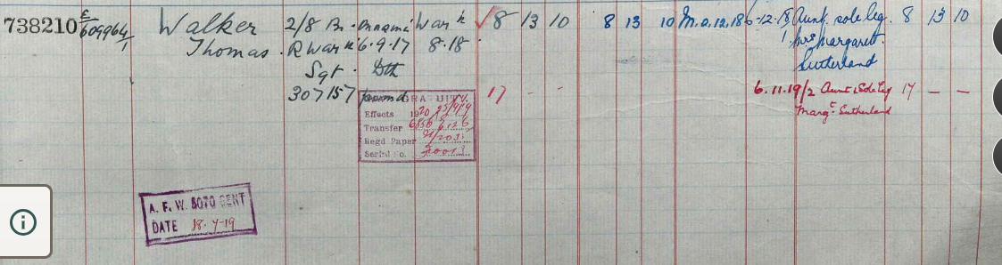  Served For United Kingdom  West Lothian Courier 6th September 1918  Stoneyburn Soldier Presumed Killed – Mrs Sutherland Dalziel Terrace, Stoneyburn, has received official notice that Sgt Thomas Walker, who has been missing since Sept of last year, is now presumed to have died at that time He joined the Royal Scots in 1914 and was stationed at Bathgate for some time. He was 16 months in France when he was posted missing. At the time he was posted missing he was recommended by his Captain for the DCM. Before joining up Sgt Walker was employed as a miner at Foulshiels Colliery. He was 29 years of age.
22410 Pte Samuel Warren  15th Btn Royal Scots | 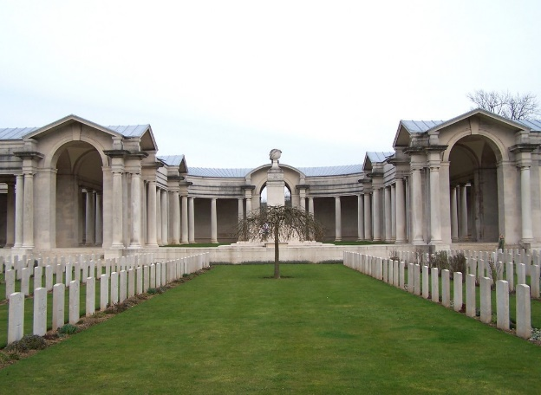  SAMUEL WARREN  Era WW1  Surname WARREN  Forename Samuel  Rank Pte  Service number 22410  Decoration  Place of birth Burnbank Lanarkshire  Date of death 28 April 1917  Theatre of death F&F  Cause of death Killed in action  SNWM roll THE ROYAL SCOTS (LOTHIAN REGIMENT)  Unit name In or attached to THE ROYAL SCOTS  Other detail 15th Bn.  Buried or commemorated at  ARRAS MEMORIAL Bay 9. France  West Lothian Courier 21st March 1918  Stoneyburn Soldier Killed – Mrs Vickers or Warren, 36 Stoneyburn, has received intimation that her son, Pte Samuel Warren, Royal Scots, reported missing on April 28th 1917, is now presumed to have been killed then.
8921 Pte William McGuire  1st Btn Queen’s Own Cameron Highlanders | WILLIAM MCGUIRE  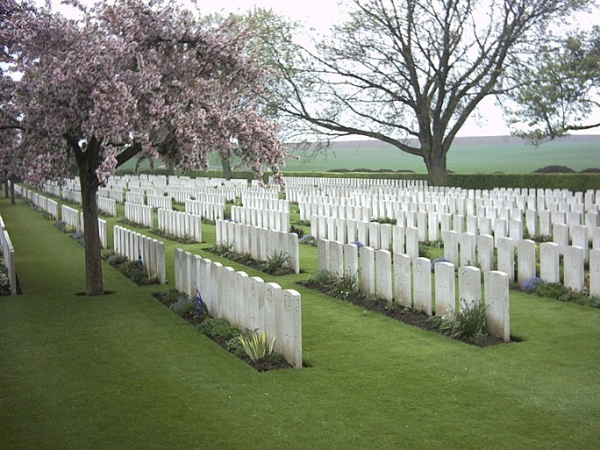  Era WW1  Surname McGUIRE  Forename William  Rank Pte  Service number 8921  Decoration  Place of birth Bathgate  Date of death 27 December 1916  Theatre of death F&F  Cause of death Killed in action  SNWM roll THE QUEEN'S OWN CAMERON HIGHLANDERS  Unit name In or attached to THE QUEEN'S OWN CAMERON HIGHLANDERS  Other detail 1st Bn.  Buried or commemorated at  WARLENCOURT BRITISH CEMETERY VII. E. 2. France
S/17701 Pte John Orr  5th Btn Queen’s Own Cameron Highlanders | 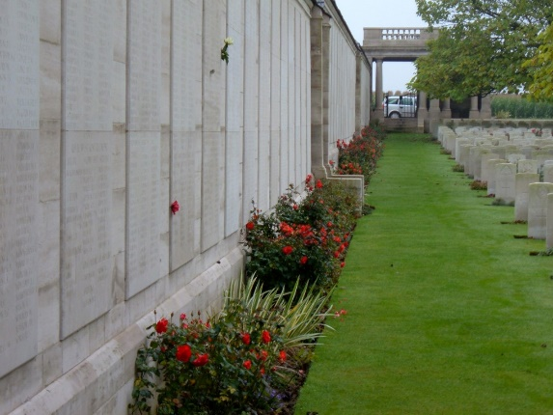  JOHN ORR  Era WW1  Surname ORR  Forename John  Rank Pte  Service number S/17701  Decoration  Place of birth Harthill Lanarkshire  Date of death 25 September 1915  Theatre of death F&F  Cause of death Killed in action  SNWM roll THE QUEEN'S OWN CAMERON HIGHLANDERS  Unit name In or attached to THE QUEEN'S OWN CAMERON HIGHLANDERS  Other detail 5th Bn.  Buried or commemorated at  LOOS MEMORIAL Panel 119 to 124. France  Country of Service United Kingdom  Additional Info Son of Agnes Orr, of 140, Stoneyburn, West Lothian, and the late James Orr.
9053 LCpl Robert Dougan  2nd Btn Seaforth Highlanders | ROBERT DOUGAN  Era WW1  Surname DOUGAN  Forename Robert  Rank L Cpl  Service number 9053  Decoration  Place of birth Bothwell Lanarkshire  Date of death 25 April 1915  Theatre of death F&F  Cause of death Killed in action  SNWM roll THE SEAFORTH HIGHLANDERS  Unit name In or attached to THE SEAFORTH HIGHLANDERS  Other detail 2nd Bn  Midlothian Advertiser 21st May, 1915.  Stoneyburn Soldier Killed in Action – Official information has been received of the death in action on the 20th April, while serving with the British Army in France, of Pte Robert Dougan, 2nd Btn Seaforth Highlanders. Pte Dougan, of whom the (photo) was a reservist, and was called up at the outbreak of war. He was among the first contingent of the British Expeditionary Force to land on French soil, and was in the famous retreat from Mons, and the subsequent battles of the Marne and the Aisne. He served nine years in India, five of which were experience on the North Western Frontier. He also took part in the now historic Zakkiakel and Mohmankel expeditions of 1908-09 for which he received medals. Pte Dougan was well respected in the village of Stoneyburn where he resided previous to the outbreak of war, and much sympathy is extended to his parents in their sad bereavement.  West Lothian Courier 28th May 1915  Pte Robert Dougan, 2nd Seaforth Highlanders is reported killed in action. He was a reservist and had been in the fighting line since the Battle of Mons. He resided in Stoneyburn before the outbreak of the war.
43094 LCpl Alexander Daly  1st Btn Royal Scots Fusiliers | 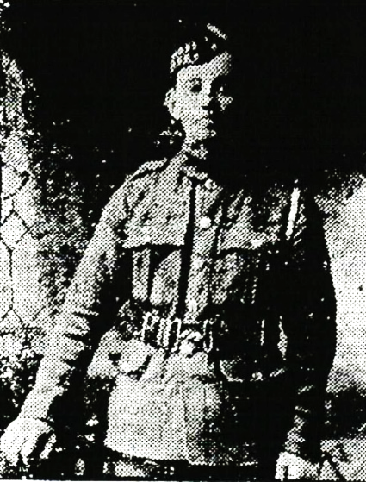  ALEXANDER DALY  Era WW1  Surname DAILY  Forename Alexander  Rank L Cpl  Service number 43094  Decoration  Place of birth West Calder Midlothian  Date of death 13 November 1916  Theatre of death F&F  Cause of death Killed in action  SNWM roll THE ROYAL SCOTS FUSILIERS  Unit name In or attached to THE ROYAL SCOTS FUSILIERS  Other detail 1st Bn.  Buried or commemorated at  SERRE ROAD CEMETERY No.1  I. B. 22. France  Commonwealth War Graves Commission  Country of Service United Kingdom  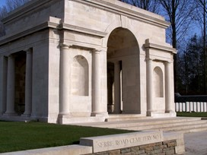  Additional Info Son of Mrs. Robert Daly, of 79, Stoneyburn, Fauldhouse, West Lothian.  Midlothian Advertiser 18th May 1917  Stoneyburn Soldier Killed - Mr Robert Daly, Stoneyburn has received official notice that his son Pte Alexander Daly of the Royal Scots, who was reported missing last November, is now presumed to have been killed in action. Deceased was a Territorial when war broke out and in civil life he worked at Foulshiels Colliery with United Collieries Ltd.  Midlothian Advertiser 9th November, 1917  Daly – In loving memory of our dearly beloved brother L/Cpl Alexander Daly, Royal Scots Fusiliers, killed in action at Arras, 13th November, 1916, also our dearly beloved cousin, killed in action at Loos 25th September, 1915.  No mother or father saw them die,  No brother or sister to say goodbye  No friend of relations to clasp their hands,  But we hope to meet them in a better land  The hardest part is yet to come  When the warriors return  And we look among the cheering crowd  For the face of our loved ones  Inserted by his sister Lizzie, and brother in law on active service, Mr & Mrs James Orr, 64 Stoneyburn.  Daly – In loving memory of my dearest sweetheart L/Cpl Alexander Daly, Royal Scots Fusiliers killed in action at Arras on the 13th November, 1916 aged 23 years.  For many years our friendly chain  Was closely linked together  But oh that chain is broken now  A dear on gone for ever.  They miss him most who loved him best  Inserted by his sweetheart, Miss Cissy Bowman, Stoneyburn.  West Lothian Courier 9th November 1917  Daly – In loving memory of our dear beloved son LCpl Alexander Daly, killed in action 13th November 1916, aged 25 years, also our dear beloved nephew Pte Alexander Daly killed at Loos on 25th September 1915.  One year has passed since that sad day  When my dear son was called away  God took him home, it was his will  Forget him, no, I never will  Peacefully sleeping resting at last  The weary pain and suffering past  Gone and forgotten by some you may be  But dear to our memory for ever you’ll be.  Inserted by his father and mother and brother Willie on active service, 79 Stoneyburn.  Daly – Killed in action 13th November 1916, LCpl Alex Daly,  His warfare o’er, his battle fought  His victory won, though dearly bought  His fresh young life could not be saved  He slumbers now in a soldier’s grave  He sleeps beside his comrades  In a hallowed grave unknown  His name is woven in letters of love  In the hearts he left at home  We mourn for you dear brother  But not with outward show  For the heart that mourns sincerely  Mourns silently and low.  Inserted by his loving rother and sister and family, Mr and Mrs D Ewing Stoneyburn.
S/3402 LCpl John Lally  8th Btn Seaforth Highlanders | 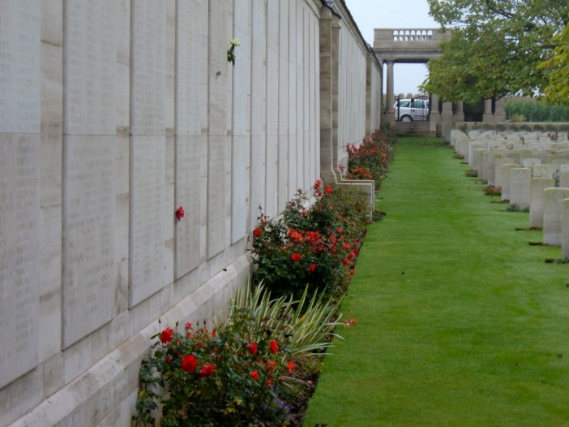  JOHN LALLY  Era WW1  Surname LALLY  Forename John  Rank L Cpl  Service number S/3402  Decoration  Place of birth West Calder  Date of death 25 September 1915  Theatre of death F&F  Cause of death Killed in action  SNWM roll THE SEAFORTH HIGHLANDERS  Unit name In or attached to THE SEAFORTH HIGHLANDERS  Other detail 8th Bn.  Buried or commemorated at  LOOS MEMORIAL Panel 112 to 115. France
12701 Transport Sgt James Carleton  RAMC | JAMES CARLETON  RAMC - No James Carleton’s in RAMC can only find one James and he was in Dublin Fusiliers. – No results for SNWM and None in CWGC  First Name: J Surname: Carleton  Incident Date: 1920 – Forces War Records only have the following but no death record  Service Number: 7248682 Former Service Number: 12701  Additional Information:  Registry of Army Numbers with relative old Regimental Numbers.  Primary Unit:  Royal Army Medical Corps  First Name: J Surname: Carleton  Rank: Transport Serjeant  Service Number: 12701  Regiment: Royal Army Medical Corps

Stoneyburn War Memorial,

Remembered Elsewhere & Those Who Served

43715 LCpl Jonathan Aird  Royal Scots  POW | JONATHAN AIRD  First Name: Jonathan Surname: Aird  Regiments served with:  Unit Rank Service Number  Scottish Rifles Private 1659  Royal Scots Lance Corporal 43715  First Name: J Surname: Aird  Incident Details: War Office Daily List No. 5361  Report Date: 11/09/1917  Rank: Lance Corporal  Service Number: 43715  Casualty Listed As: Previously reported wounded and missing, now reported prisoner of war  Next Of Kin Address: Bents  Service: British Army  Primary Unit: Royal Scots (Lothian Regiment)  Incident Details: War Office Daily List No.5779  Report Date: 23/01/1919  Rank: Lance Corporal  Service Number: 43715  Casualty Listed As: Released Prisoner of War from Germany, arrived in England  Midlothian Advertiser 8th June 1917  District Soldiers in Casualty List  The names of the following district soldiers appeared in the lists of casualties published this week  Pte J Aird, Royal Scots, Bents
David, William, James,  Oliver Bowman | DAVID, WILLIAM, JAMES, OLIVER BOWMAN  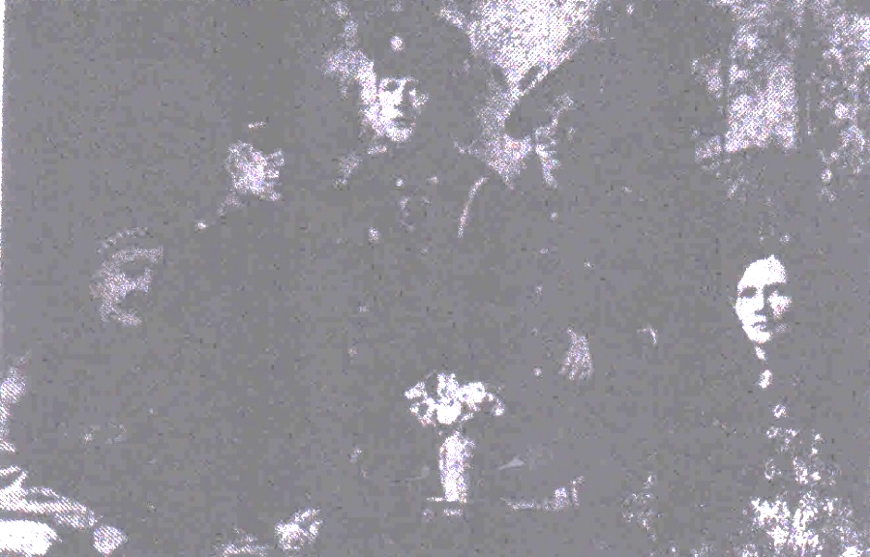  Bowman Family  Midlothian Advertiser Dec 1918  A Stoneyburn family on Service – (Photo) the photo below is a photograph of Mr David Bowman and family 20 Muir Terrace, Stoneyburn who set a most patriotic example. Mr Bowman was over age but enlisted and served in the Royal Defence Corps for home service. His son William, enlisted in the Lovat Scouts and was transferred to the Cameron Highlanders. He was severely wounded and has been in hospital for 12 months. Another son, James was in the Territorials at the outbreak of war and was mobilised with them although he had not reached his 17th birthday. He was engaged on coast defence for a time and then went on active service. He was wounded in Egypt and later was gassed in France. The third son Oliver enlisted in February 1918 and has been in France for 5 months, he has been wounded in the recent fighting. Mr David Bowman, the father was discharged for work in the mines. He will be remembered by many in the West Calder District as the popular trainer of the Mossend Swifts Football Club.  Bowman – In loving memory of my dear husband David Bowman, who was accidentally killed in Woodmuir colliery on the 13th December 1911 aged 27 years  ‘twill not be long,  the yearning heart may feel it’s every hope depart,  And grief be mingled with the song,  We’ll meet again ‘twill not be long.  Inserted by his Widow (Agnes Watson Robb Graham)  Bowman – In loving memory of David Bowman beloved son of David and Margaret Bowman, who was accidentally killed at Woodmuir Colliery on Wednesday 13th December 1911 aged 27 years  He was one of the best that God could land, A dutiful son true and kind,  A loving brother a faithful friend, A beautiful memory left behind  Inserted by his father and mother and brothers (on active service) 20 Muir Terrace, Stoneyburn  (NB Agnes Watson Robb Graham is an Aunt of the Author)
19772 J Bowman  Army Cyclist Corps | J BOWMAN  The Scotsman - Tuesday 15 May 1917  Rank & File Scottish Losses – Wounded Army Cyclist Corps  Bowman, 19772, J, Fauldhouse
226036 Pte W Bowman  Cameron Highlanders  (Silver War Badge)   | W BOWMAN  First Name: W Surname: Bowman  Incident Details: War Office Daily List No. 5421  Report Date: 20/11/1917  More Information: Entitled to wear a "Wound Stripe" as authorised under Army Order 204 of 6th July 1916. The terms of this award being met by being named in this list.  Rank: Private Service Number: 226036  Casualty Listed As: Wounded  Next Of Kin Address: Stoneyburn  Service: British Army  Primary Unit: Cameron Highlanders  Information: Particulars furnished : Perth 10/04/1919.  Rank: Private Service Number: 226036  Service From Date: 03/06/1915  Service To Date: 07/02/1919  Silver War Badge Number: B169908  War Office Ref. Number: G/A/797  Reason for Discharge: Paragraph 392 King's Regulations (xvi) No longer physically fit for war service.  Overseas: Yes  Midlothian Advertiser 23rd November, 1917  District Soldiers in Casualty Lists – The names of the following district soldiers appears in the list of casualties publish this week.  Wounded  Pte W Bowman, Cameron Highlanders, Stoneyburn.
William Glen Bowman | WILLIAM GLEN BOWMAN  West Lothian Courier 2nd August 1918  Young Miner and the Ballot for Army Service – Two young miners named John Graham, and William Glen Bowman, residing at Stoneyburn, both apparently about 19 years of age, were brought before Sheriff Moffatt in the JP Court at Linlithgow on Tuesday on a charge under the Military Service At of having been called up for permanent service and absented themselves from the Army without reasonable excuse. They pleaded guilty and asked if they could see the warrant for their apprehension. The Sheriff said that was unnecessary. If the police had information of the whereabouts of a deserter, it was their duty to arrest. The lads said they came under the ballot, and if the conditions of the ballot had been observed they would not have been called up. The conditions of the ballot provided that if 50% of any family of military age were on active service, the remaining 50% was not to be taken. They argued that these conditions had not been observed in their case. The Sheriff said that was a matter he could not go into. He fined each £2 which would be deducted from their Army pay, and they would be handed over to an escort.
8519 Pte James Connolly  10th Royal Scots (Cyclists) | PRIVATE JAMES CONNOLLY  Service Number: 8519  Regiment & Unit/Ship Royal Scots 2nd Bn.  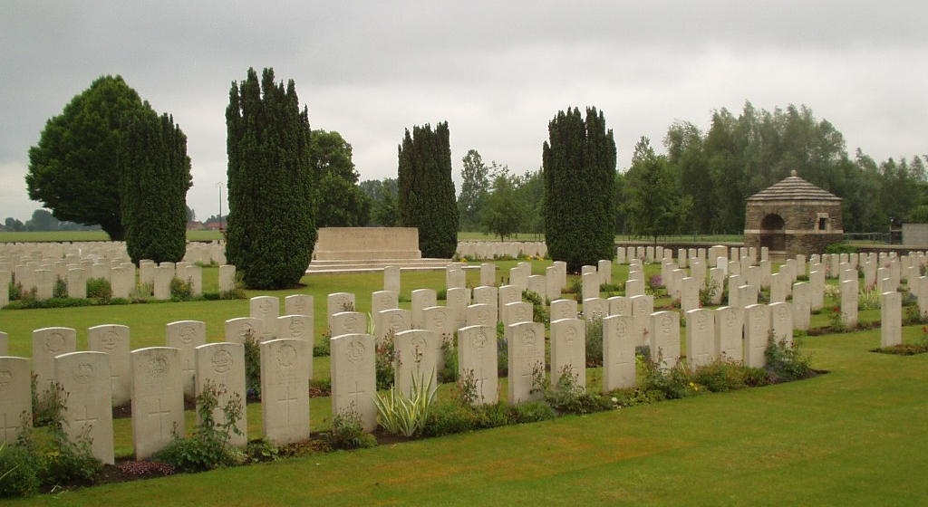  Date of Death  Died 15 October 1914 Age 28 years old  Buried or commemorated at  VIEILLE-CHAPELLE NEW MILITARY CEMETERY, LACOUTURE  VIII. B. 18. France  Country of Service  United Kingdom  Additional Info  Husband of Helen Doyle Burke (formerly Connolly), of 18, Pleasance, Edinburgh.  Midlothian Advertiser 16th July 1915  Stoneyburn Territorial Reported Killed – Information has been received that Pte Connelly of G Coy, 10th Royal Scots (Cyclists), has been killed in action in France. Pte Connolly, who resides at Stoneyburn was well known as a member of West Calder Company of Territorials. He was serving on the East Coast and volunteered for foreign service. Along with other 24 members of the Battalion he proceeded to France and has taken part in several engagements.  The Scotsman - Saturday 17 July 1915  West Calder – Connelly, 10th Royal Scots (Cyclists), whose home is at Stoneyburn, has been killed in France. He was a Territorial in West Calder Company and volunteered for foreign service. Along with other twenty-four cyclists under Captain Wolfe, he was accepted and sent to France.  West Lothian Courier 23rd July 1915  West Calder Territorial Killed – Information has been received at West Calder that Pte Connolly of the 10th Royal Scots (cyclists), has been killed in action in France. Connolly who resided at Stoneyburn was a member of the West Calder Territorial Company. He volunteered and was sent to France as a cyclist.
S/15520 Pte Alexander Daly  7th Btn Queen’s Own Cameron Highlanders | ALEXANDER DALY  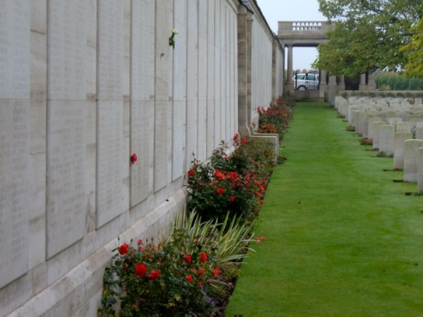  Era WW1  Surname DALY  Forename Alexander  Rank Pte  Service number S/15520  Decoration  Place of birth Glasgow  Date of death 25 September 1915  Theatre of death F&F  Cause of death Killed in action  SNWM roll THE QUEEN'S OWN CAMERON HIGHLANDERS  Unit name In or attached to THE QUEEN'S OWN CAMERON HIGHLANDERS  Other detail 7th Bn.  Buried or commemorated at  LOOS MEMORIAL Panel 119 to 124. France  Country of Service United Kingdom  Additional Info  Son of Alexander and Sarah Daly, of 74, Main St., Uddingston, Lanarkshire.  West Lothian Courier 29th September 1916  Daly – In loving memory of our dear nephew, Pte Alexander Daly, 7th Cameron Highlanders who was killed in action in France on 25th September 1915, aged 20 years.  Died in the pride of his youth and his glory  Far from his home and the land of his birth  None near to mourn him save willows weeping  Mantled the place where our hero lies sleeping.  Inserted by his Uncle and Aunt and cousins Stoneyburn.  West Lothian Courier 9th November 1917  Daly – In loving memory of our dear beloved son LCpl Alexander Daly, killed in action 13th November 1916, aged 25 years, also our dear beloved nephew Pte Alexander Daly killed at Loos on 25th September 1915.  One year has passed since that sad day  When my dear son was called away  God took him home, it was his will  Forget him, no, I never will  Peacefully sleeping resting at last  The weary pain and suffering past  Gone and forgotten by some you may be  But dear to our memory for ever you’ll be.  Inserted by his father and mother and brother Willie on active service, 79 Stoneyburn.  Daly – Killed in action 13th November 1916, LCpl Alex Daly,  His warfare o’er, his battle fought  His victory won, though dearly bought  His fresh young life could not be saved  He slumbers now in a soldier’s grave  He sleeps beside his comrades  In a hallowed grave unknown  His name is woven in letters of love  In the hearts he left at home  We mourn for you dear brother  But not with outward show  For the heart that mourns sincerely  Mourns silently and low.  Inserted by his loving brother and sister and family, Mr and Mrs D Ewing Stoneyburn.
7415 Sgt Thomas Daly  Argyll & Sutherland Highlanders  POW Germany | THOMAS DALY  First name: Thomas Surname : Daly  Incident Date: 15/01/1915  Rank: Private Duty Location: Renney  Date Of Court Martial: 17/12/1914  Nature Of Charge:  The accused was charged with the offence of "Violence to Superiors" - This is offence is detailed in section 8 of the Army Act of 1881 as being committed by a person who, "Strikes or uses or offers any violence to his superior officer or uses threatening or insubordinate language to his superior officer". The accused was charged with violence to a Corporal  Sentence: 84 days detention  Primary Unit: Argyll And Sutherland Highlanders  Secondary Unit: 4th Battalion  First Name: T Surname: Daly  Incident Details: War Office Daily List No.5719  Report Date: 11/11/1918  Rank: Sergeant Service Number: 7415  Casualty Listed As: Missing  Next Of Kin Address: Addiewell  Service: British Army  Primary Unit: Argyll And Sutherland Highlanders  First Name: Thomas Surname: Daly  Incident Details: War Office Daily List No.5758  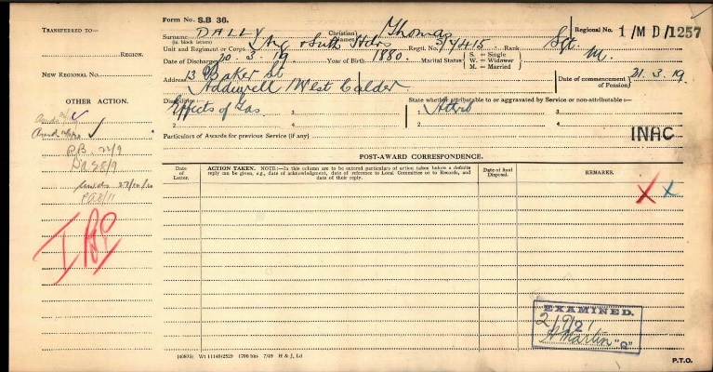  Report Date: 30/12/1918  Rank: Sergeant Service Number: 7415  Casualty Listed As: Released Prisoner of War from Germany, arrived in England  Next Of Kin Address: Addiewell  Service: British Army  Primary Unit: Argyll And Sutherland Highlanders  Thomas received a pension after the war.  Midlothian Advertiser, 28th May, 1915  Three Sons in the Army – Mr Robert Daly, 60 Stoneyburn, has three sons serving in the Army, viz: Pte Thomas Daly in the Argyll & Sutherland Highlanders, Pte W Daly in the 10th Royal Scots, and Pte A Daly also 10th Royal Scots.
Pte William Daly  10th Royal Scots | WILLIAM DALY  Midlothian Advertiser, 28th May, 1915  Three Sons in the Army – Mr Robert Daly, 60 Stoneyburn, has three sons serving in the Army, viz: Pte Thomas Daly in the Argyll & Sutherland Highlanders, Pte W Daly in the 10th Royal Scots, and Pte A Daly also 10th Royal Scots.
5366 Pte Mungo Dymock  1st Btn QO Cameron Highlanders | 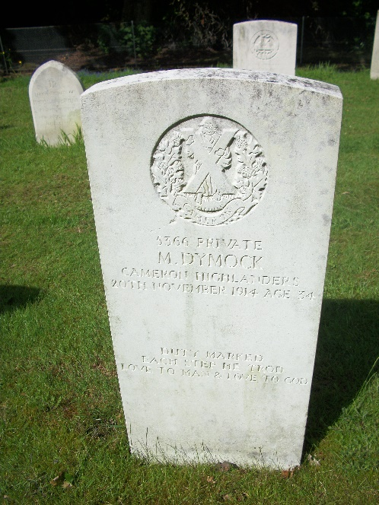  PRIVATE MUNGO DYMOCK  Service Number: 5366  Regiment & Unit/Ship Cameron Highlanders 1st Bn.  Date of Death  Died 20 November 1914 Age 34 years old  Buried or commemorated at  NETLEY MILITARY CEMETERY N. 318. United Kingdom  Country of Service United Kingdom  Additional Info Son of Thomas Dymock; husband of Elizabeth Dymock, of Sandford Cottage, Muir St., Larkhall, Lanarkshire. Born at Motherwell.  Personal Inscription  DUTY MARKED EACH STEP HE TROD  LOVE TO MAN & LOVE TO GOD  First Name: M Surname: Dymock  Index Number of Admission: 2433  Rank: Private Service Number: 5366  Ailment: Gunshot wound, hand  Date of Admission for Original Ailment: 13/11/1914  Date Transferred to Sick Convoy: 13/11/1914  Notes written in the Observations Column: To Base.  Regiment: Cameron Highlanders Battalion: 1st Battalion  West Lothian Courier 4th December 1914  Pte Mungo Dymock Reported Killed – Nephew of Mr Alex Dalziel, Stoneyburn – In September last we published some particulars regarding Pte Mungo Dymock of the Cameron Highlanders who was doing well at the front. It is now reported that he has been killed as a result of wounds sustained in action. It appears that he was on his way home to get his wounds properly attended to when he succumbed. The deceased soldier was a brother to Mr A Dymock, Muirhousedykes and a nephew of Parish Councillor Alex Dalziel, farmer Stoneyburn. Prior to being called up as reservist Pte Dymock worked as a joiner in Motherwell and had a house a 31 Airles Street, Motherwell.
307116 Sgt Robert Elliot  DCM MM  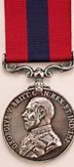  Royal Scots att’d Royal Warwickshire Rgt   | ROBERT ELLIOT  First Name: Robert Surname: Elliot  Regiments served with:  Unit Rank Service Number  Royal Warwickshire Regiment Serjeant 307116  Royal Warwickshire Regiment Serjeant 5682  First Name: R Surname: Elliot  Incident Details: War Office Daily List No.5580  Report Date: 31/05/1918  More Information: Entitled to wear a "Wound Stripe" as authorised under Army Order 204 of the 6th July 1916. The terms of this award being named on this list.  Rank: Sergeant Service Number: 307116  Casualty Listed As: Wounded  Next Of Kin Address: Fauldhouse  Service: British Army  Primary Unit: Royal Warwickshire Regiment  Gazette Date: 03/09/1918  Gallantry Awards: Distinguished Conduct Medal Military Medal  West Lothian Courier 1st February 1918  Stoneyburn Hero – Mr and Mrs John Elliot 86 Stoneyburn, have been notified that their eldest son Sgt Robert Elliot, Royal Scots, attached Royal Warwickshire has been awarded the Military Medal. The extract from the Battalion Order, notifying the award is as follows:-  For Gallantry when acting as Company Sgt Major on December 3rd 1917. Time after time he set a fine example to his men in organising counter attacks when the enemy had effected an entrance into a Sap. When his platoon was broken up, and the officers killed or wounded, he successfully re-organised and carried on until relieved when his position remained intact. Sgt Elliot had a few months before the outbreak of war joined West Calder Company of the Linlithgowshire Battalion Royal Scots. He marched with his company on the morning of the declaration of war to his home station and there served until May 1916, when he was drafted to France and attached to the Royal Warwickshires. He has been through many trying situations since taking his part in the firing line. In private life he followed the occupation of a miner in Foulshiels Colliery occupied by the United Collieries Ltd.  Midlothian Advertiser 28th February 1918  Presentation to Military Medallist – The Military Medallist, Sgt Elliot was a meeting held at Stoneyburn on Saturday, was presented with a wristlet watch and a pocket-book containing a sum of money. The chair was occupied by Mr William Frame, who called on Mr John Murphy to make the presentation. In a few appropriate remarks he asked the Sgt to accept the presentation and wished him to be long spared to wear the watch. Sgt Elliot has returned to the front again and has the good wishes of the people in Stoneyburn for his safe return  West Lothian Courier 31st May 1918  Stoneyburn MM hero gets DCM – In our issue of February 1st this year, we noted that Sgt Robert Elliot eldest son of Mr and Mrs John Elliot, 30 Dalziel Terrance Stoneyburn had been awarded the Military Medal for gallantry, while acting as Company Sgt Major on December 3rd 1917.  We have now to record that the gallant soldier, has been further honoured. He has now for gallantry in the field during recent big attacks received the DCM. In his last encounter with the enemy Sgt Elliot was knocked out of action. He sustained a bullet wound through left arm, and a shrapnel wound to right arm, and now lies in hospital in England. Sgt Elliot had, a few months before the outbreak of war, joined West Calder Company of the Linlithgowshire Battalion Royal Scots. He marched with his company on the morning of the declaration of war to his home station and there served until May 1916, when he was drafted to France and attached to the Royal Warwickshires. He has been through many trying situations since taking his part in the firing line. In private life he followed the occupation of a miner in Foulshiels Colliery occupied by United Collieries, Ltd.
4018 Pte Charles Stewart Ferguson  2nd Btn Royal Scots | CHARLES FERGUSON  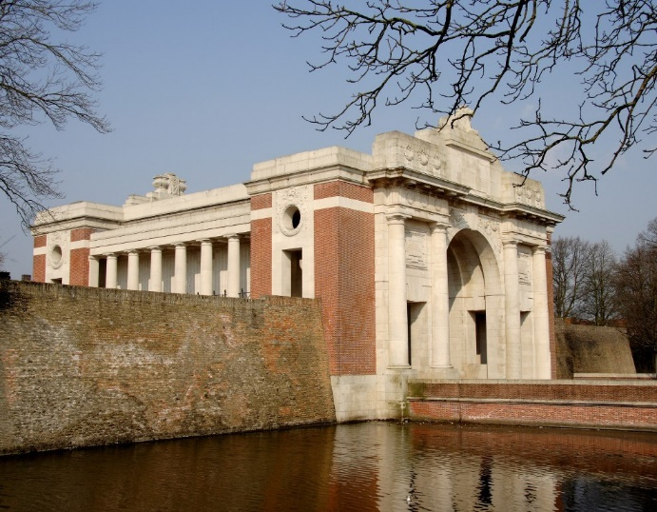  Era WW1  Surname FERGUSON  Forename Charles Stewart  Rank Pte  Service number 4018  Decoration  Place of birth West Calder  Date of death 25 September 1915  Theatre of death F&F  Cause of death Killed in action  SNWM roll THE ROYAL SCOTS (LOTHIAN REGIMENT)  Unit name In or attached to THE ROYAL SCOTS  Other detail 2nd Bn  Buried or commemorated at  YPRES (MENIN GATE) MEMORIAL Panel 11. Belgium  Midlothian Advertiser 28th September 1917  Fergusson – In fond remembrance of my dear brother, Pte Stewart Fergusson, Royal Scots, who went missing at Loos on 25th September 1915, and was afterwards reported to have died on that date.  Dear brother of my bosom you sleep with the brave  Where no tear of a brother can drop on thy grave  In the red fields of France, you are laid far away  Still my tribute of love to thy memory I pay  Inserted by his brother Dugald, 118 Stoneyburn.  Fergusson – In fond and loving memory of our dear brother, Pte Stewart Fergusson, Royal Scots who went missing at Loos, on 25th September 1915, and afterwards reported to have died on that date.  Stewart, our brother it makes our hearts sore  When e think in this life we will see you no more  It was thy sad fate to be killed by the Huns  ‘midst the splinter of shells and the roar of the guns  Inserted by his sisters, Maggie, Mary and Nellie.
10808 Cpl David Gillon  Royal Scots POW | DAVID GILLON  First Name: David A Surname: Gillon  Incident Details: War Office Daily List No.5774  Report Date: 17/01/1919  Rank: Corporal Service Number: 10808  Casualty Listed As: Released Prisoner of War from Germany, arrived in England  Next Of Kin Address: West Calder  Service: British Army Primary Unit: Royal Scots  Incident Details: War Office Daily List No. 5504  Report Date: 28/02/1918  Service Number: 10808  Casualty Listed As: Prisoner of war in Germany, arrived in Holland for internment.  Service: British Army Primary Unit: Royal Scots (Lothian Regiment)  Report Date: 28/04/1915  Information: Listed as "Previously reported Missing, now reported Prisoner of War" on the Casualty List issued by the War Office from the 28th April 1915.  Midlothian Advertiser 4th August 1916  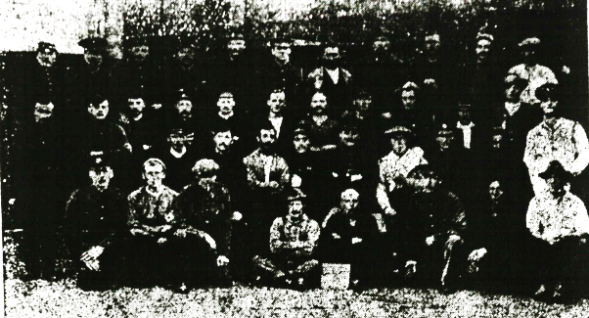  British Prisoners of War – The photograph below is interesting in that it contains a local soldier, who is a prisoner of war in Germany. Reading from left to right the third figure in the front row is Corporal David Gillon son of Mr David Gillon 111 Stoneyburn. He served five years in the 2nd Royal Scots and was made prisoner in the retreat from Mons so that he has been in the hands of the Germans for nearly two years. He is not allowed to send much information home, but it is quite evident that although he has to work hard he is largely dependent for everything on the parcels which are sent from home.
John Graham | JOHN GRAHAM  West Lothian Courier 2nd August 1918  Young Miner and the Ballot for Army Service – Two young miners named John Graham, and William Glen Bowman, residing at Stoneyburn, both apparently about 19 years of age, were brought before Sheriff Moffatt in the JP Court at Linlithgow on Tuesday on a charge under the Military Service At of having been called up for permanent service and absented themselves from the Army without reasonable excuse. They pleaded guilty and asked if they could see the warrant for their apprehension. The Sheriff said that was unnecessary. If the police had information of the whereabouts of a deserter, it was their duty to arrest. The lads said they came under the ballot, and if the conditions of the ballot had been observed they would not have been called up. The conditions of the ballot provided that if 50% of any family of military age were on active service, the remaining 50% was not to be taken. They argued that these conditions had not been observed in their case. The Sheriff said that was a matter he could not go into. He fined each £2 which would be deducted from their Army pay, and they would be handed over to an escort.
S/5638 Pte Robert Hilson  10th Btn Gordon Highlanders  Later 307862 Tank Corps | ROBERT HILSON  First Name: Robert Surname: Hilson  Regiments served with:  Unit Rank Service Number  Gordon Highlanders Private S/5638  Tank Corps Private 307862  Report Date: 27/10/1915  Information: Listed as "Suffering from gas poisoning" on the Casualty List issued by the War Office from 27th October 1915.  Further Information: This man was entitled to wear a "Wound Stripe" as authorised under Army Order 204 of 6th July 1916. The terms of this award being met by their naming in this list.  Rank: Private Service Number: S5638  Duty Location: France and Flanders  Service: British Army Primary Unit:  Gordon Highlanders Secondary Unit: 10th Battalion  West Lothian Courier 11th May 1917  Soldier Charged with Assault – Before Sheriff MacLeod at Linlithgow on Tuesday Robert Hilson a Private in the Gordon Highlanders, was charged with having on the public road heading between the Garden City and Bents Farmhouse, assaulted Jeanie Roberts, residing at 19 Garden City, by striking her on the face with his fist and committed a break of the peace. Accused adhered to his plea of not guilty, which he tendered on Wednesday of last week. Jeanie Roberts the complainant gave evidence that she along with Annie Bell and her brother James was walking on the road in question about 9 o’clock in the evening when they met accused and woman. Witness Annie Bell and her brother stepped off the footpath so as to make way for the accused and the woman along with him. As they were passing, accused struck her on the face. She had no idea why the man struck her for neither she nor those with her said a word to him. Annie Bell in her evidence said she could not say who the man was that they passed it was dark, she did not see any blow struck, but heard a noise like the crack of buttons. James Robert said he saw the man’s hand up, but did not see any blow struck. He heard a crack and his sister told him accused had struck her. Constable Lees spoke to Miss Roberts coming to him and complaining of have been struck by accused. He examined her face, and it was quite obvious that she had got a slap with the hand. Accused in his evidence said some branches caught him in the face and to get clear of them he stumbled against complainant, but he did not striker her. If she was struck it must have been with the branches. After hearing all the evidence the Sheriff said he was satisfied that accused did strike the complainant, but he found the charge of breach of the peace not proved. As he had been in the Carlton since last Wednesday, he thought he had been sufficiently punished for the assault. He was therefore discharged.
S/10420 LCpl Patrick McGuire  9th Btn Seaforth Highlanders | PATRICK MCGUIRE  First Name: Patrick Surname: McGuire  Regiments served with:  Unit Rank Service Number  Seaforth Highlanders Private S/10420  Royal Fusiliers Private 106158  Labour Corps Private 574762  First Name: P Surname: McGuire  Age: 26  Index Number of Admission: 1995  Rank: Lance Corporal  Service Number: 10420  Years Service: 3 years 6 months  Months With Field Force: 2 years 6 months  Ailment: Sprain, ankle (right)  Date of Admission for Original Ailment: 03/03/1918  Date Transferred to Sick Convoy: 04/03/1918  Date of Transfer From Sick Convoy: 1st South African Field Ambulance  Number/Designation of Ward: D1  Notes written in the Observations Column: No. 25 Ambulance Train.  Religion: Roman Catholic  Regiment: Seaforth Highlanders  Battalion: 9th (Service) Battalion Other unit info: C Company, 9th Division
8130 Pte John McKay  2nd Btn Highland Light Infantry | JOHN MCKAY  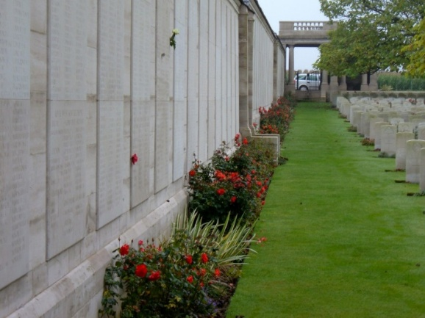  Era WW1  Surname McKAY  Forename John  Rank Pte  Service number 8130  Decoration  Place of birth Broxburn Linlithgow  Date of death 25 September 1915  Theatre of death F&F  Cause of death Killed in action  SNWM roll THE HIGHLAND LIGHT INFANTRY  Unit name In or attached to THE HIGHLAND LIGHT INFANTRY  Other detail 2nd Bn.  Buried or commemorated at  LOOS MEMORIAL Panel 108 to 112. France  Midlothian Advertiser 27th October 1916  Stoneyburn Father’s Sacrifice – Mr McKay, 131 Stoneyburn, has suffered a second loss owing to the war. His son Pte John McKay of the HLI was killed at Loos in September 1915. Another son Pte James McKay of the Seaforth Highlanders was wounded in action and died on the 24th August last. Sympathy will be felt for the father and sisters in their sore trial.  McKay – In loving Memory of Pte James McKay of the Seaforth Highlanders who died from wounds received in action on 24th August, 1916, aged 28 years, also of Pte John McKay, HLI, who was killed at Loos on 25th September, 1915, aged 26 years.  Inserted by his Father and Sisters, 131 Stoneyburn
139744 Pte George McLean  MM  Machine Gun Corps | GEORGE MCLEAN  First Name: G Surname: McLean  Resided Town: Fauldhouse  Rank: Private Service Number: 139744  Gazette Info:  Gazette Issue 30897. M.M. His Majesty the King has been graciously pleased to approve of the award of the Military Medal for bravery in the Field of the undermentioned Non-Commissioned Officers and Men.  Gazette Date: 10/09/1918 Gazette Page: 10769  Midlothian Advertiser 5th July, 1918  Medal for Stoneyburn Soldier – Pte G McLean of the Machine Gun Corps formerly of the Warwickshire Regiment whose home is at Stoneyburn has been awarded the Military Medal for gallantry on the field.  The Scotsman - Wednesday 18 September 1918  Bravery Rewarded – Military Medal  139744, Pte G McLean, Machine Gun Corps, Fauldhouse  Midlothian Advertiser October 1918  The above is a photograph of Pte George McLean of the Machine Gun Corps, son of Mr and Mrs McLean, 53 Stoneyburn, who has been awarded the Military Medal for Gallantry on the field. He has been on active service for over two years and has taken part in much of the heavy fighting. In civil life he worked as a miner in Foulshields Colliery.
Pte Richard McPake  Army Service Corps | RICHARD MCPAKE  First Name: Richard Surname: McPake  Regiments served with:  Unit Rank Service Number  Royal Scots Private 4547  Royal Scots Private 201341  This is the only Richard McPake I can find in Military Records  West Lothian Courier 26th January 1917  Court on Wednesday Robert McPake, miner Stoneyburn was charged with being a deserter from the Army Service Corps since 3rd September 1915, after having been 5 months in the Army. He had been working in the district as a miner since March of last year. It is understood that the man says he is 44 years of age but at the time he enlisted he stated his age to be 35 years. The Magistrate granted an order for his being handed over to the Military Authorities.
S/40634 LCpl P Meek  Queen’s Own Cameron Highlanders | PETER C MEEK  First Name: Peter C Surname: Meek  Regiments served with:  Unit Rank Service Number  Cameron Highlanders Corporal 5471  Cameron Highlanders Corporal S/40634  West Lothian Courier 23rd March 1917  Stoneyburn Teacher Wounded – Mr and Mrs Meek, Portland Terrace, have just received word from their son LCpl P Meek, Cameron Highlands, stating that he has been wounded in the head and hand He is now in a English hospital. It will be remembered that he was in hospital some time ago suffering from trench feet. Prior to enlisting, LCpl Meek was employed on the staff of Stoneyburn school.
S/16514 Pte Patrick Malloy MM  3rd Btn Queen’s Own Cameron Highlanders  (Silver War Badge)   | 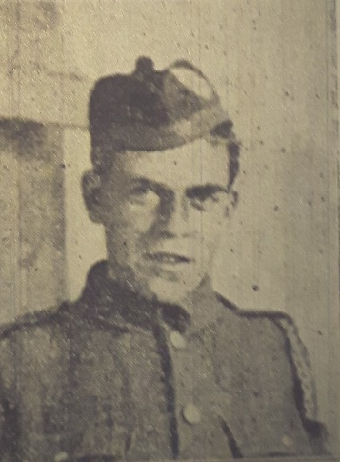  PATRICK MALLOY  First Name: P Surname: Malloy  Rank: Private Service Number: S.16514  Gazette Info:  Gazette issue 29794. M.M. His Majesty the King has been graciously pleased to award the Military Medal for bravery in the Field.  Gazette Date: 20/10/1916 Gazette Page: 10219  Service: British Army  Regiment: Cameron Highlanders  Information:  Particulars furnished: Perth, 10/05/1919.  Rank: Private  Service Number: S/16514  Service From Date: 04/01/1915  Service To Date: 14/12/1918  Silver War Badge Number: B196319  War Office Ref. Number: G/A/910  Reason for Discharge:  Paragraph 392 King's Regulations (xvia) Surplus to military requirements (having suffered impairment since entry into the service). Army Order 29 of 1919.  Overseas: Yes  Primary Unit: Cameron Highlanders Secondary Unit: 3rd Battalion  Midlothian Advertiser 1st June 1917  Presentation to Stoneyburn Military Medallist – A number of well-wishers and friends met Pte Patrick Milloy, Military Medallist in the Institute at Stoneyburn on Tuesday evening and presented him with a token of their appreciation of his bravery whilst serving with the British Army in France. Mr William Paton manager of the local Picture House presided, and in a few well-chosen remarks said they had met to do honour to one of their comrades who had been fighting on their behalf and in defence of right and liberty on the battlefields of Francce. It was encouraging to think that one of their many representatives from the village should have shown such bravery as warranted his receiving such a distinguished honour. Along with others, he had been acquainted with Pte Milloy for many years, and had always found him of a quiet good natured disposition. He therefore considered it an honour to have been asked to preside on such a prominent occasion. The presentation which took the form of a handsome wristlet watch with initials, was made by Mr Alexander Dalziel JP who in a few appropriate remarks said that Pte Milloy, being a miner previous to enlistment, he might easily have stayed at home. Imbued with the fighting spirit however he enlisted in the Cameron Highlanders on January 14th 1915, and after a period of training he was dispatched with a draft to France, where he experiences fully nine months of the hottest fighting. Describing the deed which won Pte Milloy the Military Medal, Mr Dalziel said that along with a number of comrades he was attending to a number of trench guns in a very exposed position. The battery was playing havoc among the Germans until their position was signalled and as a result showers of bullets and small shells came pouring in among them. One by one his comrades were either killed or wounded until at last he was the only one left to defend the position until relief came up. Bravely he stuck to his task until he unfortunately got severely wounded in the right arm, B this time, however the relief part arrived, and the position was saved. Such a brave deed was worthy of the highest praise. In asking Pte Milloy to accept of the gift not for its intrinsic value, but for the good feeling and admiration which prompted it, he hoped that he would come safely through the great struggle for right against might and be long spared to wear it, (Applause). Pte Milloy in reply thanked his many kind friends for the handsome gift and said that what he had done was only his duty. While lying in hospital at New port, Pte Milloy was also presented with a silver cigarette case by the inmates and staff when he had the pleasure of hearing Mr Whit Cuncliff the famous versatile comedian sing a couple of songs to celebrate the occasion. Pte Milloy’s brother is also at present serving with the colours.  West Lothian Courier 8th June 1917  Stoneyburn Soldier Honoured – we show a portrait of Pte Molloy, Cameron Highlanders, son of Mrs Molloy, Stoneyburn who recently at Western General Hospital at Newport had pinned upon his breast by Colonel Hepburn, the Military Medal. The honour was gained under the following circumstances – Pte Molly’s battalion had been in action on August 29th 1916 at High Wood for five days. They had suffered heavily, and on this day Pte Molloy was the only man left out of the whole Battery. In response, to orders from headquarters he kept the guns firing all day single handed until he himself received a bullet through the arm and was then forced to retire.  Pte Molloy is a native of Stoneyburn and previous to enlisting was employed as a miner in Foulshiels Colliery. On Tuesday, the workmen in Foulshiels Colliery and friends met in Stoneyburn Institute and paid tribute to their gallant comrade. Mr Dalziel, who made the presentation to the soldier of wristlet Watch and purse of money spoke in eloquent terms of how the news of Pte Molloy’s achievement had thrilled the people of his native village.
170206 Pte James Orr  MT Coy, ASC | JAMES ORR  First Name: James Surname: Orr  Rank: Private  Service Number: DM2170206  Regiment: Army Service Corps  Midlothian Advertiser 9th November, 1917  Stoneyburn Soldiers Thanks – Pte James Orr, No 170206, Salonica 778 MT Coy, ASC, begs to thank the people of Stoneyburn and Bents for their kindness in sending the parcel, as the contents were very good and was very thankfully received.
13560 Pte James Shaw  5th Dragoon Guards (Princess Charlotte of Wales) | 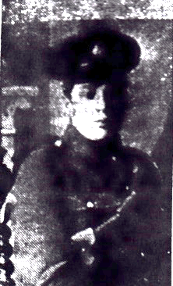  PRIVATE JAMES SHAW  Service Number: 13560  Regiment & Unit/Ship  5th Dragoon Guards (Princess Charlotte of Wales's)  Date of Death  Died 22 March 1918  Buried or commemorated at  POZIERES MEMORIAL Panel 2. France  Country of Service  United Kingdom  Midlothian Advertiser 3rd May 1918  Local Soldier Killed – We show a photograph of Pre James Shaw, of the Dragoon Guards, son of Mrs Moffat, 19 Stoneyburn who was killed in action on the 22nd March. Pte Shaw was in his 22nd year, and had been in France for two years, where he had taken his share of the heavy fighting. Previous to enlisted he worked as a miner in West Mains Colliery.
Thomas Smith | THOMAS SMITH  (TAFLINA RUDIZIEVICIUS)  The Scotsman - Wednesday 08 October 1919  Naturalisation of Aliens  Taflina Rudizievicius, known as Thomas Smith, Russian, 31 Stoneyburn, by Fauldhouse, miner  Served or is serving in HM Forces
43209 Sgt Alan J Steuart  Royal Canadian Engineers | ALAN J STEUART  43209 St Alan John Steuart Royal Canadian Engineers  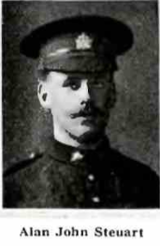  West Lothian Courier 14th May 1915  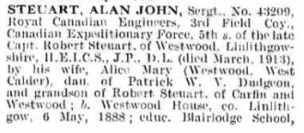  Son of the Late Captain Steuart, Westwood Killed – Information has come to Mrs Steuart of Westwood, West Calder, that her son Pte Alan Steuart has died from wounds received in action in France on April 24th. Pte Steuart who was an electrical engineer, joined the Canadian Engineers and came across with the first contingent. He was 27 years of age and was the fourth son of the Late Captain Steuart of Westwood.  The Roll of Honour, Volume I, De Ruvigny  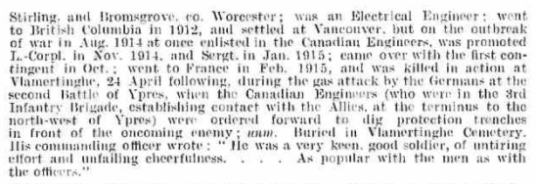
5943 Pte Peter Thomson  1st Black Watch | PETER THOMSON  Black Watch  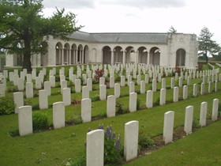  Era WW1  Surname THOMSON  Forename Peter  Rank Pte  Service number 3/2943  Decoration  Place of birth Loganlea Midlothian  Date of death 6 January 1915  Theatre of death F&F  Cause of death Killed in action  SNWM roll THE BLACK WATCH (ROYAL HIGHLANDERS)  Unit name In or attached to THE BLACK WATCH ROYAL HIGHLANDERS  Other detail 1st Bn.  Private PETER THOMSON  Service Number: 3/2943  Regiment & Unit/Ship  Black Watch (Royal Highlanders)  1st Bn.  Date of Death  Died 06 January 1915  Buried or commemorated at  LE TOURET MEMORIAL  Panels 24 to 26.  France  West Lothian Courier 14th May 1915  Harthill Soldier Killed in Action – It has now been officially confirmed that No 5943 Pte Peter Thomson 1st Black Watch, who had resided here for the past ten years, was killed in action on 6th January last. He is said to be a native of Stoneyburn, near West Calder. He had previous military training having been in the Black Watch (Militia) for 6 years. He was very fond of music and dancing and was at one time a member of the Pipe Band. He was of a very cheerful pleasant nature. He was 36 years of age and unmarried.
Mr Weir  Headmaster of School | Mr Weir, Headmaster  West Lothian Courier 7th April 1916  Stoneyburn – Presentation – A very peasant function took place in Stoneyburn School on Wednesday afternoon, when Mr Weir, Headmaster was made the recipient of a handsome wristlet watch on the occasion of his leaving to serve his King and Country. Miss Mary Moonie, one of the pupils in making the presentation said – “We are met here today to say goodbye to our headmaster, who is leaving us for a time we hope – to enter the service of the country. We are sorry to part with him but hope it will not be for long. We realise that we are losing a really “good man”, and if Mr Weir performs his duties as a solider in the same capable way as his scholastic ones the British Army will profit thereby. I have much please in asking you Mr Weir, on behalf of the staff and pupils of Stoneyburn to accept this watch as a small token of our appreciation and esteem and hope you will be long spared to wear it. In closing we all wish you the best of luck and a speedy return to your old duties.” – Mr Weir made a very feeling and appropriate reply.
Pte A Wilson  KOSB  POW | A WILSON  West Lothian Courier 7th January 1916  A Fauldhouse Man Prisoner in Germany – Mr John Combe, Stoneyburn Farm, Fauldhouse has received an interesting letter from Pte A Wilson KOSB, who is a prisoner at Sennelager Germany. He writes in a cheery vein, but as is expected, owing to the German Censor’s pencil he is not allowed to give descriptions of the camp or pen sketches of the people. Pte Wilson, who was taken prisoner in the retreat from Mons is kept constantly at work being in good health and last winter he held the plough just like old times. Pte Wilson was a reservist and prior to the war he was a farm servant to Mr Combe, Stoneyburn Farm. Pte Wilson in his letter returns thanks for gifts sent but says that he is not needing anything just now – having plenty of food and clothing etc to keep him going.  (Can’t identify this man as yet - records are still incomplete)

